

FACULTY OF COMPUTING AND INFORMATION TECHNOLOGY

BACS3183 ADVANCED DATABASE MANAGEMENT
Assignment
Semester 202501

Programme (Year, Sem & Group) | : | RDS2S2 G3
Date Submitted | : | 25 / 4 / 2025

Team members:
No | Name (Block Letters - Alphabetical Order) | Student ID | Marks
1 | DORCAS LIM YUAN YAO | 2314535
2 | TAN YEN PING (L) | 2314615
3 | TAY MIAN YIN | 2314619
4 | TAY ZHUANG YIN | 2315116
5 | WONG JIN XUAN | 2314630

Declaration

We confirm that we have read and shall comply with all the terms and conditions of TAR UMT’s plagiarism policy.
We declare that this assignment is free from all forms of plagiarism and for all intents and purposes is my own properly derived work.
 |  |  |  | 
Name: Dorcas Lim Yuan Yao | Name: Tan Yen Ping | Name: Tay Mian Yin | Name: Tay Zhuang Yin | Name: Wong Jin Xuan
Signature:   | Signature:   | Signature:   | Signature:   | Signature:  
Date: 13/2/2025 | Date: 13/2/2025 | Date: 13/2/2025 | Date: 13/2/2025 | Date: 13/2/2025

Assignment Assessment Form
No | Member Name (Alphabetical order) | Programme (Year-Semester-Group)
1. | Dorcas Lim Yuan Yao | RDS Year 2 Semester 2 Group 3
2. | Tan Yen Ping | RDS Year 2 Semester 2 Group 3
3. | Tay Mian Yin | RDS Year 2 Semester 2 Group 3
4. | Tay Zhuang Yin | RDS Year 2 Semester 2 Group 3
5. | Wong Jin Xuan | RDS Year 2 Semester 2 Group 3

Task  No. |  |  | Task Descriptions | Weightage | Criteria | 1 | 2 | 3 | 4 | 5 | Comment
1  (CLO 1) |  |  | Entity Relationship Diagram | 10% | - A complete ER data model in 3rd Normal Form.  - All primary keys, foreign keys, relationships and attributes must be clearly shown.  - Standalone system design will be given lower marks compare to online system design.
2  (CLO 1) |  |  | Data Definition (DDL) | 10% | - Relevant integrity constraints to ensure database integrity must be included.  - Necessary check constraints and default values to enforce business rules should also be included.
3  (CLO 1) |  |  | Data records | 5% | - Sufficient quality data records must be created for each table.
4  (CLO 3) |  |  | Queries | 5% | - Each team member is to design and produce two quality and useful queries for decision making at any two different management levels: strategic, tactical or operational.  - Single table queries are not allowed.  - Multiple table queries with aggregate functions (where appropriate) must be used.  - View(s) is/are ought to be incorporated, where necessary.  - These 2 queries cannot be used directly for report body.
 |  |  |  | 5%
5  (CLO 2) |  |  | Stored Procedures | 5% | - Each team member is to design and create two stored procedures that cater for the use case scenarios for the system.  - Quality, usefulness and importance of the stored procedures must be considered.
 |  |  |  | 5%
6  (CLO 2) |  |  | Triggers | 5% | - Each team member is to design and create two triggers that enforces system-wide business rules and policies.  - Quality, usefulness and functionality of the triggers must be considered.
 |  |  |  | 5%
7  (CLO 3) |  |  | Reports | 10% | - Each team member is to create two procedures to generate two reports (summary, detail and on demand basis reports) for the company.  - Parameter value(s) should be passed to the procedure, where necessary.  - Cursor must be used in report generation (prefer nested cursors or multiple cursors).  - Usefulness, complexity and presentation of the reports must be considered.
 |  |  |  | 10%
8  (CLO 2) |  |  | Extra Effort | 10% | - Sequences, indexes, views, output formatting, exceptions and/or functions, must be incorporated where necessary.  - Usefulness and application of each of the above to enhance the efficiency and effectiveness of the information system must be considered.  - Linking of all the tasks of every team member in creating a quality information system must be considered.
9  (CLO 3) |  |  | Presentation & Participation | 15% | - Run the single script file from Task 2 – 3 to create the new system database on the lab server.  - Individual presentation on Task 4 – 8.  - Q & A  - Actively participate in class discussion.
Assignment Marks / 100
*CLO 1: Develop the relational database system with the appropriate integrity constraints and security control. (P3, PLO3)
*CLO 2: Design the solutions to issues pertaining to database efficiency and effectiveness using appropriate techniques. (C4, PLO2)
*CLO 3: Extract information from the database using efficient SQL query construct. (C4, PLO6)

Table of Content
Table of Content 4
Chapter 1 Background of the System 8
1.1 Type of Systems - Online System 8
1.2 List of Modules 9
Chapter 2 Entity Relationship Modeling 10
2.1 Business Rules and Assumptions 10
DBDL for Library Management System 17
2.2 Entity Relationship Diagram ERD Diagram.draw io 18
Chapter 3 Data Definition 19
Chapter 4 Queries, Procedures, Triggers and Reports 23
4.1 Dorcas Lim Yuan Yao 23
4.1.1 Query 1: Total REservations Handled by Each Staff Per Shift (Ranked) 23
4.1.2 Query 2: Recent Members Reservation Activity (APR-JUN 2024) 25
4.1.3 Stored Procedure 1: Add New Reservation 27
4.1.4 Stored Procedure 2: Check Book Availability 29
4.1.5 Trigger 1: Automatic Membership Status Update 31
4.1.6 Trigger 2: Enforce Borrow Limit 32
4.1.7 Report 1: Reservation Report by Status and Month 33
4.1.8 Report 2: Overdue Books Report 34
4.2 Tan Yen Ping 38
4.2.1 Query 1: Borrowing And Member Activity Tracking 38
4.2.2 Query 2: Borrowing Status And Return History 40
4.2.3 Stored Procedure 1: Add Borrowed Book 42
4.2.4 Stored Procedure 2: Get Current Book Status 45
4.2.5 Trigger 1: Generate Audit id 49
4.2.6 Trigger 2: Prevent Invalid action for Book Audit 49
4.2.7 Trigger 3: Borrowed Book Actions 50
4.2.8 Trigger 4: Manage Loan Extension 51
4.2.9 Report 1: Report 1- Detail report of Top 5 Members Who Borrowed Books in a Given Months 52
4.2.10 Report 2: Report 2- Summary report of Loan Extension 57
4.3 Tay Mian Yin 60
4.3.1 Query 1: Monthly Reservation Overview 60
4.3.2 Query 2: High-Demand Books: Frequently Reserved but Unavailable 62
4.3.3 Stored Procedure 1: Check Shift Overlap 64
4.3.4 Stored Procedure 2: Get Staff Attendance Summary 66
4.3.5 Trigger 1: Auto-mark Staff as 'Late' Based on Shift Start Time 68
4.3.6 Trigger 2: Enforce 40-Hour Weekly Limit for Staff 69
4.3.7 Report 1: On-Demand Detailed Attendance Report by Shift Date 70
4.3.8 Report 2: Late Attendance Report 73
4.4 Tay Zhuang Yin 76
4.4.1 Query 1: Analysis of Active Members with High Extensions and Overdue Activity 76
4.4.2 Query 2: Top N Member With Most Fine Payments 78
4.4.3 Stored Procedure 1: Add New Fine 80
4.4.4 Stored Procedure 2: Get All Fine By Member 83
4.4.5 Trigger 1: Update Fine Amount 85
4.4.6 Trigger 2: Update Payment Amount 86
4.4.7 Trigger 3: Manage Fines 87
4.4.8 Trigger 4: Manage Payments 88
4.4.9 Report 1: Fine Payment Trends Report (Jan to Jun 2024) 88
4.4.10 Report 2: Unpaid Fine Analytics 93
4.5 Wong Jin Xuan 97
4.5.1 Query 1: Most Borrowed Books (Popular Books Ranking) 97
4.5.2 Query 2: Staff Performance and Efficiency Analysis 100
4.5.3 Stored Procedure 1: Get Borrow History for a Member 104
4.5.4 Stored Procedure 2: Add New Book Title with Copies 107
4.5.5 Trigger 1: Manage Book Details Validation 111
4.5.6 Trigger 2: Automatic Book Status Update 114
4.5.7 Report 1: Most Popular Genres & Authors: A Genre Borrowing Analytics Report 118
4.5.8 Report 2: Book Status Analytics: Availability & Borrowing Duration Report 124
Chapter 5 Extra Effort Highlights 129
5.1 Dorcas Lim Yuan Yao 129
5.1.1 Views 129
View 1: StaffShiftReservationSummary 129
View 2: RecentMemberReservation 131
5.1.2 Indexes 133
Index 1: idx_reservation_statusmonth 133
Index 2: idx_due_return 134
5.1.3 User Defined Functions 135
Function 1: TotalBooksBorrowed(memberID)&DisplaysBookIDsNotReturned 135
Function 2: TotalBooksLostOrDamage 136
5.1.4 User Defined Exceptions 137
Exception 1: RAISE_APPLICATION_ERROR 137
Exception 2: Default Exception Handling 138
Exception 3: Custom Execption 139
5.1.5 Sequences 140
Sequence 1: Reservation_seq 140
5.1.6 Output Formatting 141
Query 1: Total Reservation Handled by Each Staff per Shift 141
Query 2: Recent Member Reservation Activity (Apr-Jun 2024) 142
5.2 Tan Yen Ping 143
5.2.1 Views 143
View 1: BorrowingReturnTracking 143
View 2: Book_Borrow_Return_History 143
5.2.2 Indexes 144
Indexes 1: idx_borrow_month 144
Indexes 2: idx_borrow_member_book 145
5.2.3 User Defined Functions 145
Function 1: Get_Borrow_Duration 145
Function 2: Get_Member_Since_Days 146
Function 3: Get_Extension_Percent 146
5.2.4 User Defined Exceptions 147
Exception 1: Book Audit Validation Rules 147
Exception 2: Check if the member exists 147
Exception 3: Handle general errors in Add_Borrowed_Book 147
Exception 4: Handle error in SP-Get_Book_Status 147
Exception 5: Check Any Data in Function Get_Extension_Percent 147
5.2.5 Sequence 148
Sequence 1: bookaudit_seq 148
Sequence 2: borrow_seq 148
5.2.6 Output Formatting 148
5.3 Tay Mian Yin 151
5.3.1 Views 151
View 1: MonthlyReservationOverview_View 151
View 2: BookDemand_View 153
5.3.2 Indexes 153
Indexes 1: idx_shiftdate 153
Indexes 2: idx_sa_status_sched 154
5.3.3 User Defined Functions 155
Function 1: Get Shift Duration 155
Function 2: Calculate Minutes Late 155
5.3.4 User Defined Exceptions 156
Exception 1: table_missing
Implementation: Stored Procedure 1 - proc_check_shift_overlap
Implementation: Stored Procedure 2 - proc_staff_attendance_summary
Purpose:
The table_missing exception is explicitly designed to catch the Oracle error ORA-00942, which occurs when a table or view does not exist in the database. This maps the system error ORA-00942 to a named exception (table_missing), which you can handle specifically in the EXCEPTION block.
Justification of Using table_missing Exception: 156
Exception 2: WHEN OTHERS 157
5.3.5 Sequence 157
Sequence 1: shift_schedules_seq 157
Sequence 2: staff_attendance_seq 158
5.3.6 Output Formatting 158
5.4 Tay Zhuang Yin 159
5.4.1 Views 159
VIEW 1: MemberBorrowStatus_VIEW 159
VIEW 2: MemberFinePayments_VIEW 160
5.4.2 Indexes 161
Index 1: idx_payments_method_date 161
Index 2: idx_fines_status 162
5.4.3 User Defined Functions 162
Function 1: get_paid_amount 162
Function 2: get_paid_fines_count 163
5.4.4 User Defined Exceptions 164
Exception 1: Return Status Checking 164
Exception 2: Member Existing Checking 164
5.4.6 Output Formatting 167
5.5 Wong Jin Xuan 169
5.5.1 Views 169
View 1: BookBorrow_View 169
View 2: staff_basic_view 171
5.5.2 Indexes 172
Index 1: idx_genre_bookid 172
Index 2: idx_status_bookcopy 173
5.5.3 User Defined Functions 174
Function 1: CalculateTotalHoursWorked(staff_id) 174
Function 2: CalculateLoanProcessed(staff_id) 175
5.5.4 User Defined Exceptions 176
Exception 1: ISBN Uniqueness Check 176
Exception 2: Publication Year Validation 176
Exception 3: Price Validation 177
Exception 4: Popularity Validation 177
Exception 5: Invalid Genre Validation 178
Exception 6: Invalid Copy Count Validation 179
Exception 7: Duplicate Book ID or ISBN (PRAGMA EXCEPTION_INIT) 179
5.5.5 Sequences 181
Sequence 1: book_id_seq 181
Sequence 2: copy_id_seq 182
5.5.6 Output Formatting 183

Chapter 1 Background of the System

1.1 Type of Systems - Online System
The library management system in this project is best described as an online system. This is because it’s designed to run on a centralized server, allowing multiple users to access and update data in real time from different locations. The system’s setup suits environments where up-to-date information needs to be shared and managed efficiently across a network, whether through the internet or an internal connection.

Justification
- Multi-user Environment
The system is designed for use by different user groups, including library staff and members. Staff members manage book inventories, shifts, audits, and fines, while members perform actions such as borrowing books, making reservations, and paying fines. All these functions must occur concurrently, which requires a system that supports multi-user access in which an online system does well on this.

- Centralized Data Management
The system maintains crucial shared data such as book availability, member status, staff schedules, and borrowing records. Centralized data storage ensures consistency and prevents conflicts between user actions.
For example, when a book is reserved, its status is instantly updated to be reserved across the system. This prevents another member from trying to borrow the same book at the same time, ensuring consistency.

- Real-Time Transactions and Status Updates
Real-time updates are essential in this system. For instance, when a member borrows or returns a book, the book’s status such as available, borrowed, or reserved needs to be updated immediately. Likewise, accurate information on staff attendance, shift schedules, and membership status is crucial to ensure smooth day-to-day operations and informed decision-making.

- Remote Accessibility
Members may need to renew memberships, check book availability, or make reservations from outside the library premises. An online system allows for such functionality through online web or mobile interfaces.

- Scalability and Future Expansion
As the library expands, the number of users, book records, and transactions will naturally grow. An online system offers the scalability needed to handle these increases and can easily support additional features or users in the future.

1.2 List of Modules
Mandatory Modules:
- Membership Registration
Allows users to register as library members by providing necessary details such as name, contact information, and payment for registration.

- Track Membership Validity
Automatically updates and monitors the membership status (active or expired) based on the expiry date and renewal actions.

- Borrowing and Returning Process
Handles the borrowing of available book copies, recording of borrowing dates, due dates, and return details. Updates the book status accordingly.

- Book Reservation
Enables members to reserve books that are currently on loan or unavailable, with automatic status updates and cancellation if not collected on time.

- Track Due Dates and Overdue Books
Notifies members of upcoming due dates and flags overdue books for follow-up and fine processing.

- Fine Processing
Calculates and applies fines based on late returns, lost, or damaged books. Ensures the accuracy of the fine amount based on library rules.

- Generate Fine Invoices
Calculates and applies fines based on late returns, lost, or damaged books. Ensures the accuracy of the fine amount based on library rules.

- Book Loan Extension
Allows members to request one-time loan extensions within the allowed period, with approval handled by staff.

- Advanced Book Search
Offers filter options to search for books by genre, author, publication year, and popularity rating, enhancing the browsing experience.

Additional Module:
- Staff Shift and Performance Tracking
This module monitors staff assignments, shift schedules, and attendance records. It ensures each staff member is assigned only one shift per day and validates attendance against scheduled shifts.
Managers can track staff punctuality, presence, and performance across different roles such as librarian, assistant, security, cleaner, and others, allowing for effective human resource management.

Chapter 2 Entity Relationship Modeling

2.1 Business Rules and Assumptions
Assumptions
- The library operates from 9am to 10pm, Monday to Friday.

- Income: Libraries generally do not operate for profit, but they still generate income through fines, memberships, and donations to maintain operations.

- The popularity rating of a book that ranges from 1.0 to 5.0 is obtained from publicly available datasets on Kaggle. These datasets include ratings and reviews that collected from Amazon and others public review sources.

- All records start from 1/1/2024 until 30/6/2024, except staff attendance and staff schedule remain only two months 1/5/2024 until 30/6/2024 .

- Only registered members with active membership status can borrow books.

- Staff actual start time that is earlier than the scheduled start time is not considered ‘Arrived early’. It is classified as ‘Present’ status for the purposes of staff attendance tracking.

Business Rules
Members
- Unique Identification
Each member in the system is uniquely identified by memberId, ensuring that every library user has a different record. memberEmail and memberTel should be unique to prevent duplicate registration. memberTel must be a valid phone number format (+60xx - xxxxxx, 9 to 10 digits) and memberEmail must be in a valid email format. ( ends with @____.com )
- Membership status and Access Control
Each new member is registered with an active status. Only active members can borrow books and make reservations. Members must renew their membership before expiration to retain access to borrowing and reservation services. Although borrowing and making a new reservation is not allowed, a member still can return books and also pay for fines.
Members with expired status must renew their membership before accessing library services.
- When a member did not pay for membership renewal, the system updates memberStatus from active → expire once the expireDate is reached.
- When the memberStatus is expire, the reservation status will be updated to cancelled.

New Membership: RM 50/per year
Renewal: RM 25/per year

- Registration and Expiry Date Validity
Registration date must be a valid date (working day) and cannot be in the future. expireDate is exactly one year from the registrationDate for new members. If the member renews their membership, expireDate is extended by one additional year from the current expireDate
Staff and Shift
- Unique Identification
Each staff member is uniquely identified by staffId, ensuring proper tracking of employees. staffEmail and staffTel should be unique to prevent duplicate records. staffTel must be a valid phone number format (+60xx - xxxxxx, 9 to 10 digits) and staffEmail must be in a valid email format. ( ends with @____.com )
- Staff Roles and Constraints
Each staff member is assigned to one specific role and cannot hold multiple roles at the same time. The role must be one of the predefined values: librarian, manager, assistant, security, or cleaner to ensure consistency in staff assignments.
- Shift Scheduling and Staff Assignments
The library operates in fixed shifts, and each shift has a unique shiftId for identification. Each shift includes a shiftType and fixed startTime and endTime. A shift can be assigned to multiple staff members based on the library’s scheduling needs. Staff members can only be assigned to one shift per day.
Attendance and Shift Schedules
- Working hours: Maximum 40 hours per week
- Unique Identification
Each shift schedule is uniquely identified by scheduleId, which guarantees that every shift assignment is unique and properly managed. The attendanceId is used to uniquely identify each attendance record in order to avoid duplication and guarantee precise staff attendance tracking by manager.
- Relationship Between Staff and Shift
A valid shiftId and staffId must be referenced in every shift assignment and attendance record. Only valid shifts may be assigned to staff members, and only existing staff members may be assigned to shifts. Only staff members assigned to a scheduled shift can have attendance recorded.
- Shift Date Validity
The shiftDate in ShiftSchedules table must be valid, which is within the last two months. Records in ShiftSchedules that have a shiftDate more than two months old will be automatically deleted.

- Attendance Date Validity
The ScheduleId in the StaffAttendance table must reference a valid shiftDate in the ShiftSchedules table. If a ScheduleId in the ShiftSchedules table references a shiftDate that is more than two months old, the corresponding StaffAttendance record will be considered invalid and should be removed.
- Attendance Status Constraint
There are four predefined values for attendanceStatus, which are ‘Present’, ‘Absent’, and ‘Late ’in order to guarantee consistency when tracking staff presence in the library management system. If the staff’s arrival time is later than their shift start time, mark them as 'Late'; otherwise, mark them as 'Present’.
- Actual Start and End Time Validation
The actualStartTime and actualEndTime in the StaffAttendance table must be valid time values ​​and must fall within the scheduled start and end times for a given shift as defined in the library's official shift schedule. These times must accurately reflect the staff member's attendance during the given shift.
Books
- Unique identification
Each book title in the system is uniquely identified by bookId, ensuring proper organization and management of book records. ISBN is also unique and must not be duplicated across different books.
- Publication Year, Pricing and Popularity Constraints
The publication year must be a valid four-digit number and cannot have a future publication year, must be less than or equal to the current year. The price must be a positive value (zero or greater). Popularity is stored as a decimal value ranging from 1.0 to 5.0 to ensure consistency in rating.
- Relationship between BookTitles and BookCopies
Each book copy (copyId) belongs to one and only one book title (bookId). A book copy cannot exist without an associated book title, it must reference a valid bookId.
- Book Copies Availability and Status
Each book copy in the BookCopies table has a bookStatus that determines its current state in the library system. The possible statuses are available, reserved, borrowed, and unavailable (if it is damaged, lost, repaired, or removed).
The system automatically updates the bookStatus based on user actions from borrowing transactions, book audits and reservations.
- When a book is borrowed, its status changes from available → borrowed.
- When a book is returned, its status changes from borrowed → available (unless it is reserved, in which case it remains reserved until picked up).
- If a reserved book is not picked up within a specified time frame (e.g., 2 days), its status changes from reserved → available.
- If a book is reported lost, its status changes to unavailable.
- Books that are marked as damaged or removed are also assigned unavailable status.
Borrowing and Loan Extensions
- Borrowing Rules and Status
When a member borrows a book, the system creates a borrowing transaction that points to a specific book copy. Members are allowed to borrow multiple copies of the books but cannot exceed the maximum limit of five books at a time.
A book copy can only be borrowed by one member at a time. Each borrowing record includes a borrow date and a due date. The return status included on loan, returned, overdue, lost.
- When a book is borrowed , the borrowed status is set to on loan.
- If the book is returned on or before the due date, the status changes to returned.
- If the book is not returned before the due date, it will update the status to overdue.
- If the book is reported lost, status changes to lost and the system applies a fine.
- Loan Extensions in Borrowing Transactions
Loan extension for each book copy also provided to members, the extended status included unsubmitted, pending, approved, rejected, canceled. The extension period is fixed within 7 days after the borrowing period and each borrowing transaction allows extension only once. A member who lost the book more than 3 time will be rejected all the Extensions. When members apply for a book loan extension:
- The default extension status will be unsubmitted, it will update to pending status.
- If the extension applies successfully, the extension status changes from pending to approved, return status will remain on loan and the due date will be updated.
- If the extension is rejected by the librarian, status changes from pending to rejected.
- If the member cancels the library's approved loan, status will change from approved to canceled.

- Audit Tracking and Action Types
This library system records all the key actions that are related to borrowed books to maintain accountability. The action types that are recorded in book audit include loaned, returned, lost.
- When a book is borrowed, a loaned action is recorded.
- When a book is returned, a returned action is logged.
- If a book is reported lost, a lost action is recorded and the book’s status is updated to unavailable.
Fines
- Unique identification
Each fine record has a unique identification fineId that is used to differentiate all the fine records. They all have a corresponding borrowId and paymentId.
- Relationship between Fine and BorrowedBooks
borrowId ensures that every fine is linked to specific borrowing transactions. There might not be all the borrowing transactions issued, but any imposed fines should be solved via a payment made by the member.
- Relationship between Fine and Payment
paymentId can indicate the fine has been paid by the corresponding member. A member can pay for multiple payments, but each fine is paid one and only one payment record once settled.
- Type of fine
The type of each fine will not be consistent because it is based on the situation of returning the book. If the member returns the book late, the type will be recorded as a late return. The type of fine is a lost book if the members lost the book they borrowed before. Late return books exceeding 7 days also will become lost books for fine type. Damaged book means the fine is under the damaged fine category.
- The amount of fine
The total amount will be calculated depending on the type of fine and the quantity of the book associated with the fine. Each fine type represent different amount of fine:
- Lost books will charge for the book's original price and RM20.
- Damage charge for the book’s original price.
- Late return within 7 days will charge RM30.
- Late return exceeding 7 days will consider the book was lost.
- Fine Date
fineDate refers to the date on which the fine was issued. It records the exact day when the penalty was applied to the member's account.
- The status of fine
Status of the fine is unpaid and it will be changed to paid while the member paid the fine.
Payments
- Unique identification
paymentId is unique in that it refers to the different payment transactions. It has its own corresponding memberId in order to know who issued that payment.
- The date of the payment for the fine
The paymentDate indicates the date on which the fine was issued.
- The amount that are process in the payment process
Some payment values will be the same with the corresponding record in the fine table based on the foreign key of paymentID to track. Others are based on the membership annual fees.
- The payment method
Members can make payment through some method such as cash, duitnow and tng.
- The type of payment
There are two types of payment which are membership registration and fines. The type is recorded based on the specific payment transaction.
- The number of receipt
The members will get the receipt which has the unique receiptNo after the payment is completed.
Reservations
- Reservation Rules
Members can make reservations for books, a single book copy can be many reservations over time (but only one active reservation at a time).Once a reservation is applied, it will remain pending until the book becomes available.
If the member does not collect the book within 48 hours of availability, the system will automatically cancel the reservation to allow other members to apply for reservation.
Each member has a maximum of three active reservations at any given time. If a member wants to make a new reservation, they must cancel the existing reservation since it reaches this limit.
- Reservation Status
If a book copy is currently on loan, the reservation remains pending until the book is returned and labeled as available.
- When the book is not available (reserved, borrowed, lost), the reservationStatus is set as pending
- If the book is returned and is ready for the reserved member to collect, the reservationStatus updated from pending → available
- If a member reserves a book but does not collect the book within 48 hours, the reservationStatus automatically updated from pending → cancelled
- If a member applies to cancel its reservation, the reservationStatus also be updated from pending → cancelled

DBDL for Library Management System
Members (memberId, memberName, memberTel, memberEmail, memberAddress, memberStatus, registrationDate, expireDate)
*memberStatus : Active, Expire
Staff (staffId, staffName, staffEmail, staffTel, role)
Shift (shiftId, shiftType, shiftStartTime, shiftEndTime)
BookTitles (bookId, title, author, genre, publicationYear, isbn, price, popularity)
BookCopies (copyId, bookId*, bookStatus)
*bookStatus: Available, Reserved, Borrowed, Unavailable
BorrowedBooks (borrowId, memberId*, copyId*, borrowDate, dueDate, returnDate, returnStatus, extendStatus )
*returnStatus :On loan, Returned, Overdue, Lost
*extendStatus :Unsubmitted, Pending, Approved, Rejected, Canceled.
BookAudit (auditId, borrowId*, staffId*, actionType, actionDate, notes)
*actionType: Loaned, Returned, Lost
ShiftSchedules (scheduleId, shiftId*, staffId*, shiftDate)
StaffAttendance (attendanceId, scheduleId*, attendanceStatus, actualStartTime, actualEndTime)
*attendanceStatus : Present, Absent, Late
Fines (fineId, borrowId*, paymentId*, fineType, fineAmount, fineDate, fineStatus)
*fineType : Late Return, Lost Book, Damage
*fineStatus : Unpaid, Paid
Payments (paymentId, memberId*, paymentDate, payAmount, paymentMethod, paymentType, receiptNo)
*paymentType: Membership Registration, Fines
Reservation (reservationId, memberId*, copyId*, reservationDate, reservationStatus)
*reservationStatus: Available, Pending, Cancelled

2.2 Entity Relationship Diagram ERD Diagram.draw io
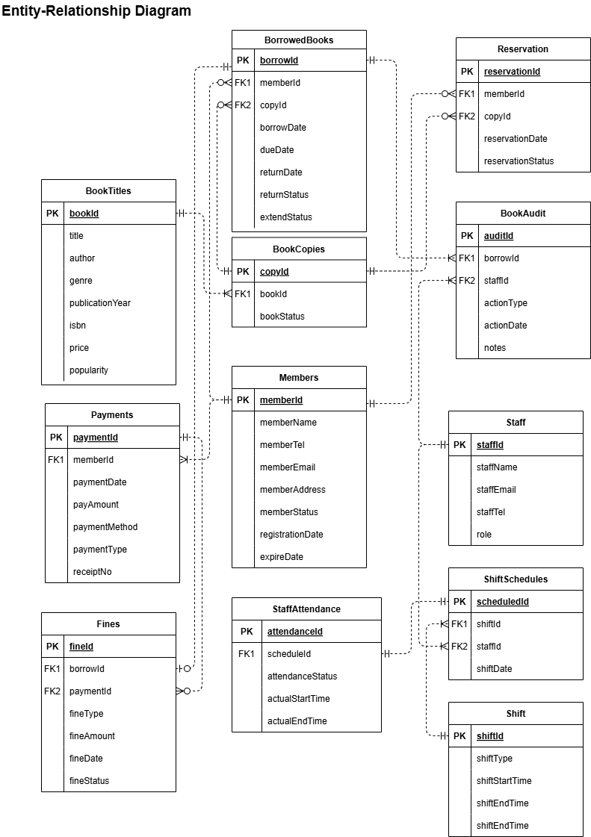

Chapter 3 Data Definition
Members
CREATE TABLE Members(
memberId VARCHAR2(4) NOT NULL,
memberName VARCHAR2(100) NOT NULL,
memberTel VARCHAR2(20) UNIQUE NOT NULL,
memberEmail VARCHAR2(100) UNIQUE NOT NULL,
memberAddress VARCHAR2(255) NOT NULL,
memberStatus VARCHAR2(10) NOT NULL,
registrationDate DATE DEFAULT SYSDATE NOT NULL,
expireDate DATE NOT NULL,
CONSTRAINT chk_memberStatus CHECK (memberStatus IN ('active', 'expire')),
CONSTRAINT pk_Member PRIMARY KEY (memberId)
);

Staff
CREATE TABLE Staff (
staffId VARCHAR2(4) NOT NULL,
staffName VARCHAR2(100) NOT NULL,
staffEmail VARCHAR2(100) NOT NULL UNIQUE,
staffTel VARCHAR2(20) NOT NULL UNIQUE,
role VARCHAR2(20) NOT NULL,
CONSTRAINT chk_role CHECK (role IN ('librarian', 'manager', 'assistant', 'security', 'cleaner')),
CONSTRAINT pk_Staff PRIMARY KEY (staffId)
);

Shift
CREATE TABLE Shift (
shiftId VARCHAR2(4) NOT NULL,
shiftType VARCHAR2(50) NOT NULL,
startTime TIMESTAMP NOT NULL,
endTime TIMESTAMP NOT NULL,
CONSTRAINT chk_shift_time CHECK (startTime < endTime),
CONSTRAINT pk_Shift PRIMARY KEY (shiftId)
);

BookTitles
CREATE TABLE BookTitles (
bookId VARCHAR2(4) NOT NULL,
title VARCHAR2(255) NOT NULL,
author VARCHAR2(255) NOT NULL,
genre VARCHAR2(100) NOT NULL,
publicationYear NUMBER(4) NOT NULL,
isbn VARCHAR2(20) UNIQUE NOT NULL,
price NUMBER(6,2) NOT NULL CHECK (price >= 0),
popularity NUMBER(2,1) CHECK (popularity BETWEEN 1.0 AND 5.0),
CONSTRAINT pk_BookTitles PRIMARY KEY (bookId)
);

BookCopies
CREATE TABLE BookCopies (
copyId VARCHAR2(4) NOT NULL,
bookId VARCHAR2(4) NOT NULL,
bookStatus VARCHAR2(20) DEFAULT 'available' NOT NULL,
CONSTRAINT pk_BookCopies PRIMARY KEY (copyId),
CONSTRAINT fk_BookCopies_BookTitles FOREIGN KEY (bookId) REFERENCES BookTitles(bookId) ON DELETE CASCADE,
CONSTRAINT chk_BookStatus CHECK (bookStatus IN ('available', 'reserved', 'borrowed', 'unavailable'))
);

BorrowedBooks
CREATE TABLE BorrowedBooks (
borrowId VARCHAR2(5) NOT NULL,
memberId VARCHAR2(4) NOT NULL,
copyId VARCHAR2(4) NOT NULL,
borrowDate DATE NOT NULL,
dueDate DATE NOT NULL,
returnDate DATE,
returnStatus VARCHAR2(10) DEFAULT 'On loan' NOT NULL CHECK (
returnStatus IN ('On loan', 'Returned', 'Overdue', 'Lost')
),
extendStatus VARCHAR2(20) DEFAULT 'Unsubmitted' CHECK (
extendStatus IN ('Unsubmitted', 'Pending', 'Approved', 'Rejected', 'Canceled')
),
CONSTRAINT pk_BorrowedBooks PRIMARY KEY (borrowId),
CONSTRAINT fk_BorrowedBooks_Members FOREIGN KEY (memberId) REFERENCES Members(memberId) ON DELETE CASCADE,
CONSTRAINT fk_BorrowedBooks_BookCopies FOREIGN KEY (copyId) REFERENCES BookCopies(copyId) ON DELETE CASCADE
);

BookAudit
CREATE TABLE BookAudit (
auditId VARCHAR2 (6) NOT NULL,
borrowId VARCHAR2 (5) NOT NULL,
staffId VARCHAR2 (4) NOT NULL,
actionType VARCHAR2(10) CHECK (actionType IN ('Loaned', 'Returned', 'Lost')) NOT NULL,
actionDate DATE DEFAULT SYSDATE NOT NULL,
notes VARCHAR2 (100),
CONSTRAINT pk_BookAudit PRIMARY KEY (auditId),
CONSTRAINT fk_bookAudit_borrowedBooks FOREIGN KEY (borrowId) REFERENCES BorrowedBooks(borrowId) ON DELETE CASCADE,
CONSTRAINT fk_bookAudit_staff FOREIGN KEY (staffId) REFERENCES Staff(staffId) ON DELETE CASCADE
);

Reservation
CREATE TABLE Reservation (
reservationId VARCHAR2(4) NOT NULL,
memberId VARCHAR2(4) NOT NULL,
copyId VARCHAR2(4) NOT NULL,
reservationDate DATE DEFAULT SYSDATE NOT NULL,
reservationStatus VARCHAR2(20) CHECK (reservationStatus IN ('Pending', 'Available', 'Cancelled')) NOT NULL,
CONSTRAINT pk_Reservation PRIMARY KEY (reservationId),
CONSTRAINT fk_reservation_members FOREIGN KEY (memberId) REFERENCES Members(memberId) ON DELETE CASCADE,
CONSTRAINT fk_reservation_bookCopies FOREIGN KEY (copyId) REFERENCES BookCopies(copyId) ON DELETE CASCADE
);

ShiftSchedules
CREATE TABLE ShiftSchedules (
scheduleId VARCHAR2(5) NOT NULL,
shiftId VARCHAR2(4) NOT NULL,
staffId VARCHAR2(4) NOT NULL,
shiftDate DATE NOT NULL,
CONSTRAINT pk_ShiftSchedules PRIMARY KEY (scheduleId),
CONSTRAINT uq_ShiftSchedules_StaffDate UNIQUE (staffId, shiftDate),
CONSTRAINT fk_ShiftSchedules_Shift FOREIGN KEY (shiftId) REFERENCES Shift(shiftId),
CONSTRAINT fk_ShiftSchedules_Staff FOREIGN KEY (staffId) REFERENCES Staff(staffId)
);

StaffAttendance
CREATE TABLE StaffAttendance (
attendanceId VARCHAR2(5) NOT NULL,
scheduleId VARCHAR2(5) NOT NULL,
attendanceStatus VARCHAR2(10) NOT NULL,
actualStartTime TIMESTAMP,
actualEndTime TIMESTAMP,
CONSTRAINT pk_StaffAttendance PRIMARY KEY (attendanceId),
CONSTRAINT fk_StaffAtt_ShiftSched FOREIGN KEY (scheduleId) REFERENCES ShiftSchedules(scheduleId),
CONSTRAINT chk_attendanceStatus CHECK (attendanceStatus IN ('Present', 'Absent', 'Late')),
CONSTRAINT chk_StaffAttendance_Time CHECK (actualStartTime IS NULL OR actualEndTime IS NULL OR actualStartTime < actualEndTime)
);

Payments
CREATE TABLE Payments (
paymentId VARCHAR2(4) NOT NULL,
memberId VARCHAR2(4) NOT NULL,
paymentDate DATE NOT NULL,
payAmount NUMBER(8,2) NULL,
paymentMethod VARCHAR2(9) NOT NULL,
paymentType VARCHAR2(25) NOT NULL,
receiptNo VARCHAR2(6) NOT NULL,
CONSTRAINT pk_Payments PRIMARY KEY (paymentId),
CONSTRAINT fk_Payments_Members FOREIGN KEY (memberId) REFERENCES Members (memberId),
CONSTRAINT chk_paymentMethod CHECK (paymentMethod IN ('Tng', 'Cash', 'Duitnow')),
CONSTRAINT chk_paymentType CHECK (paymentType IN ('Fines', 'Membership Registration'))
);

Fines
CREATE TABLE Fines (
fineId VARCHAR2(4) NOT NULL,
borrowId VARCHAR2(5) NOT NULL,
paymentId VARCHAR2(4) NULL,
fineType VARCHAR2(12) NOT NULL,
fineAmount NUMBER(8,2) NULL,
fineDate DATE NOT NULL,
fineStatus VARCHAR2(6) NOT NULL,
CONSTRAINT pk_Fines PRIMARY KEY (fineId),
CONSTRAINT fk_Fines_BorrowedBooks FOREIGN KEY (borrowId) REFERENCES BorrowedBooks (borrowId),
CONSTRAINT chk_fineType CHECK (fineType IN ('Late Return', 'Lost Book', 'Damage')),
CONSTRAINT chk_fineStatus CHECK (fineStatus IN ('Unpaid', 'Paid'))
);

Chapter 4 Queries, Procedures, Triggers and Reports

4.1 Dorcas Lim Yuan Yao

4.1.1 Query 1: Total REservations Handled by Each Staff Per Shift (Ranked)

Purpose:
This SQL query serves as a staff performance analysis report for library management, primarily tracking how many book reservations each librarian and assistant processes during their shifts, ranked from highest to lowest volume. Its key business purposes include evaluating staff performance by identifying top performers, analyzing workload distribution across different shifts, optimizing staff scheduling based on reservation demand patterns, and monitoring service efficiency.

The report provides specific metrics including staff details, shift information, and counts of successfully processed reservations (only those with 'Available' status), all sorted by reservation volume. Technically, it ensures accurate counting by linking reservations to staff through the BookAudit table, focusing only on relevant roles, counting distinct reservations to avoid duplication, and including only fulfilled reservations.

Management can leverage this data to recognize high performers, identify training opportunities for staff with lower numbers, balance workloads effectively across shifts, and assess whether current staffing levels adequately meet reservation demands. Ultimately, this report measures how effectively frontline library staff handle one of the core patron services—book reservations—during their assigned work shifts, providing actionable insights for operational improvement.

SQL statement:
-- SETUP SQLPLUS ENVIRONMENT
SET LINESIZE 200
SET PAGESIZE 50
SET WRAP OFF
SET TRIMSPOOL ON

-- FORMAT OUTPUT FOR SQLPLUS
COLUMN "STAFF ID" FORMAT A10
COLUMN "STAFF NAME" FORMAT A25
COLUMN "SHIFT ID" FORMAT A10
COLUMN "SHIFT TYPE" FORMAT A20
COLUMN "START TIME" FORMAT A10
COLUMN "END TIME" FORMAT A10
COLUMN "TOTAL RESERVATIONS" FORMAT 9999

-- HEADER
PROMPT
PROMPT ======================== TOTAL RESERVATIONS HANDLED BY EACH STAFF PER SHIFT (RANKED) ========================
PROMPT

SELECT
s.staffId AS "STAFF ID",
s.staffName AS "STAFF NAME",
sh.shiftId AS "SHIFT ID",
sh.shiftType AS "SHIFT TYPE",
TO_CHAR(sh.startTime, 'HH24:MI') AS "START TIME",
TO_CHAR(sh.endTime, 'HH24:MI') AS "END TIME",
COUNT(DISTINCT r.reservationId) AS "TOTAL RESERVATIONS"
FROM
Staff s
JOIN
ShiftSchedules ss ON s.staffId = ss.staffId
JOIN
Shift sh ON ss.shiftId = sh.shiftId
LEFT JOIN
BookAudit ba ON ba.staffId = s.staffId
AND ba.actionType IN ('Loaned', 'Returned')
LEFT JOIN
BorrowedBooks bb ON ba.borrowId = bb.borrowId
LEFT JOIN
Reservation r ON (r.copyId = bb.copyId OR r.memberId = bb.memberId)
AND r.reservationStatus = 'Available'
WHERE
s.role IN ('librarian', 'assistant')
GROUP BY
s.staffId, s.staffName, sh.shiftId, sh.shiftType, sh.startTime, sh.endTime
ORDER BY
COUNT(DISTINCT r.reservationId) DESC,
sh.shiftType,
s.staffId;

Sample Output:
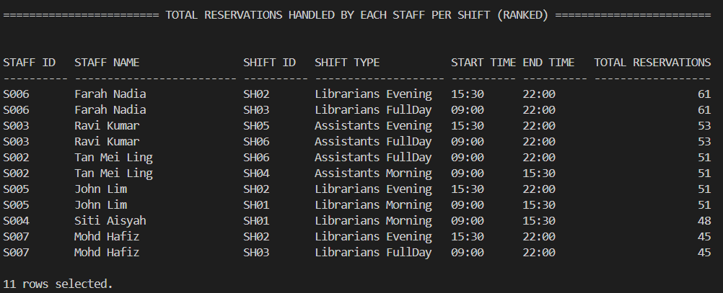

4.1.2 Query 2: Recent Members Reservation Activity (APR-JUN 2024)

Purpose:
This SQL query generates a quarterly reservation activity report that analyzes member engagement with the library's reservation system during April-June 2024. The report serves to track and evaluate how actively members are utilizing the reservation service, identifying both frequent users and those with declining engagement. By compiling each member's latest reservation date and total number of reservations, it provides valuable insights into usage patterns and helps staff assess the overall effectiveness of the reservation system.

The query specifically highlights which books are most in demand through its aggregated list of reserved book IDs, offering collection development insights that can inform future purchasing decisions. The data output supports multiple operational purposes - from recognizing active members who heavily use the service to identifying members who may need re-engagement efforts. Library managers can use this information to optimize reservation workflows during peak periods, improve book availability based on demand trends, and make data-driven decisions about resource allocation. The report's sorting by most recent reservations ensures staff can quickly identify current user activity patterns while the comprehensive view of reserved titles helps anticipate future circulation needs.

SQL statement:
-- SETUP SQLPLUS ENVIRONMENT
SET LINESIZE 200
SET PAGESIZE 30
SET WRAP OFF
SET TRIMSPOOL ON

-- FORMAT OUTPUT FOR SQLPLUS
COLUMN "MEMBER ID" FORMAT A10
COLUMN "MEMBER NAME" FORMAT A25
COLUMN "LATEST RESERVATION" FORMAT A19
COLUMN "TOTAL RESERVATIONS" FORMAT 9999
COLUMN "RESERVED BOOK ID(S)" FORMAT A30

-- HEADER
PROMPT
PROMPT =========================== RECENT MEMBERS RESERVATION ACTIVITY (APR-JUN 2024) ===========================
PROMPT

-- QUERY
SELECT
m.memberId AS "MEMBER ID",
m.memberName AS "MEMBER NAME",
TO_CHAR(MAX(r.reservationDate), 'YYYY-MM-DD') AS "LATEST RESERVATION",
COUNT(r.reservationId) AS "TOTAL RESERVATIONS",
LISTAGG(bt.bookId, ', ')
WITHIN GROUP (ORDER BY bt.bookId) AS "RESERVED BOOK ID(S)"
FROM
Members m
JOIN
Reservation r ON r.memberId = m.memberId
JOIN
BookCopies bc ON r.copyId = bc.copyId
JOIN
BookTitles bt ON bc.bookId = bt.bookId
WHERE
r.reservationDate BETWEEN TO_DATE('01-APR-2024', 'DD-MON-YYYY')
AND TO_DATE('30-JUN-2024', 'DD-MON-YYYY')
GROUP BY
m.memberId, m.memberName
ORDER BY
"LATEST RESERVATION" DESC, m.memberId;

Sample Output:
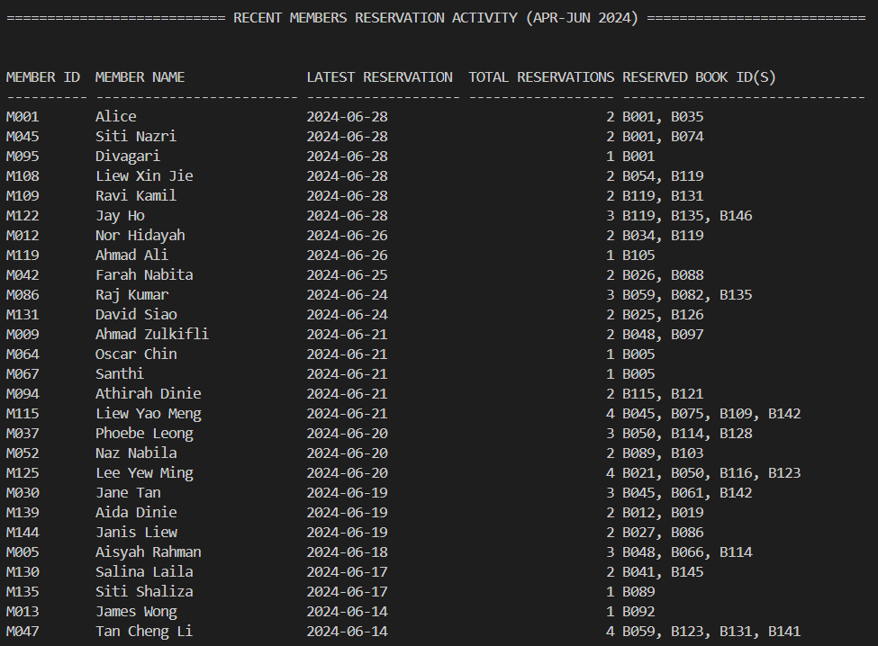

4.1.3 Stored Procedure 1: Add New Reservation
Purpose:
This stored procedure serves to automate and standardize the process of adding new book reservations in the library management system. It encapsulates the business logic for creating reservations while preventing duplicate entries for the same member, book copy, and date combination.
Usefulness:
- Duplicate Prevention: The procedure checks for existing reservations before creating new ones, avoiding duplicate reservations that could lead to confusion or double-bookings.
- Simplified Application Logic: By moving complex reservation validation into the database layer, application code becomes simpler and more maintainable.
- Consistent ID Generation: Automatically generates standardized reservation IDs (like R001, R002) using a sequence, ensuring uniform identification.
- Immediate Feedback: Provides clear output messages indicating whether the reservation was successful or if a duplicate was detected.
Importance:
- Data Integrity: Maintains clean reservation records by preventing duplicate entries that could corrupt reporting and analytics.
- Operational Efficiency: Streamlines the reservation process for library staff by handling validation and ID generation automatically.
- Error Reduction: Minimizes human error in reservation creation by enforcing business rules at the database level.
- Scalability: Supports high-volume reservation processing with built-in concurrency controls through database transactions.
- Centralized Logic: Ensures all applications using the database follow the same reservation rules, whether it's a staff interface, self-service kiosk, or online portal.
SQL statement:
-- Stored Procedure 1: Add New Reservation

CREATE OR REPLACE PROCEDURE AddNewReservation (
p_memberId IN Reservation.memberId%TYPE,
p_copyId IN Reservation.copyId%TYPE,
p_reservationDate IN DATE,
p_status IN Reservation.reservationStatus%TYPE
)
AS
v_exists NUMBER;
BEGIN
-- Check if a reservation already exists for this member and copy on the same date
SELECT COUNT(*) INTO v_exists
FROM Reservation
WHERE memberId = p_memberId
AND copyId = p_copyId
AND reservationDate = p_reservationDate;

IF v_exists > 0 THEN
DBMS_OUTPUT.PUT_LINE('Reservation already exists for this book copy on the selected date.');
ELSE
INSERT INTO Reservation (
reservationId, memberId, copyId, reservationDate, reservationStatus
)
VALUES (
'R' || LPAD(Reservation_seq.NEXTVAL, 3, '0'),
p_memberId,
p_copyId,
p_reservationDate,
p_status
);

DBMS_OUTPUT.PUT_LINE('Reservation successfully added.');
END IF;
END;
/

Sample Output:
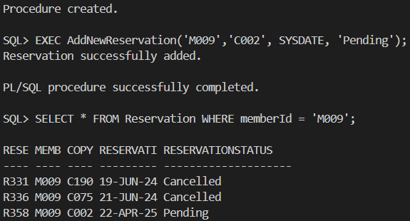

4.1.4 Stored Procedure 2: Check Book Availability

Purpose:
This stored procedure is designed to check the real-time availability of a book in the library system by counting how many copies of a given book are not currently reserved (status ≠ 'Reserved') and providing immediate feedback on whether the book is available for borrowing.
Usefulness:
- Quick Availability Check: It allows librarians and members (via an application) to instantly verify if a book is available without manually querying the database and helps avoid unnecessary reservation attempts for unavailable books.
- Prevents Over-Reservation: Ensures that only truly available copies are counted (excludes copies with active reservations) and reduces conflicts where multiple users try to reserve the same book simultaneously.
- Clear Output Feedback: Returns a direct message indicating either:
- "Book ID [X] has [N] available copy/copies." (if available)
- "No available copies for Book ID [X]." (if unavailable)
- Optimized for Performance: Uses a single SQL query with a subquery to efficiently check availability without complex joins and reduces database load compared to multiple ad-hoc queries.

Importance:
- Improves Patron Experience: Members can quickly determine if a book is ready for borrowing, reducing frustration. It also supports self-service kiosks or online portals by providing real-time availability status.
- Operational Efficiency for Staff: Librarians can instantly verify availability before processing reservations or loans. Reduces manual checking and potential errors in book status tracking.
- Prevents Double-Booking Issues: Ensures that reserved books are not mistakenly marked as available, maintaining data integrity.
- Scalable for High Demand: Can be integrated into APIs, mobile apps, or web interfaces for automated availability checks. Works efficiently even with large book collections and high reservation volumes.

SQL statement:
-- Stored Procedure 2: Check Book Availability

CREATE OR REPLACE PROCEDURE CheckBookAvailability (
p_bookId IN VARCHAR2
)
IS
v_available_count NUMBER;
BEGIN
SELECT COUNT(*)
INTO v_available_count
FROM BookCopies bc
WHERE bc.bookId = p_bookId
AND NOT EXISTS (
SELECT 1 FROM Reservation r
WHERE r.copyId = bc.copyId AND r.reservationStatus = 'Reserved'
);

IF v_available_count > 0 THEN
DBMS_OUTPUT.PUT_LINE('Book ID ' || p_bookId || ' has ' || v_available_count || ' available copy/copies.');
ELSE
DBMS_OUTPUT.PUT_LINE('No available copies for Book ID ' || p_bookId);
END IF;
END;
/

Sample Output:
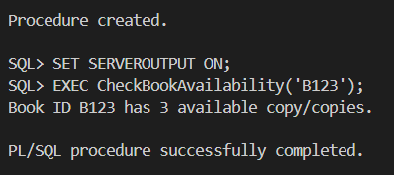

4.1.5 Trigger 1: Automatic Membership Status Update

Purpose:
This trigger automatically updates the status of a member to 'Expired' when their membership has expired. It is triggered before an update to the Members table.
- Status Update:
- Changes memberStatus from 'active' to 'Expire' when expireDate ≤ current date (SYSDATE)
- Ensures members can't borrow/reserve books after expiration
- Reservation Cleanup:
- Cancels all pending reservations for the expired member
- Prevents reservation queue clogging from inactive members
These rules maintains accurate membership status without manual intervention and automatically enforces access control rules. It keeps reservation system clean by removing invalid requests

Trigger code:

CREATE OR REPLACE TRIGGER trg_auto_expire_membership
BEFORE UPDATE ON Members
FOR EACH ROW
WHEN (NEW.expireDate <= SYSDATE AND OLD.memberStatus = 'active')
BEGIN
-- Automatically update the member status to 'Expire'
:NEW.memberStatus := 'Expire';

-- Cancel all pending reservations for this member
UPDATE Reservation
SET reservationStatus = 'Cancelled'
WHERE memberId = :OLD.memberId
AND reservationStatus = 'Pending';
END;
/

4.1.6 Trigger 2: Enforce Borrow Limit

Purpose:
Purpose: This trigger enforces borrowing limits for members when they attempt to borrow a book. It is triggered before an insert into the BorrowedBooks table.

This trigger helps:
- Prevents over-borrowing
- Enforces membership policy automatically
- Eliminates manual eligibility checks at checkout
These rules ensures that a member can borrow books only if they have fewer than 5 active borrowings and that only active members are allowed to borrow books.

Trigger code:

CREATE OR REPLACE TRIGGER trg_borrow_limit_enforcement
BEFORE INSERT ON BorrowedBooks
FOR EACH ROW
DECLARE
v_active_borrow_count NUMBER;
v_member_status Members.memberStatus%TYPE;
BEGIN
-- Get the current number of active borrowings (not returned or lost)
SELECT COUNT(*)
INTO v_active_borrow_count
FROM BorrowedBooks
WHERE memberId = :NEW.memberId
AND returnStatus IN ('On Loan', 'Overdue');

IF v_active_borrow_count >= 5 THEN
RAISE_APPLICATION_ERROR(-20010, 'Borrowing limit reached: A member can borrow up to 5 books only.');
END IF;

-- Check if the member is active
SELECT memberStatus INTO v_member_status
FROM Members
WHERE memberId = :NEW.memberId;

IF v_member_status != 'active' THEN
RAISE_APPLICATION_ERROR(-20011, 'Only active members can borrow books.');
END IF;
END;
/

Sample output from the trigger
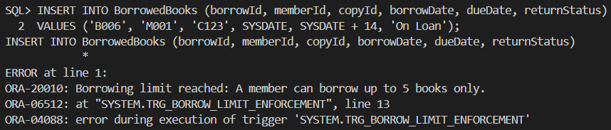

4.1.7 Report 1: Reservation Report by Status and Month

Purpose:
The rpt_reservation_by_statusmonth procedure generates a monthly reservation report filtered by status to help library staff track and analyze reservation activity. It combines data from multiple tables to produce a detailed view of reservations, including member information, book titles, genres, and reservation dates for a specific month.

This automated report serves key operational needs by allowing staff to monitor different reservation statuses (Pending, Available, Cancelled) and analyze monthly patterns. It helps with workflow prioritization, inventory planning, and understanding seasonal demand fluctuations, all while eliminating manual data compilation. The procedure outputs the information directly in a readable format, providing immediate insights without requiring additional tools or complex queries.

Report code:
SET SERVEROUTPUT ON;
SET PAGESIZE 1000;
SET LINESIZE 300;

CREATE OR REPLACE PROCEDURE rpt_reservation_by_statusmonth(
p_status IN VARCHAR2,
p_month IN VARCHAR2
)
IS
CURSOR cur_reservations IS
SELECT r.reservationId, r.memberId, r.copyId, r.reservationDate
FROM Reservation r
WHERE LOWER(TRIM(r.reservationStatus)) = LOWER(TRIM(p_status))
AND TO_CHAR(r.reservationDate, 'MM') = LPAD(p_month, 2, '0')
ORDER BY r.reservationDate;

CURSOR cur_reservation_details(p_memberId VARCHAR2, p_copyId VARCHAR2) IS
SELECT m.memberName, bt.title, bt.genre
FROM Members m
JOIN BookCopies bc ON bc.copyId = p_copyId
JOIN BookTitles bt ON bt.bookId = bc.bookId
WHERE m.memberId = p_memberId;

v_row_num NUMBER := 0;
v_total_reservations NUMBER := 0;
BEGIN
DBMS_OUTPUT.PUT_LINE(RPAD('=', 130, '='));
DBMS_OUTPUT.PUT_LINE('|| Reservation Report - Status: ' || UPPER(p_status) ||
' | Month: ' || TO_CHAR(TO_DATE(p_month, 'MM'), 'Month') ||
RPAD(' ', 70 - LENGTH(p_status)) || '||');
DBMS_OUTPUT.PUT_LINE('|| Generated On: ' || TO_CHAR(SYSDATE, 'DD-MON-YYYY HH24:MI:SS') || RPAD(' ', 84) || '||');
DBMS_OUTPUT.PUT_LINE(RPAD('=', 130, '='));

DBMS_OUTPUT.PUT_LINE(
RPAD('No.', 5) ||
RPAD('Reservation ID', 18) ||
RPAD('Member ID', 12) ||
RPAD('Member Name', 25) ||
RPAD('Book Title', 35) ||
RPAD('Genre', 20) ||
RPAD('Reservation Date', 25)
);
DBMS_OUTPUT.PUT_LINE(RPAD('-', 130, '-'));

FOR res IN cur_reservations LOOP
v_row_num := v_row_num + 1;
v_total_reservations := v_total_reservations + 1;

FOR detail IN cur_reservation_details(res.memberId, res.copyId) LOOP
DBMS_OUTPUT.PUT_LINE(
RPAD(v_row_num, 5) ||
RPAD(res.reservationId, 18) ||
RPAD(res.memberId, 12) ||
RPAD(detail.memberName, 25) ||
RPAD(SUBSTR(detail.title, 1, 34), 35) ||
RPAD(detail.genre, 20) ||
RPAD(TO_CHAR(res.reservationDate, 'DD-MON-YYYY'), 25)
);
END LOOP;
END LOOP;

DBMS_OUTPUT.PUT_LINE(RPAD('-', 130, '-'));

IF v_total_reservations > 0 THEN
DBMS_OUTPUT.PUT_LINE('|| Total Reservations Found: ' || v_total_reservations ||
RPAD(' ', 94 - LENGTH(TO_CHAR(v_total_reservations))) || '||');
ELSE
DBMS_OUTPUT.PUT_LINE('|| No reservations found for the given status and month.' || RPAD(' ', 70) || '||');
END IF;

DBMS_OUTPUT.PUT_LINE(RPAD('=', 130, '='));
END;

Sample Output:
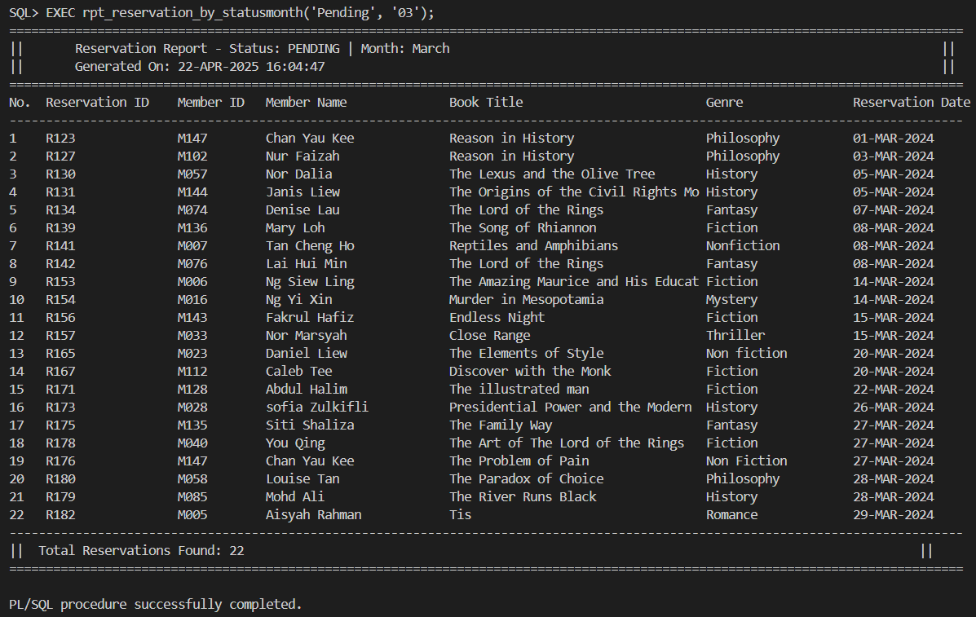

4.1.8 Report 2: Overdue Books Report
Purpose:
The rpt_overdue_books procedure generates a comprehensive report to help library staff track and manage overdue books efficiently. It identifies all unreturned books with due dates that have passed, providing key details such as borrower information, book titles, genres, due dates, and the number of days overdue. This enables staff to quickly identify late returns and prioritize follow-up actions with members, ensuring timely book recovery and minimizing disruptions for other patrons.

The report serves as a valuable tool for maintaining library operations by offering a clear, formatted overview of overdue items. It includes essential metrics like total overdue counts and days overdue, helping staff assess the severity of delays and implement appropriate measures, such as sending reminders or applying fines. By automating this process, the procedure saves time, reduces manual errors, and ensures consistent handling of overdue books across the library system.

Report code:
SET SERVEROUTPUT ON;
SET LINESIZE 220;
SET PAGESIZE 1000;

CREATE OR REPLACE PROCEDURE rpt_overdue_books
IS
CURSOR cur_overdue IS
SELECT bb.borrowId, bb.memberId, bb.copyId, bb.borrowDate, bb.dueDate
FROM BorrowedBooks bb
WHERE bb.returnDate IS NULL
AND bb.dueDate < SYSDATE
ORDER BY bb.dueDate;

CURSOR cur_details(p_memberId VARCHAR2, p_copyId VARCHAR2) IS
SELECT m.memberName, bt.title, bt.genre
FROM Members m
JOIN BookCopies bc ON bc.copyId = p_copyId
JOIN BookTitles bt ON bt.bookId = bc.bookId
WHERE m.memberId = p_memberId;

v_row_num NUMBER := 0;
v_total_overdue NUMBER := 0;
BEGIN
DBMS_OUTPUT.PUT_LINE(RPAD('=', 150, '='));
DBMS_OUTPUT.PUT_LINE('|| Overdue Books Report' || RPAD(' ', 119) || '||');
DBMS_OUTPUT.PUT_LINE('|| Generated On: ' || TO_CHAR(SYSDATE, 'DD-MON-YYYY HH24:MI:SS') || RPAD(' ', 105) || '||');
DBMS_OUTPUT.PUT_LINE(RPAD('=', 150, '='));

DBMS_OUTPUT.PUT_LINE(
RPAD('No.', 5) ||
RPAD('Borrow ID', 12) ||
RPAD('Member ID', 12) ||
RPAD('Member Name', 25) ||
RPAD('Book Title', 50) ||
RPAD('Genre', 15) ||
RPAD('Due Date', 15) ||
RPAD('Days Overdue', 15)
);

DBMS_OUTPUT.PUT_LINE(RPAD('-', 150, '-'));

FOR rec IN cur_overdue LOOP
v_row_num := v_row_num + 1;
v_total_overdue := v_total_overdue + 1;

FOR det IN cur_details(rec.memberId, rec.copyId) LOOP
DBMS_OUTPUT.PUT_LINE(
RPAD(v_row_num, 5) ||
RPAD(rec.borrowId, 12) ||
RPAD(rec.memberId, 12) ||
RPAD(det.memberName, 25) ||
RPAD(SUBSTR(det.title, 1, 49), 50) || -- match padding
RPAD(det.genre, 15) ||
RPAD(TO_CHAR(rec.dueDate, 'DD-MON-YYYY'), 15) ||
RPAD(TRUNC(SYSDATE - rec.dueDate), 15)
);
END LOOP;
END LOOP;

DBMS_OUTPUT.PUT_LINE(RPAD('-', 150, '-'));

IF v_total_overdue > 0 THEN
DBMS_OUTPUT.PUT_LINE('|| Total Overdue Books: ' || v_total_overdue || RPAD(' ', 125 - LENGTH(TO_CHAR(v_total_overdue))) || '||');
ELSE
DBMS_OUTPUT.PUT_LINE('|| No overdue books found. ' || RPAD(' ', 128) || '||');
END IF;

DBMS_OUTPUT.PUT_LINE(RPAD('=', 150, '='));
END;
/

Sample Output:
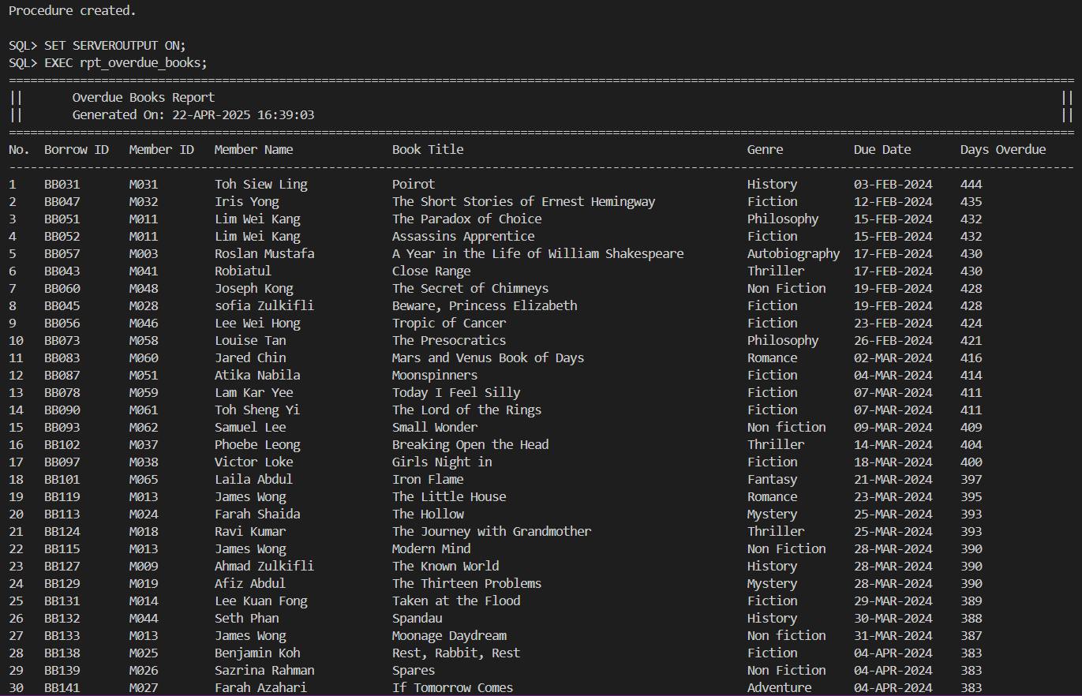

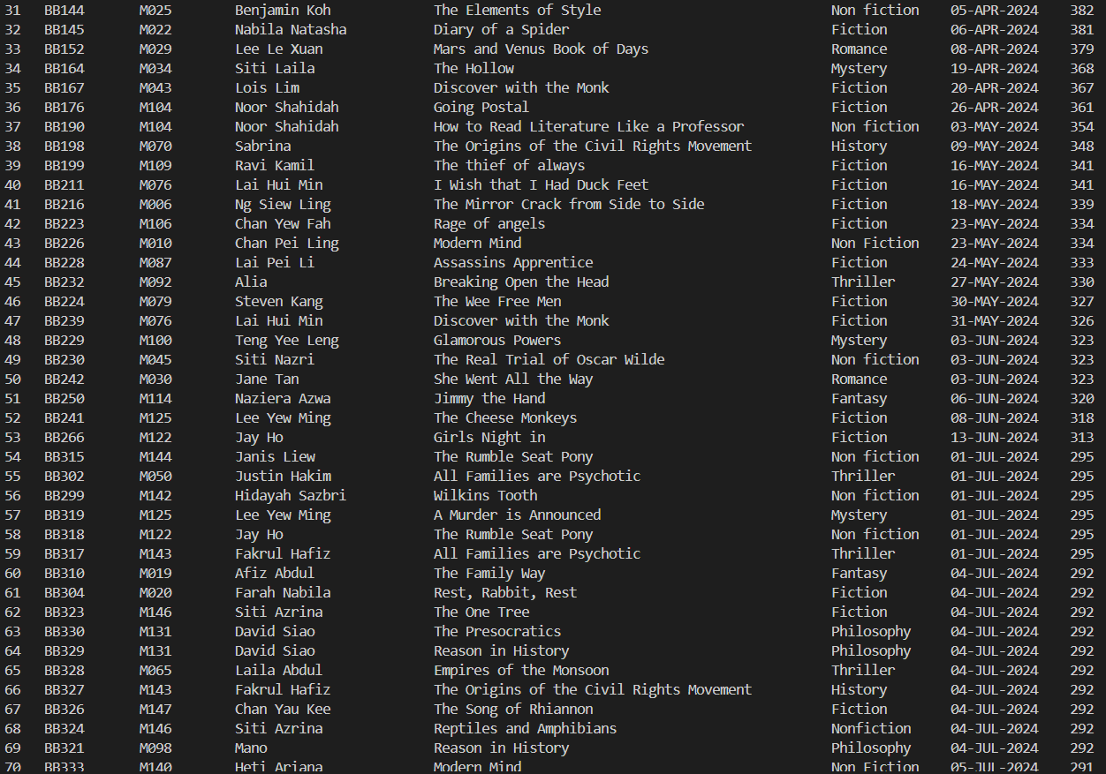
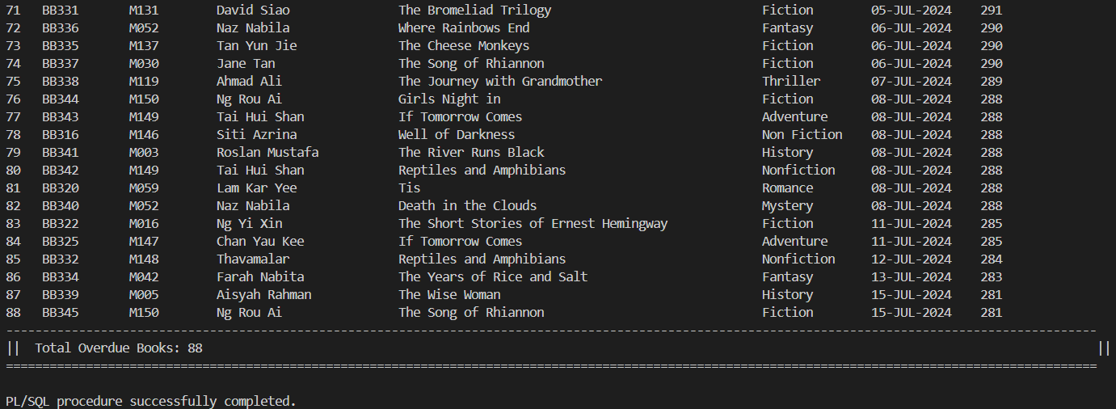

4.2 Tan Yen Ping

4.2.1 Query 1: Borrowing And Member Activity Tracking
Purpose:
The purpose of this query is to track and provide detailed information about the borrowing activity and return history of books within a specified time period. It includes data on total borrow transactions, distinct books borrowed, and the return status of those books. This helps in monitoring the activity of library members and assessing their return behavior.
Operational Management Level Focus:
- Monitoring Borrowing and Return Trends: Enables staff and management to identify trends in borrowing and returning books, helping in resource planning and stock management.
- Assessing Return Rates: Provides a clear view of how many books have been returned versus borrowed, allowing for the identification of overdue items and assisting in follow-up actions.
- Member Activity Tracking: Tracks the borrowing patterns of members, enabling personalized follow-ups and ensuring efficient management of member interactions.
- Evaluating Book Circulation: Helps assess the circulation of books by identifying the most frequently borrowed books and understanding the return rates associated with them.
Usage:
- Easy Monitoring: Offers a quick and efficient way for staff to track borrowing and return transactions across all members during a given time period.
- Return Status Tracking: Assists in managing overdue books and following up with members who have not returned books on time.
- Operational Insights: Helps in optimizing library operations by providing insight into borrowing and return patterns, enabling better decision-making related to book inventory and member engagement.
- Member Behavior Analysis: Facilitates understanding of member borrowing habits, enabling staff to implement targeted actions like reminders for overdue books.
SQL statement:
-- SETUP SQLPLUS ENVIRONMENT
SET LINESIZE 200
SET PAGESIZE 50
SET WRAP OFF
SET TRIMSPOOL ON

-- Ask user to input the start and end dates
ACCEPT month_start CHAR PROMPT 'Enter the start Date (DD-MON-YYYY): '
ACCEPT month_end CHAR PROMPT 'Enter the end Date (DD-MON-YYYY): '

-- FORMAT OUTPUT FOR SQLPLUS
COLUMN "DATE" FORMAT A20
COLUMN "MEMBER ID" FORMAT A15
COLUMN "MEMBER NAME" FORMAT A25
COLUMN "TOTAL BORROWS" FORMAT 9999
COLUMN "TOTAL BOOKS BORROWED" FORMAT 9999
COLUMN "TOTAL RETURNED" FORMAT 9999

-- HEADER
PROMPT
PROMPT ================================= BORROWING AND MEMBER RETURN RATE TRACKING ====================================

-- Query to fetch the borrowing and return data
SELECT
TO_CHAR(bb.borrowDate, 'DD-MON-YYYY') AS "DATE",
m.memberId AS "MEMBER ID",
m.memberName AS "MEMBER NAME",
COUNT(bb.borrowId) AS "TOTAL BORROWS", -- Total borrow transactions
COUNT(DISTINCT bb.copyId) AS "TOTAL BOOKS BORROWED", -- Distinct books borrowed
SUM(CASE WHEN bb.returnStatus = 'Returned' THEN 1 ELSE 0 END) AS "TOTAL RETURNED" -- Books returned
FROM
BorrowedBooks bb
JOIN
Members m ON bb.memberId = m.memberId
JOIN
BookCopies bc ON bb.copyId = bc.copyId
JOIN
BookTitles bt ON bc.bookId = bt.bookId
WHERE
bb.borrowDate BETWEEN TO_DATE('&&month_start', 'DD-MON-YYYY')
AND TO_DATE('&&month_end', 'DD-MON-YYYY')
GROUP BY
bb.borrowDate, m.memberId, m.memberName
ORDER BY
bb.borrowDate DESC, m.memberId;

Sample Output:
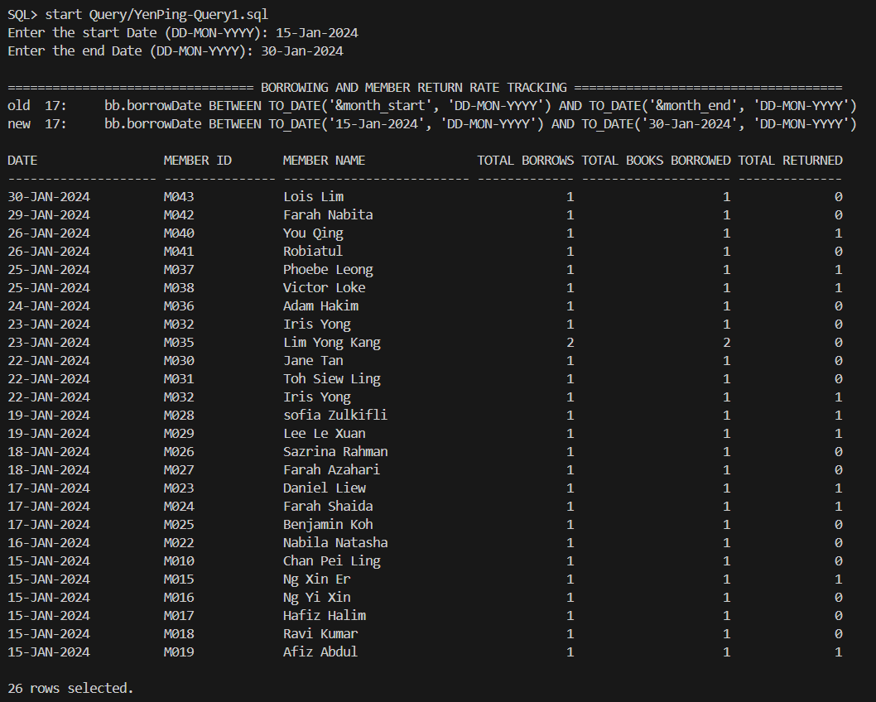

4.2.2 Query 2: Borrowing Status And Return History

Purpose: Get info about borrowing status and return history of book
The purpose of this query is to provide detailed information about the borrowing status and return history of books, including actions taken by library staff. It helps in monitoring the status of borrowed books and understanding the actions performed during the borrowing and returning processes.

Operational Management Level Focus:
- Tracking Borrowed Books: Helps staff and management track books that are currently borrowed, including overdue items.
- Monitoring Staff Actions: Provides insight into staff activities by showing which staff members recorded borrow and return actions.
- Return Status Review: Useful for identifying overdue books and follow-up actions needed to retrieve them.
- Filtering by Member: Allows for filtering records by a specific member, enabling detailed reviews of their borrowing history.
Usage:
- Easy Monitoring: Enables quick checks of borrowed books, their due dates, and whether they've been returned.
- Staff Activity Logging: Tracks library staff involvement in the borrowing and returning process, providing accountability.
- Operational Insights: Helps in managing book circulation and identifying areas where action is needed, such as overdue books or frequent borrowing patterns of members.

SQL statement:
-- SETUP SQLPLUS ENVIRONMENT
SET LINESIZE 200
SET PAGESIZE 50
SET WRAP OFF
SET TRIMSPOOL ON

-- FORMAT OUTPUT FOR SQLPLUS
COLUMN "BOOK TITLE" FORMAT A45
COLUMN "MEMBER ID" FORMAT A10
COLUMN "BORROW DATE" FORMAT A15
COLUMN "DUE DATE" FORMAT A15
COLUMN "RETURN STATUS" FORMAT A15
COLUMN "ACTION TYPE" FORMAT A15
COLUMN "STAFF ID" FORMAT A10
COLUMN "ACTION DATE" FORMAT A15

-- ASK USER TO ENTER MEMBER ID FILTER
ACCEPT member_filter CHAR PROMPT 'Enter Member ID to filter (leave empty for no filter): '

-- HEADER
PROMPT
PROMPT ========================================= BORROWING STATUS AND RETURN HISTORY ================================================
PROMPT

-- QUERY
SELECT
bt.title AS "BOOK TITLE",
bb.memberId AS "MEMBER ID",
bb.borrowDate AS "BORROW DATE",
bb.dueDate AS "DUE DATE",
bb.returnStatus AS "RETURN STATUS",
ba.actionType AS "ACTION TYPE",
ba.staffId AS "STAFF ID",
ba.actionDate AS "ACTION DATE"
FROM
BorrowedBooks bb
JOIN
BookCopies bc ON bb.copyId = bc.copyId
JOIN
BookTitles bt ON bc.bookId = bt.bookId
JOIN
BookAudit ba ON bb.borrowId = ba.borrowId
WHERE
(bb.memberId = '&member_filter' OR '&member_filter' IS NULL)
ORDER BY
ba.actionDate DESC, bb.borrowDate DESC;

Sample Output:
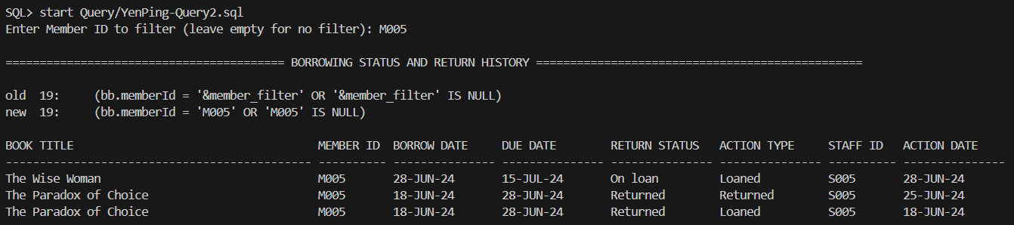

4.2.3 Stored Procedure 1: Add Borrowed Book

Purpose: Insert/Add a new borrowed book record
The purpose of this stored procedure is to add a new borrowed book record to the library system when a member borrows a book. The procedure ensures the validity of the borrowing transaction by verifying whether the member exists, if the book is available for borrowing, and then generates a unique Borrow ID for each transaction. It records the borrowing details, such as the member, book copy, borrow date, due date, and sets the return status as 'On loan'. This process is critical for maintaining accurate borrowing records and tracking book availability.
Usefulness for library system:
- Librarians can use it to process book borrowing transactions and ensure that the borrowing process is handled correctly. They can also monitor borrowing transactions and ensure that only available books are issued to members.
- Reports can be generated to track borrowing activity, such as the number of books borrowed by each member or the frequency of borrowing.
Importance:
This procedure directly supports the library system's ability to track borrowed books and member activity.
It is important because:
- It prevents errors in the borrowing process by ensuring that only valid members can borrow books and that books are available for borrowing.
- It helps track the borrowing history of each member and ensures that the correct borrow records are added to the system.
- It improves accountability by associating each borrowing transaction with a unique Borrow ID and keeping track of which staff member processed the transaction.
- It ensures data integrity by performing necessary checks and validations before inserting any new borrowing records, thus maintaining reliable data for future reporting, audits, and customer service.
SQL statement:
CREATE OR REPLACE PROCEDURE Add_Borrowed_Book (
p_member_id IN VARCHAR2,
p_copy_id IN VARCHAR2,
p_borrow_date IN DATE,
p_due_date IN DATE
) IS
v_count_books INTEGER;
v_member_exists INTEGER;
v_copy_available INTEGER;
v_borrow_seq_val NUMBER;
v_borrow_id VARCHAR2(10);
BEGIN
-- Check if the member exists
SELECT COUNT(*) INTO v_member_exists
FROM Members
WHERE memberId = p_member_id;

IF v_member_exists = 0 THEN
RAISE_APPLICATION_ERROR(-20001, 'Member does not exist.');
END IF;

-- Check if the book copy is available for borrowing
SELECT COUNT(*) INTO v_copy_available
FROM BorrowedBooks
WHERE copyId = p_copy_id
AND returnStatus IN ('On loan', 'Overdue');

IF v_copy_available > 0 THEN
RAISE_APPLICATION_ERROR(-20002, 'The book copy is already borrowed or overdue.');
END IF;

-- Get the next sequence value and generate Borrow ID
SELECT borrow_seq.NEXTVAL INTO v_borrow_seq_val FROM dual;
v_borrow_id := 'BB' || TO_CHAR(v_borrow_seq_val);

-- Insert the record using the generated borrow ID
INSERT INTO BorrowedBooks (
borrowId, memberId, copyId, borrowDate, dueDate, returnStatus
) VALUES (
v_borrow_id, p_member_id, p_copy_id, p_borrow_date, p_due_date, 'On loan'
);

COMMIT;

DBMS_OUTPUT.PUT_LINE('Book borrowed successfully for member: ' || p_member_id);
DBMS_OUTPUT.PUT_LINE('Generated Borrow ID: ' || v_borrow_id);

EXCEPTION
WHEN OTHERS THEN
ROLLBACK;
DBMS_OUTPUT.PUT_LINE('Error: ' || SQLERRM);
END;
/

SET SERVEROUTPUT ON;

-- Accept input from the user
ACCEPT member_id CHAR PROMPT 'Enter Member ID: '
ACCEPT copy_id CHAR PROMPT 'Enter Copy ID: '
ACCEPT borrow_date DATE PROMPT 'Enter Borrow Date (DD-MON-YYYY): '
ACCEPT due_date DATE PROMPT 'Enter Due Date (DD-MON-YYYY): '

-- Begin calling the procedure with the inputs
BEGIN
Add_Borrowed_Book(
p_member_id => '&member_id',
p_copy_id => '&copy_id',
p_borrow_date => TO_DATE('&borrow_date', 'DD-MON-YYYY'),
p_due_date => TO_DATE('&due_date', 'DD-MON-YYYY')
);
END;
/

Sample Output:
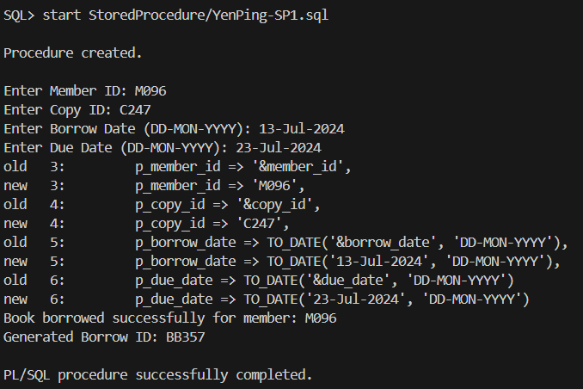

Successful storing:

4.2.4 Stored Procedure 2: Get Current Book Status

Purpose: Know the book current Status
The purpose of this stored procedure is to retrieve and display the current status of books in the library for a specified month and optional status filter (e.g., 'BORROWED', 'RETURNED', 'OVERDUE'). It provides essential details such as the book title, copy ID, current status, staff involved, action date, and member ID. This helps library staff track book circulation, manage overdue books, and monitor the activities of library staff.
Usefulness for the Library System:
- Operational Monitoring: Helps track borrowed, returned, and overdue books, ensuring accurate inventory management and timely follow-ups on overdue items.
- Staff Accountability:Records staff names for each transaction, adding accountability to the borrowing and return process.
- Reporting and Analysis:Generates reports for specific months and book statuses, helping identify borrowing trends, high-demand books, and overdue items.
- Member Management:Filters by member to review individual borrowing histories, making it easier to manage overdue books and member accounts.

Importance:
- Accurate Book Tracking: Ensures all borrowed books are tracked correctly throughout their lifecycle.
- Managing Overdue Books: Identifies overdue books, helping staff take prompt actions to recover them.
- Operational Efficiency: Streamlines the process of monitoring book statuses, allowing staff to focus on priority tasks.
- Data Integrity: Validates inputs and ensures reliable data for reporting and decision-making.
- Policy Enforcement: Ensures transparency and accountability by tracking which staff member handled each transaction.
SQL statement:
CREATE OR REPLACE PROCEDURE Get_Book_Status(
p_month IN VARCHAR2, -- Prompt for month input in format 'MON-YYYY'
p_status_filter IN VARCHAR2 DEFAULT NULL -- Optional filter like 'BORROWED', 'RETURNED', 'OVERDUE'
) IS
CURSOR status_cursor IS
SELECT DISTINCT
TO_CHAR(ba.actionDate, 'MON-YYYY') AS month_group,
bt.title AS book_title,
bc.copyId AS copy_id,
bb.returnStatus AS current_status,
st.staffName AS sign_by, -- Replacing actionType with staffName as 'sign by'
ba.actionDate AS action_date,
ba.staffId AS staff_id,
bb.memberId AS member_id
FROM
BookTitles bt
JOIN
BookCopies bc ON bt.bookId = bc.bookId
JOIN
BorrowedBooks bb ON bc.copyId = bb.copyId
JOIN
BookAudit ba ON bb.borrowId = ba.borrowId
JOIN
Staff st ON ba.staffId = st.staffId -- Join with Staff table to get staff name
WHERE
(p_status_filter IS NULL OR UPPER(bb.returnStatus) = UPPER(p_status_filter))
AND TO_CHAR(ba.actionDate, 'MON-YYYY') = UPPER(p_month)
ORDER BY
ba.actionDate DESC;

-- Variables to hold values
v_month_group VARCHAR2(15);
v_book_title VARCHAR2(100);
v_copy_id VARCHAR2(10);
v_current_status VARCHAR2(15);
v_sign_by VARCHAR2(100); -- Variable for staff name
v_action_date DATE;
v_staff_id VARCHAR2(10);
v_member_id VARCHAR2(10);
BEGIN
DBMS_OUTPUT.PUT_LINE('================================================================================================================================');
DBMS_OUTPUT.PUT_LINE('| BOOK CURRENT STATUS FOR ' || p_month || ' AND STATUS ' || p_status_filter || ' |');
DBMS_OUTPUT.PUT_LINE('================================================================================================================================');
DBMS_OUTPUT.PUT_LINE(RPAD('TITLE', 55) || RPAD('COPY ID', 10) || RPAD('STATUS', 12) ||
RPAD('SIGNED BY', 18) || RPAD('DATE', 15) || RPAD('STAFFID', 10) || RPAD('MEMBERID', 10));
DBMS_OUTPUT.PUT_LINE('---------------------------------------------------------------------------------------------------------------------------------');

OPEN status_cursor;
LOOP
FETCH status_cursor INTO v_month_group, v_book_title, v_copy_id, v_current_status,
v_sign_by, v_action_date, v_staff_id, v_member_id;
EXIT WHEN status_cursor%NOTFOUND;

-- Print each entry for the specified month and status
DBMS_OUTPUT.PUT_LINE(RPAD(SUBSTR(v_book_title, 1, 55), 55) ||
RPAD(v_copy_id, 10) ||
RPAD(v_current_status, 12) ||
RPAD(v_sign_by, 18) ||
RPAD(TO_CHAR(v_action_date, 'DD-MON-YYYY'), 15) ||
RPAD(v_staff_id, 10) ||
RPAD(v_member_id, 10));
END LOOP;
CLOSE status_cursor;

DBMS_OUTPUT.PUT_LINE('==============================================================================================================================');

EXCEPTION
-- Handling errors when no records are found
WHEN NO_DATA_FOUND THEN
DBMS_OUTPUT.PUT_LINE('No records found for the specified month: ' || p_month || ' and status: ' || p_status_filter || '.');

-- Handling invalid month format or any other input-related issues
WHEN VALUE_ERROR THEN
DBMS_OUTPUT.PUT_LINE('Invalid input provided. Please check the format of the month or status.');

-- Handling any other unexpected errors
WHEN OTHERS THEN
DBMS_OUTPUT.PUT_LINE('An unexpected error occurred: ' || SQLERRM);
DBMS_OUTPUT.PUT_LINE('Please check your input or the system configuration.');
END;
/
END;
/

SET SERVEROUTPUT ON;
ACCEPT month_input CHAR PROMPT 'Enter Month (e.g., JUN-2024): '
ACCEPT status_input CHAR PROMPT 'Enter Status (e.g., BORROWED, RETURNED, OVERDUE): '

BEGIN
Get_Book_Status(p_month => '&month_input', p_status_filter => '&status_input');
END;
/

Sample Output:
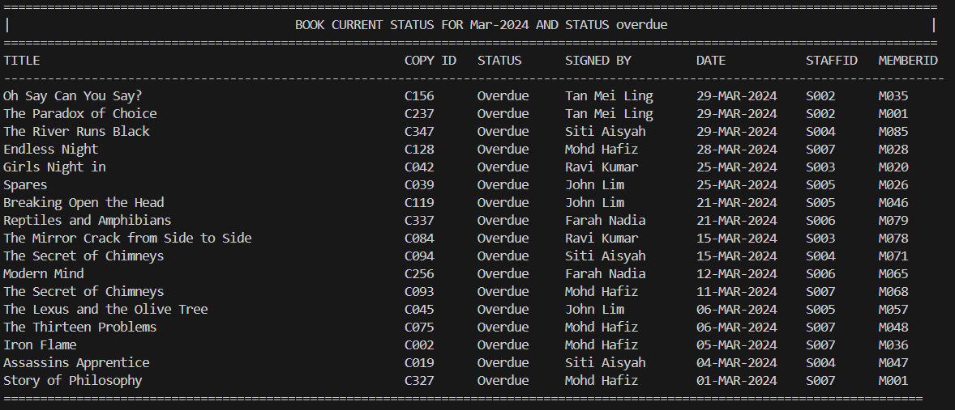

4.2.5 Trigger 1: Generate Audit id
Purpose:
- Automatically generates a unique audit ID for each new BookAudit record.
- Ensures each audit entry has a distinct identifier in the format 'BA' + zero-padded sequence number (e.g., BA0001, BA0002).
- Ensures data integrity and traceability for book-related actions.
- Eliminates manual entry of the audit ID, reducing the risk of errors.
- Ensures every record inserted into the BookAudit table has a unique audit ID for easy reference.
Trigger code:
CREATE OR REPLACE TRIGGER trg_generate_audit_id
BEFORE INSERT ON BookAudit
FOR EACH ROW
BEGIN
IF :NEW.auditId IS NULL THEN
SELECT 'BA' || LPAD(bookaudit_seq.NEXTVAL, 4, '0') INTO :NEW.auditId FROM dual;
END IF;
END;
/

4.2.6 Trigger 2: Prevent Invalid action for Book Audit
Purpose:
- Validates actionType before inserting into the BookAudit table.
- Prevents logging invalid actions like "Returned" or "Lost" when the status in BorrowedBooks doesn’t match.
- Checks if the returnStatus in BorrowedBooks matches the actionType (e.g., "Returned" should only be logged if returnStatus is "Returned").
- Raises an error if an invalid action is attempted, ensuring data consistency.
- Prevents incorrect audit records, maintaining the integrity of the borrowing system.

Trigger code:
CREATE OR REPLACE TRIGGER trg_prevent_invalid_action
BEFORE INSERT ON BookAudit
FOR EACH ROW
DECLARE
v_returnStatus VARCHAR2(10);
BEGIN
-- Get the returnStatus from BorrowedBooks
SELECT returnStatus INTO v_returnStatus
FROM BorrowedBooks
WHERE borrowId = :NEW.borrowId;

-- Validation rules
IF :NEW.actionType = 'Returned' AND v_returnStatus != 'Returned' THEN
RAISE_APPLICATION_ERROR(-20001, 'Book must be marked as Returned in BorrowedBooks to log a Returned action.');
ELSIF :NEW.actionType = 'Lost' AND v_returnStatus != 'Lost' THEN
RAISE_APPLICATION_ERROR(-20002, 'Book must be marked as Lost in BorrowedBooks to log a Lost action.');
END IF;
END;
/

4.2.7 Trigger 3: Borrowed Book Actions
Purpose: Fix vorrowedBook actions and insert records into BookAudit
This trigger is a compound trigger that handles both insert and update functions on the BorrowedBook table. It makes sure that every record is inserted or updated, and is made in the BookAudit table to log the corresponding action (eg.Loaned, Returned, Lost).
- The trigger records loan actions when a book is loaned, which is INSERT action.
- It tracks changes in return status, which Returned or Lost in the BorrowedBooks table which UPDATE action.
- The trigger prevents duplicate audit entries for the same borrowedId and actionType.
- It generates a unique auditId value using the bookaudit_seq.NEXTVAl sequence. Format is like BAXXX, with a prefix(BA) and leading zeros.
- A random staffId (S002-S007) that they role is librarian and assistant, simulates that they are using their own account to log in the library system and make a record that proves they are handling this borrow transaction.

Trigger code:
CREATE OR REPLACE TRIGGER trg_borrowedbooks_actions
FOR INSERT OR UPDATE ON BorrowedBooks
COMPOUND TRIGGER

TYPE t_audit_rec IS RECORD (
borrowId BorrowedBooks.borrowId%TYPE,
actionType BookAudit.actionType%TYPE
);

TYPE t_audit_tab IS TABLE OF t_audit_rec INDEX BY PLS_INTEGER;
v_audits t_audit_tab;
v_index INTEGER := 0;

-- BEFORE EACH ROW section
BEFORE EACH ROW IS
BEGIN
-- INSERT CASE (loaned)
IF INSERTING THEN
v_index := v_index + 1;
v_audits(v_index).borrowId := :NEW.borrowId;
v_audits(v_index).actionType := 'Loaned';

-- UPDATE CASE (returnStatus changed to Returned/Lost)
ELSIF UPDATING THEN
IF :OLD.returnStatus IS NULL OR :OLD.returnStatus != :NEW.returnStatus THEN
IF :NEW.returnStatus = 'Returned' THEN
v_index := v_index + 1;
v_audits(v_index).borrowId := :NEW.borrowId;
v_audits(v_index).actionType := 'Returned';
ELSIF :NEW.returnStatus = 'Lost' THEN
v_index := v_index + 1;
v_audits(v_index).borrowId := :NEW.borrowId;
v_audits(v_index).actionType := 'Lost';
END IF;
END IF;
END IF;
END BEFORE EACH ROW;

-- AFTER STATEMENT section
AFTER STATEMENT IS
BEGIN
FOR i IN 1 .. v_index LOOP
-- Check if the audit entry already exists before inserting
DECLARE
v_exists INTEGER;
BEGIN
-- Check if the audit record already exists for the same borrowId and actionType
SELECT COUNT(*)
INTO v_exists
FROM BookAudit
WHERE borrowId = v_audits(i).borrowId
AND actionType = v_audits(i).actionType;

-- Only insert if no existing record is found
IF v_exists = 0 THEN
INSERT INTO BookAudit (
auditId, borrowId, staffId, actionType, actionDate, notes
) VALUES (
'BA' || LPAD(bookaudit_seq.NEXTVAL, 4, '0'),
v_audits(i).borrowId,
'S00' || TRUNC(DBMS_RANDOM.VALUE(2, 8)), -- random S002 to S007
v_audits(i).actionType,
SYSDATE,
'Action Type recorded.'
);
END IF;
END;
END LOOP;
END AFTER STATEMENT;

END;
/

4.2.8 Trigger 4: Manage Loan Extension
Purpose: Manage Loan Extension update flow
- Track Loan Extension Changes : It tracks updates to the loan extension status in BorrowedBooks.
- Approve/Reject Extension : It approves extensions for members with fewer than three lost books and rejects extensions for members with three or more lost books.
- Extend update to Due Date : It extends the due date by 7 days for approved extensions and reduces it by 7 days if canceled.
- Prevent Extensions for Lost Books : Prevent extensions for members with three/more lost books.
- Updated Loan Records : It ensures the extension status and due dates are accurate after any changes.
Trigger code:
CREATE OR REPLACE TRIGGER trg_manage_loan_extension
FOR UPDATE OF extendStatus ON BorrowedBooks
COMPOUND TRIGGER

TYPE t_ext IS RECORD (
borrowId BorrowedBooks.borrowId%TYPE,
memberId BorrowedBooks.memberId%TYPE,
oldStatus BorrowedBooks.extendStatus%TYPE,
newStatus BorrowedBooks.extendStatus%TYPE
);

TYPE t_ext_tab IS TABLE OF t_ext INDEX BY PLS_INTEGER;
v_ext t_ext_tab;
v_index INTEGER := 0;

AFTER EACH ROW IS
BEGIN
v_index := v_index + 1;
v_ext(v_index).borrowId := :NEW.borrowId;
v_ext(v_index).memberId := :NEW.memberId;
v_ext(v_index).oldStatus := :OLD.extendStatus;
v_ext(v_index).newStatus := :NEW.extendStatus;
END AFTER EACH ROW;

AFTER STATEMENT IS
BEGIN
FOR i IN 1 .. v_index LOOP
IF v_ext(i).newStatus = 'Pending' THEN
DECLARE
v_lost_count INTEGER;
BEGIN
SELECT COUNT(*)
INTO v_lost_count
FROM BorrowedBooks
WHERE memberId = v_ext(i).memberId
AND returnStatus = 'Lost';

IF v_lost_count >= 3 THEN
UPDATE BorrowedBooks
SET extendStatus = 'Rejected'
WHERE borrowId = v_ext(i).borrowId;
ELSE
UPDATE BorrowedBooks
SET extendStatus = 'Approved',
dueDate = dueDate + 7
WHERE borrowId = v_ext(i).borrowId;
END IF;
END;

ELSIF v_ext(i).oldStatus = 'Approved' AND v_ext(i).newStatus = 'Canceled' THEN
UPDATE BorrowedBooks
SET dueDate = dueDate - 7
WHERE borrowId = v_ext(i).borrowId;
END IF;
END LOOP;
END AFTER STATEMENT;

END;
/

4.2.9 Report 1: Report 1- Detail report of Top 5 Members Who Borrowed Books in a Given Months

Purpose: Find the Top 5 Members
The purpose of this report is to identify and highlight the top 5 members who actively borrowed books during a specified month. It aims to support library administrators, membership coordinators, and user engagement teams by providing insights into:
- Which members are the most active based on borrowing frequency.
- How long books are the most active based on these top members.
- The borrowing habits and commitment duration of long-term members.

Usefulness:
- To support membership recognition and award programs by highlighting active and loyal members.

Description:
In this report, it accept a month input (eg. JAN-2024) and generates a ranked list of top 5 members based on the number of books borrowed. For each member, the report presents:
- Basic details: MemberID, Name, Phone Number
- Total number of books borrowed in the month
- Total number of borrowing days which is get from the function 1: Get_Borrow_Duration
- How long the member has been with the library (calculated by function 2: Get_Member_Since_days)
By using a nested cursor(for borrowed books) , it is used to retrieve detailed book borrowing information for each top member and display the info which is borrowId, book title, borrowDate, return date and duration. The combination of a main cursor (for top members) and nested cursor (for borrowed books) ensures that the clear and structured reporting based on Member to Borrowed Book hierarchy.It shows better modularity and performance by limiting queries to relevant data only.

Report code:

-- ==========================================
-- Procedure: rpt_Top_Members - Top 10 Members with Most Borrowed Books Per Month
-- Prepared By: Manager - 'John Tan' (StaffID: S001)
-- Date Generated: 10-JUL-2024
-- ==========================================
SET SERVEROUTPUT ON;
SET PAGESIZE 1000;
SET LINESIZE 300;

CREATE OR REPLACE PROCEDURE rpt_Top_Members (p_month IN VARCHAR2) IS
CURSOR top_members_cursor IS
SELECT *
FROM (
SELECT
RANK() OVER (ORDER BY COUNT(bb.borrowId) DESC) AS rank_no,
bb.memberId,
m.memberName,
m.memberTel,
COUNT(bb.borrowId) AS total_borrowed,
SUM(Get_Borrow_Duration(bb.borrowDate, bb.returnDate)) AS total_duration_days,
Get_Member_Since_Days(m.registrationDate) AS member_since_days
FROM
BorrowedBooks bb
JOIN Members m ON bb.memberId = m.memberId
WHERE
TO_CHAR(bb.borrowDate, 'MON-YYYY') = UPPER(p_month)
GROUP BY
bb.memberId, m.memberName, m.memberTel, m.registrationDate
)
WHERE rank_no <= 5
ORDER BY rank_no;

CURSOR book_details_cursor(p_memberId VARCHAR2) IS
SELECT
bb.borrowId,
bt.title,
bb.borrowDate,
bb.returnDate,
NVL(
CASE
WHEN bb.returnDate IS NOT NULL THEN
bb.returnDate - bb.borrowDate
ELSE
0
END, 0
) AS borrow_duration
FROM
BorrowedBooks bb
JOIN BookCopies bc ON bb.copyId = bc.copyId
JOIN BookTitles bt ON bc.bookId = bt.bookId
WHERE
bb.memberId = p_memberId
AND TO_CHAR(bb.borrowDate, 'MON-YYYY') = UPPER(p_month);

-- Variables
v_rank_no NUMBER;
v_memberId Members.memberId%TYPE;
v_memberName Members.memberName%TYPE;
v_memberTel Members.memberTel%TYPE;
v_total_borrowed NUMBER;
v_total_duration_days NUMBER;
v_member_since_days NUMBER;
v_staffName VARCHAR2(100);

v_borrowId BorrowedBooks.borrowId%TYPE;
v_title BookTitles.title%TYPE;
v_borrowDate DATE;
v_returnDate DATE;
v_days_borrowed NUMBER;

BEGIN

-- Get the staff name of the report preparer
SELECT staffName INTO v_staffName FROM Staff WHERE staffId = 'S001';

-- Start report output
DBMS_OUTPUT.PUT_LINE('==============================================================================================');
DBMS_OUTPUT.PUT_LINE('======================= TOP 5 MEMBERS WHO BORROWED BOOKS IN ' || UPPER(p_month) || ' =========================');
DBMS_OUTPUT.PUT_LINE('==============================================================================================');
DBMS_OUTPUT.PUT_LINE('Report Prepared By Manager : Mr.' || v_staffName);
DBMS_OUTPUT.PUT_LINE('Report Generated On: ' || TO_CHAR(SYSDATE, 'DD-MON-YYYY'));

OPEN top_members_cursor;
LOOP
FETCH top_members_cursor INTO
v_rank_no, v_memberId, v_memberName, v_memberTel,
v_total_borrowed, v_total_duration_days, v_member_since_days;
EXIT WHEN top_members_cursor%NOTFOUND;

DBMS_OUTPUT.PUT_LINE('----------------------------------------------------------------------------------------------');
DBMS_OUTPUT.PUT_LINE('Rank : #' || v_rank_no);
DBMS_OUTPUT.PUT_LINE('Member ID : ' || v_memberId);
DBMS_OUTPUT.PUT_LINE('Name : ' || v_memberName);
DBMS_OUTPUT.PUT_LINE('Telephone : ' || v_memberTel);
DBMS_OUTPUT.PUT_LINE('Books Borrowed: ' || v_total_borrowed);
DBMS_OUTPUT.PUT_LINE('Total Days : ' || v_total_duration_days || ' day(s)');
DBMS_OUTPUT.PUT_LINE('Joined For : ' || v_member_since_days || ' day(s)');
DBMS_OUTPUT.PUT_LINE('Book Details:');
DBMS_OUTPUT.PUT_LINE(RPAD(' BorrowID', 22) || RPAD('Title', 40) || RPAD('Borrow Date', 15) || RPAD('Return Date', 15) || 'Days');

OPEN book_details_cursor(v_memberId);
LOOP
FETCH book_details_cursor INTO v_borrowId, v_title, v_borrowDate, v_returnDate, v_days_borrowed;
EXIT WHEN book_details_cursor%NOTFOUND;
DBMS_OUTPUT.PUT_LINE(RPAD(' -> ', 10) || RPAD(v_borrowId, 13) || RPAD(SUBSTR(v_title, 1, 38), 40) ||
RPAD(TO_CHAR(v_borrowDate, 'DD-MON-YY'), 15) ||
RPAD(NVL(TO_CHAR(v_returnDate, 'DD-MON-YY'), 'NOT RETURNED'), 15) ||
v_days_borrowed);
END LOOP;
CLOSE book_details_cursor;
END LOOP;
CLOSE top_members_cursor;

DBMS_OUTPUT.PUT_LINE('==============================================================================================');
END;
/

SET SERVEROUTPUT ON;

ACCEPT p_month CHAR PROMPT 'Enter Month (e.g., JUN-2024): '

EXEC rpt_Top_Members('&p_month');

Sample Output:

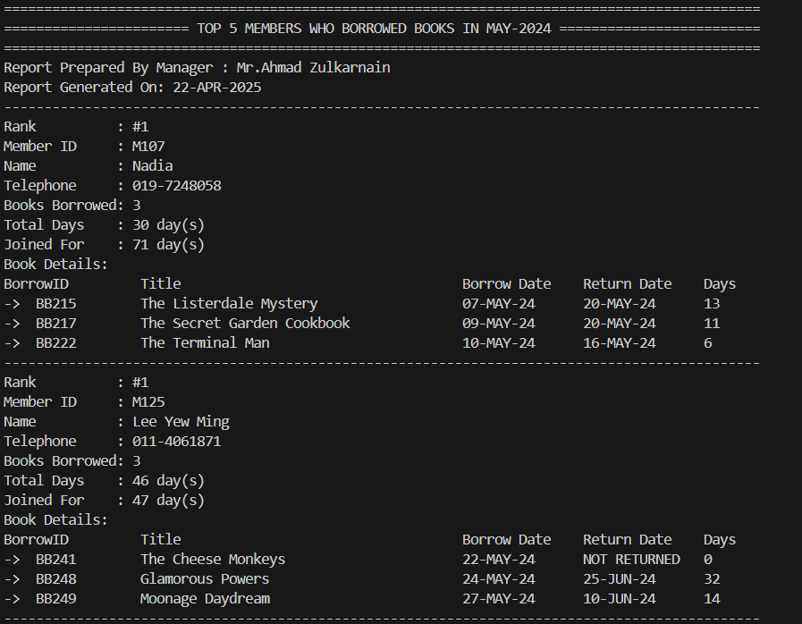
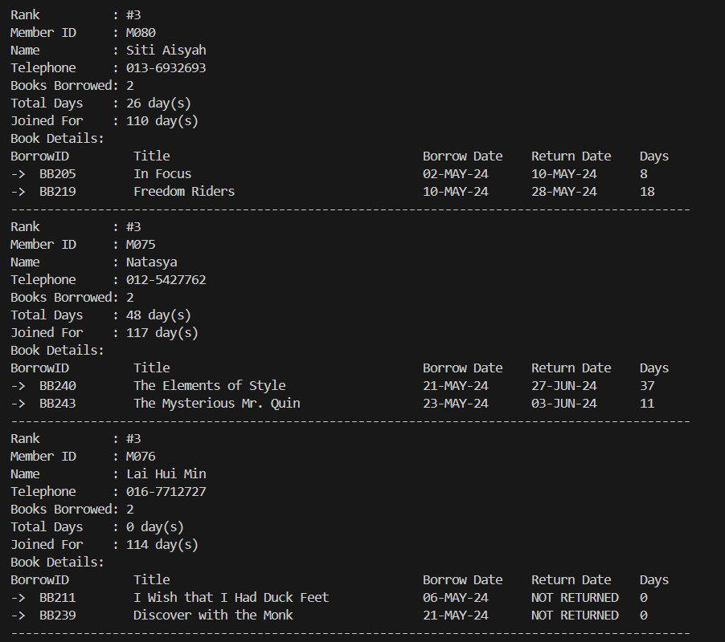

4.2.10 Report 2: Report 2- Summary report of Loan Extension

Purpose: Find the necessary and efficiency of Apply Loan Extension
The purpose of this report is to provide a summary report of all loan extensions approved in a selected month. To identify members who had loan extensions that were approved by the staff librarian, along with their:
- contact information
- borrowed book details and
- duration of loan extensions

Description:
Percentage contribution (Function 3: Get_Extension_Percent) is calculated and displayed by each member to the total number of loan extensions. It helps to assist library managers in monitoring extension behavior, identifying frequent extensions, and making decisions for further library system development improvement.

Cursor Explanation:
The use of a nested cursor in this report enables a structured and organized presentation of loan extension data. The main cursor (member_cur) is responsible for retrieving a distinct list of members who had at least one approved loan extension within the selected reporting month. For each member returned by the main cursor, a nested cursor(extension_cur) is executed to fetch detailed information about each of their approved borrowings. This includes the borrow ID, book title, borrow date, due date, return date, and the number of extension days, which is calculated by subtracting the borrow date from the due date.

This nested approach facilitates a clear hierarchical display of data, where member information is followed by the corresponding borrowing records. It also promotes clean modularization of the logic, allowing the summary (which is handled by the main cursor) to be clearly separated from the details (which is handled by the nested cursor). Additionally, filtering borrow records by member within the nested cursor ensures efficient processing and improves the clarity and readability of the report output.

Report code:

SET SERVEROUTPUT ON;
SET PAGESIZE 1000;
SET LINESIZE 300;

CREATE OR REPLACE PROCEDURE rpt_loanExtend(p_month IN VARCHAR2) IS
CURSOR member_cur(p_month VARCHAR2) IS
SELECT DISTINCT bb.memberId, m.memberName, m.memberTel
FROM BorrowedBooks bb
JOIN Members m ON bb.memberId = m.memberId
WHERE TO_CHAR(bb.returnDate, 'MON-YYYY') = UPPER(p_month)
AND bb.extendStatus = 'Approved';

CURSOR extension_cur(p_member_id VARCHAR2, p_month VARCHAR2) IS
SELECT bb.borrowId, b.Title, bb.borrowDate, bb.dueDate,
bb.returnDate,
( bb.dueDate - bb.borrowDate) AS extension_days
FROM BorrowedBooks bb
JOIN BookCopies bc ON bb.copyId = bc.copyId
JOIN BookTitles b ON bc.bookId = b.bookId
WHERE bb.memberId = p_member_id
AND TO_CHAR(bb.returnDate, 'MON-YYYY') = UPPER(p_month)
AND bb.extendStatus = 'Approved';

v_month VARCHAR2(20) := UPPER(p_month);
v_total_count NUMBER;
v_percentage NUMBER;
v_staffName VARCHAR2(100);
BEGIN
-- Get staff name
SELECT staffName INTO v_staffName FROM Staff WHERE staffId = 'S001';

-- Get total extensions in month
SELECT COUNT(*) INTO v_total_count
FROM BorrowedBooks
WHERE TO_CHAR(returnDate, 'MON-YYYY') = v_month
AND extendStatus = 'Approved';

-- Header
DBMS_OUTPUT.PUT_LINE('==================================================================================================');
DBMS_OUTPUT.PUT_LINE('=========================== Loan Extension Summary Report IN ' || v_month || ' ============================');
DBMS_OUTPUT.PUT_LINE('==================================================================================================');
DBMS_OUTPUT.PUT_LINE('Report Prepared By: Manager - ' || v_staffName);
DBMS_OUTPUT.PUT_LINE('Generated On: ' || TO_CHAR(SYSDATE, 'DD-MON-YYYY'));
DBMS_OUTPUT.PUT_LINE('Report Month: ' || v_month);
DBMS_OUTPUT.PUT_LINE(RPAD('-', 98, '-'));

-- Loop members
FOR mrec IN member_cur(v_month) LOOP
v_percentage := Get_Extension_Percent(mrec.memberId, v_month);

DBMS_OUTPUT.PUT_LINE('Member ID: ' || mrec.memberId ||
', Name: ' || mrec.memberName ||
', Tel: ' || mrec.memberTel);
DBMS_OUTPUT.PUT_LINE('Contribution to Total Extensions: ' || ROUND(v_percentage, 2) || '%');
DBMS_OUTPUT.PUT_LINE(' Borrow ID Book Title Borrow Date Due Date Return Date Extension Days');
DBMS_OUTPUT.PUT_LINE(RPAD('-', 98, '-'));

-- Nested loop: borrowings for member
FOR erec IN extension_cur(mrec.memberId, v_month) LOOP
DBMS_OUTPUT.PUT_LINE(RPAD('-> ', 4) ||
RPAD(erec.borrowId, 8) ||
RPAD(erec.Title, 34) ||
RPAD(TO_CHAR(erec.borrowDate, 'DD-MON'),13) ||
RPAD(TO_CHAR(erec.dueDate, 'DD-MON'),13) ||
RPAD(TO_CHAR(erec.returnDate, 'DD-MON'),13)||
erec.extension_days);
END LOOP;

DBMS_OUTPUT.PUT_LINE('==================================================================================================');
DBMS_OUTPUT.PUT_LINE(RPAD('-', 98, '-'));
END LOOP;

DBMS_OUTPUT.PUT_LINE('Total Loan Extensions in ' || v_month || ': ' || v_total_count);
END;
/

SET SERVEROUTPUT ON;

ACCEPT p_month CHAR PROMPT 'Enter report month (e.g., JUN-2024): '

EXEC rpt_loanExtend('&p_month');

Sample Output:
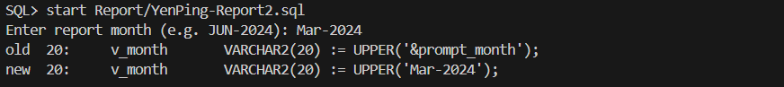
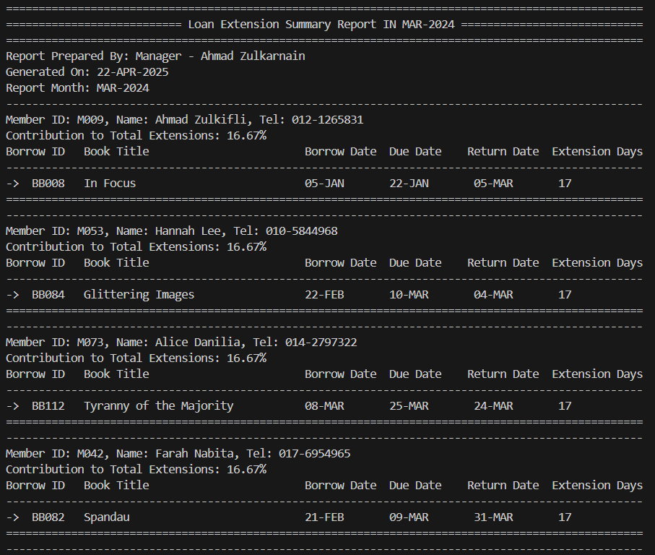
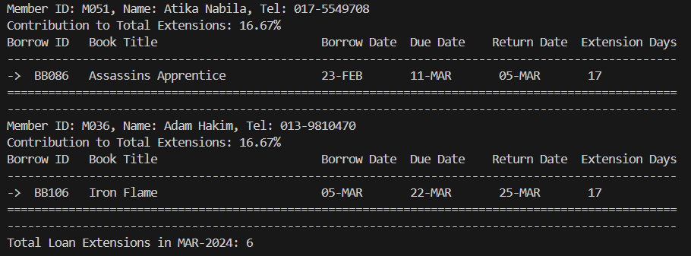

4.3 Tay Mian Yin

4.3.1 Query 1: Monthly Reservation Overview
Purpose:
The purpose of this query is designed to generate a detailed monthly reservation overview made on books by members of a library. This kind of report is important for tactical and operational management to monitor usage trends, ascertain the popularity of books, and assess reservation fulfillment performance.
Usefulness:
This query is great for tactical-level decision making.
- Library Managers could monitor user engagement trends such as how many people are using reservations.
- Helps to identify bottlenecks because too many reservations outstanding may be a sign of not enough copies.
- Track member behavior like how many cancel or fail to comply.
- Test the diversity of book demand to determine if people are pre-ordering only a few popular books or many different titles.
- Helps to measure library service efficiency by the following columns in this query:
- “Fulfilled Reservations” indicate how effectively the library is meeting user needs. A higher number of filled reservations indicates that the library has sufficient resources and is responsive to user needs.
- “Pending Reservations” help in identifying potential delays or unavailability of popular books. Rising pending reservations might indicate resource shortages or inefficiency in filling reservations.
- “Cancelled Reservations” may call to mind issues with the user interface or communication flaws in the system. Over-cancellations could mean that members are not receiving timely notice, or that reserve books aren't becoming available within a reasonable time frame.

SQL statement:
-- SETUP SQLPLUS ENVIRONMENT
SET LINESIZE 200
SET PAGESIZE 100
SET TRIMSPOOL ON
SET TAB OFF
SET FEEDBACK ON
SET VERIFY OFF

-- FORMAT OUTPUT FOR SQLPLUS
COLUMN "Month" FORMAT A15
COLUMN "Total Reservations" FORMAT 9999
COLUMN "Unique Reservers" FORMAT 9999
COLUMN "Fulfilled Reservations" FORMAT 9999
COLUMN "Pending Reservations" FORMAT 9999
COLUMN "Cancelled Reservations" FORMAT 9999
COLUMN "Distinct Books Reserved" FORMAT 9999
COLUMN "Latest Reservation" FORMAT A20

-- HEADER
PROMPT
PROMPT ================================================================== Monthly Reservations Overview ==================================================================
PROMPT

-- MAIN QUERY
SELECT
month AS "Month",
total_reservations AS "Total Reservations",
unique_reservers AS "Unique Reservers",
fulfilled_reservations AS "Fulfilled Reservations",
pending_reservations AS "Pending Reservations",
cancelled_reservations AS "Cancelled Reservations",
distinct_books_reserved AS "Distinct Books Reserved",
latest_reservation AS "Latest Reservation"
FROM
MonthlyReservationsOverview
ORDER BY
month DESC;

Sample Output:
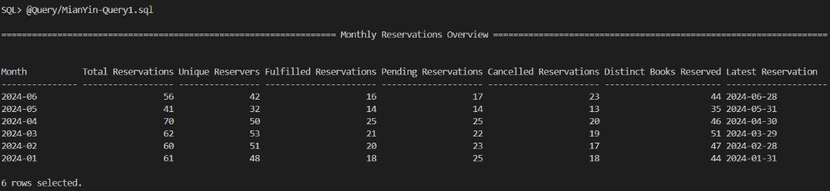

4.3.2 Query 2: High-Demand Books: Frequently Reserved but Unavailable
Purpose:
The purpose of this query is to identify high-demand books that are not available at the time of high demand, and for which there are more than 3 pending reservations. This allows the library to assess book titles highly reserved but unavailable for borrowing. The library can get insight into the demand by the public and determine which titles may need additional copies. The library can take action on resource allocation to reduce user frustration and waiting time.

Usefulness:
This query is great for tactical-level decision making.
- Highlights the gap between supply and demand for a library's collection.
- Helps managers respond to member demand trends in a timely manner.
- Enables libraries to proactively reduce wait times for popular books.
- For example, if the number of pending orders for several books is consistently high, the library can place orders to increase inventory, set reservation limits to improve fairness, and promote other books to relieve congestion.

SQL statement:
-- SETUP SQLPLUS ENVIRONMENT
SET LINESIZE 120
SET PAGESIZE 50
SET WRAP OFF
SET TRIMSPOOL ON

-- FORMAT OUTPUT FOR SQLPLUS
COLUMN "Title" FORMAT A60
COLUMN "Total Reservations" FORMAT 9999

-- Header
PROMPT
PROMPT =========== High-Demand Books: Frequently Reserved but Unavailable ============
PROMPT

-- Main query
SELECT * FROM BooksDemandView
ORDER BY total_reservations DESC;

Sample Output:
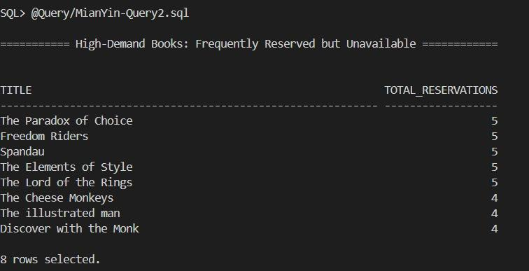

4.3.3 Stored Procedure 1: Check Shift Overlap

Purpose:
The purpose of this procedure is designed to check if a staff has already been scheduled for a shift on a given date so that there is no overlap of shifts. No staff is assigned twice on one day in this manner to enable smooth management of shifts as well as prevention of scheduling issues. It supports the Scheduling and Staff Performance modules in the library information system by maintaining basic rules of scheduling prior to inserting or modifying shift details.

Usefulness:
This procedure is tactically useful for library supervisors or operations staff involved in scheduling. It helps to prevent scheduling conflicts for staff, ensuring that each shift is assigned fairly and without duplication. It also maintains data integrity in the shift scheduling system. Besides, this procedure enhances accountability by ensuring staff shifts are accurately logged without overlaps. It also improves workflow automation, as the procedure can be called before insertions in other programs or triggers.

Procedure code:
-- Stored Procedure 1: Check Shift Overlap
CREATE OR REPLACE PROCEDURE proc_check_shift_overlap (
p_staffId IN VARCHAR2,
p_shiftDate IN DATE
)
IS
v_count NUMBER;

-- Custom exception for invalid table or column access (ORA-00942: table or view does not exist)
table_missing EXCEPTION;
PRAGMA EXCEPTION_INIT(table_missing, -00942);
BEGIN
SELECT COUNT(*) INTO v_count
FROM ShiftSchedules
WHERE staffId = p_staffId AND shiftDate = p_shiftDate;

IF v_count > 0 THEN
RAISE_APPLICATION_ERROR(-20023, 'Staff already scheduled for this date.');
ELSE
DBMS_OUTPUT.PUT_LINE('No overlapping shift.');
END IF;

EXCEPTION
WHEN table_missing THEN
DBMS_OUTPUT.PUT_LINE('Error: Required table or view does not exist. Please check ShiftSchedules table.');
WHEN OTHERS THEN
DBMS_OUTPUT.PUT_LINE('Error checking shift overlap: ' || SQLERRM);
END;
/

SET SERVEROUTPUT ON

-- Prompt user for staff ID & date input
ACCEPT v_staffId CHAR PROMPT 'Enter staff ID: '
ACCEPT v_shiftDate CHAR PROMPT 'Enter shift date (DD-MON-YYYY): '

-- Execute the procedure with user input
EXEC proc_check_shift_overlap('&v_staffId','&v_shiftDate');

Sample Output:
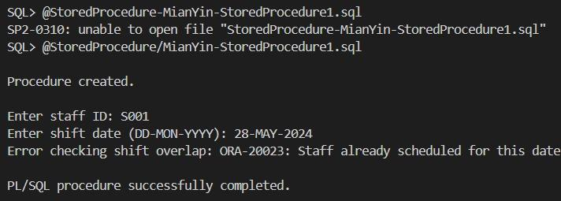

4.3.4 Stored Procedure 2: Get Staff Attendance Summary
Purpose:
The purpose of this procedure proc_staff_attendance_summary is to generate a summary report of an attendance record of a staff member based on their staffId. It provides the count of times the staff has been 'Present', 'Absent', 'Late'. Exception handling is implemented to handle non-existent tables or views. It also catches and prints any other runtime error.
Usefulness:
- Manager Quick summary. This procedure enables staff managers to quickly access a staff’s attendance record.
- Validation before report generation. The process prevents unnecessary query executions in case the staff does not have schedules.
- Aids performance evaluation. It can be used as input for performance reviews or disciplinary actions.
- Automates what otherwise would be a time-consuming manual process.
- Enables Auditing & Reporting. It can be included in scheduled reports or dashboards.

Procedure code:
-- Stored Procedure 2: Get Staff Attendance Summary
CREATE OR REPLACE PROCEDURE proc_staff_attendance_summary (
p_staffId IN VARCHAR2
)
IS
v_present NUMBER := 0;
v_absent NUMBER := 0;
v_late NUMBER := 0;

-- Custom exception for table/view not found
table_missing EXCEPTION;
PRAGMA EXCEPTION_INIT(table_missing, -00942);

BEGIN
-- Check if the staffId has any schedule records
DECLARE
v_check NUMBER;
BEGIN
SELECT COUNT(*) INTO v_check
FROM ShiftSchedules
WHERE staffId = p_staffId;

IF v_check = 0 THEN
RAISE_APPLICATION_ERROR(-20031, 'No shift schedules found for the given staff ID.');
END IF;
END;

-- Count Present attendance
SELECT COUNT(*) INTO v_present
FROM StaffAttendance sa
JOIN ShiftSchedules ss ON sa.scheduleId = ss.scheduleId
WHERE ss.staffId = p_staffId AND sa.attendanceStatus = 'Present';

-- Count Absent attendance
SELECT COUNT(*) INTO v_absent
FROM StaffAttendance sa
JOIN ShiftSchedules ss ON sa.scheduleId = ss.scheduleId
WHERE ss.staffId = p_staffId AND sa.attendanceStatus = 'Absent';

-- Count Late attendance
SELECT COUNT(*) INTO v_late
FROM StaffAttendance sa
JOIN ShiftSchedules ss ON sa.scheduleId = ss.scheduleId
WHERE ss.staffId = p_staffId AND sa.attendanceStatus = 'Late';

-- Output summary
DBMS_OUTPUT.PUT_LINE('==============================================');
DBMS_OUTPUT.PUT_LINE(' Staff Attendance Summary ');
DBMS_OUTPUT.PUT_LINE('==============================================');
DBMS_OUTPUT.PUT_LINE(' Staff ID : ' || p_staffId);
DBMS_OUTPUT.PUT_LINE(' Present Days : ' || v_present);
DBMS_OUTPUT.PUT_LINE(' Absent Days : ' || v_absent);
DBMS_OUTPUT.PUT_LINE(' Late Days : ' || v_late);
DBMS_OUTPUT.PUT_LINE('==============================================');

EXCEPTION
WHEN table_missing THEN
DBMS_OUTPUT.PUT_LINE('Error: Missing required table/view. Please check StaffAttendance or ShiftSchedules.');
WHEN OTHERS THEN
DBMS_OUTPUT.PUT_LINE('Error generating summary: ' || SQLERRM);
END;
/

SET SERVEROUTPUT ON

-- Prompt user for staff ID input
ACCEPT v_staffId CHAR PROMPT 'Enter staff ID: '

-- Execute the procedure with user input
EXEC proc_staff_attendance_summary('&v_staffId');

Sample Output:
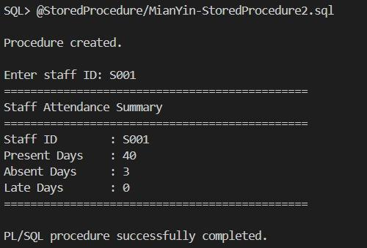

4.3.5 Trigger 1: Auto-mark Staff as 'Late' Based on Shift Start Time
Purpose:
The purpose of this trigger is to automatically mark a staff as ‘Late’ or ‘Present’ based on the comparison between the staff’s actual arrival time (actualStartTime) in the StaffAttendance table and the scheduled start time (startTime) in the ShiftSchedules table. This trigger enforces a business rule: "If the staff’s arrival time is later than their shift start time, mark them as 'Late'; otherwise, mark them as 'Present'".
Usefulness:
- Imposes punctuality without human intervention
- Reduces errors in data entry
- Saves staff arrival time by automatically checking for punctuality
- Ensures system-wide consistency for assignment of attendance status

Example Use Case:
The scheduled Start Time of a librarian for morning shift is 9:00AM.
- If actualStartTime is 9:10AM, mark him as ‘Late’.
- If actualStartTime is 8:59AM, mark him as ‘Present’.

Trigger code:
-- Trigger 1: Auto-mark Staff as 'Late' Based on Shift Start Time
CREATE OR REPLACE TRIGGER trg_auto_mark_late
BEFORE INSERT OR UPDATE ON StaffAttendance
FOR EACH ROW
DECLARE
v_shiftStart TIMESTAMP;
BEGIN
SELECT s.startTime INTO v_shiftStart
FROM ShiftSchedules ss
JOIN Shift s ON ss.shiftId = s.shiftId
WHERE ss.scheduleId = :NEW.scheduleId;

IF :NEW.actualStartTime IS NOT NULL THEN
IF :NEW.actualStartTime > v_shiftStart THEN
:NEW.attendanceStatus := 'Late';
ELSE
:NEW.attendanceStatus := 'Present';
END IF;
END IF;
END;
/

4.3.6 Trigger 2: Enforce 40-Hour Weekly Limit for Staff

Purpose:
The purpose of this trigger is to enforce a business policy that prevents staff from working more than 40 hours per week. This trigger enforces the following business rule: "Each staff can work a maximum of 40 hours per week". This is in line with labor law or internal policy on workload, overtime and benefits to employees.

Assumption: Only functions when both actualStartTime and actualEndTime are provided.

Usefulness:
- Prevents Overwork: Automatically applies the weekly restriction.
- Protects the business from legal or union-related violations.
- Improves fairness in shift assignments.
- Prevents scheduling repeated or unnecessary overlapping shifts inadvertently.
- Maintains neat records of attendance and policy-compliant.

Trigger code:

-- Trigger 2: Enforce 40-Hour Weekly Limit for Staff
CREATE OR REPLACE TRIGGER trg_check_weekly_hours
BEFORE INSERT OR UPDATE ON StaffAttendance
FOR EACH ROW
DECLARE
v_staffId ShiftSchedules.staffId%TYPE;
v_shiftDate DATE;
v_weekStart DATE;
v_totalHours NUMBER := 0;
v_newHours NUMBER := 0;
BEGIN
SELECT staffId, shiftDate INTO v_staffId, v_shiftDate
FROM ShiftSchedules
WHERE scheduleId = :NEW.scheduleId;

v_weekStart := TRUNC(v_shiftDate, 'IW');

SELECT NVL(SUM(
EXTRACT(DAY FROM (actualEndTime - actualStartTime)) * 24 + EXTRACT(HOUR FROM (actualEndTime - actualStartTime))
), 0)
INTO v_totalHours
FROM StaffAttendance sa
JOIN ShiftSchedules ss ON sa.scheduleId = ss.scheduleId
WHERE ss.staffId = v_staffId
AND TRUNC(ss.shiftDate, 'IW') = v_weekStart;

IF :NEW.actualStartTime IS NOT NULL AND :NEW.actualEndTime IS NOT NULL THEN
v_newHours := (EXTRACT(DAY FROM (:NEW.actualEndTime - :NEW.actualStartTime)) * 24) + EXTRACT(HOUR FROM (:NEW.actualEndTime - :NEW.actualStartTime));
END IF;

IF (v_totalHours + v_newHours) > 40 THEN
RAISE_APPLICATION_ERROR(-20002, 'Total working hours for this staff in the week would exceed 40 hours.');
END IF;
END;
/

4.3.7 Report 1: On-Demand Detailed Attendance Report by Shift Date
Purpose:
The purpose of this report is to generate an on-demand, detailed attendance report for a specific shift date, only upon request by the user. The report lists all shifts scheduled on a specific date and the assigned staff member for each shift, their attendance status, and their actual clock-in and clock-out times. Nested cursors are used in report generation.
Use Case: Check who worked which shift, when they started or ended, and if they were punctual or late by inputting a specific date.
Report code:
-- On-Demand Detailed Attendance Report by Shift Date
SET LINESIZE 120;
SET PAGESIZE 50;
CREATE OR REPLACE PROCEDURE rpt_attend_detail_by_date(
p_shiftDate IN DATE
)
IS
-- Outer cursor to get shift schedules for the given date
CURSOR shift_cur IS
SELECT ss.scheduleId, ss.shiftId, s.shiftType,
s.startTime, s.endTime
FROM ShiftSchedules ss
JOIN Shift s ON ss.shiftId = s.shiftId
WHERE TRUNC(ss.shiftDate) = TRUNC(p_shiftDate)
ORDER BY s.startTime;

-- Nested cursor to get staff attendance for each schedule
CURSOR staff_attendance_cur(p_scheduleId VARCHAR2) IS
SELECT st.staffName, st.role, sa.attendanceStatus,
sa.actualStartTime, sa.actualEndTime
FROM StaffAttendance sa
JOIN ShiftSchedules ss ON sa.scheduleId = ss.scheduleId
JOIN Staff st ON ss.staffId = st.staffId
WHERE sa.scheduleId = p_scheduleId
ORDER BY st.staffName;

v_shift_rec shift_cur%ROWTYPE;
v_staff_count NUMBER;
BEGIN
DBMS_OUTPUT.PUT_LINE(RPAD('=', 62, '='));
DBMS_OUTPUT.PUT_LINE('Attendance Report for ' || TO_CHAR(p_shiftDate, 'DD-MON-YYYY'));
DBMS_OUTPUT.PUT_LINE(RPAD('=', 62, '='));

OPEN shift_cur;
LOOP
FETCH shift_cur INTO v_shift_rec;
EXIT WHEN shift_cur%NOTFOUND;

DBMS_OUTPUT.PUT_LINE('Shift ID: ' || v_shift_rec.shiftId || ' | Type: ' || v_shift_rec.shiftType);
DBMS_OUTPUT.PUT_LINE('Time: ' || TO_CHAR(v_shift_rec.startTime, 'HH24:MI') || ' - ' || TO_CHAR(v_shift_rec.endTime, 'HH24:MI') || ' (' || get_shift_duration(v_shift_rec.startTime, v_shift_rec.endTime) || ')');
DBMS_OUTPUT.PUT_LINE('--------------------------------------------------------------');

v_staff_count := 0;

FOR att_rec IN staff_attendance_cur(v_shift_rec.scheduleId) LOOP
DBMS_OUTPUT.PUT_LINE(RPAD(att_rec.staffName, 20) ||
RPAD(att_rec.role, 15) ||
RPAD(att_rec.attendanceStatus, 12) ||
RPAD(NVL(TO_CHAR(att_rec.actualStartTime, 'HH24:MI'), 'N/A'), 10) ||
RPAD(NVL(TO_CHAR(att_rec.actualEndTime, 'HH24:MI'), 'N/A'), 10));
v_staff_count := v_staff_count + 1;
END LOOP;

IF v_staff_count = 0 THEN
DBMS_OUTPUT.PUT_LINE('No staff assigned to this shift');
END IF;

DBMS_OUTPUT.PUT_LINE(CHR(10));
END LOOP;

IF shift_cur%ROWCOUNT = 0 THEN
DBMS_OUTPUT.PUT_LINE('No shifts scheduled for this date');
END IF;

CLOSE shift_cur;

-- Print the footer for the report
DBMS_OUTPUT.PUT_LINE(RPAD('-', 62, '-'));
DBMS_OUTPUT.PUT_LINE('Report generated on: ' || TO_CHAR(SYSDATE, 'DD-MON-YYYY HH24:MI:SS'));
DBMS_OUTPUT.PUT_LINE(RPAD('=', 62, '='));
EXCEPTION
WHEN OTHERS THEN
DBMS_OUTPUT.PUT_LINE('Error generating attendance detail report: ' || SQLERRM);
IF shift_cur%ISOPEN THEN
CLOSE shift_cur;
END IF;
END;
/

SET SERVEROUTPUT ON

-- Prompt user for date input
ACCEPT v_date CHAR PROMPT 'Enter report date (DD-MON-YYYY): '

-- Execute the procedure with user input
EXEC rpt_attend_detail_by_date('&v_date');

Sample Output:
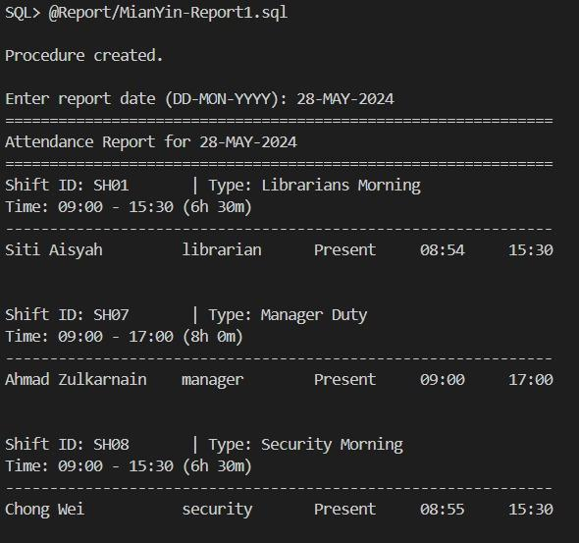
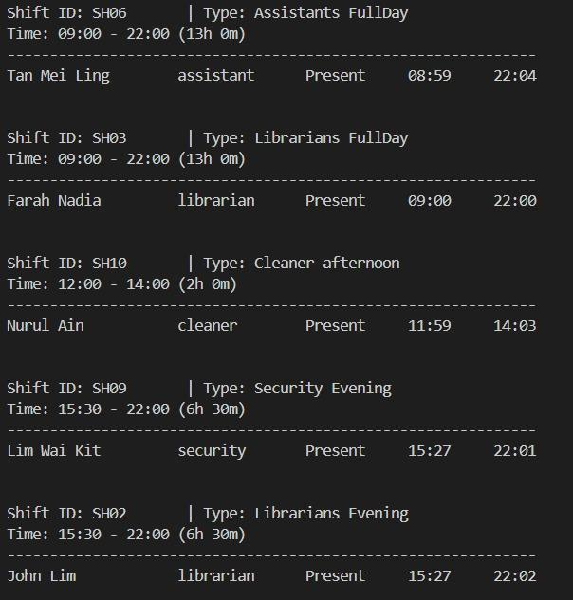
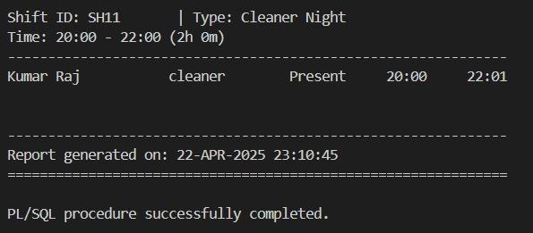

4.3.8 Report 2: Late Attendance Report
Purpose:
The purpose of this report is to generate a summary, detailed report that identifies staff who arrived late for their scheduled shifts. It shows the shift type, staff name, scheduled start time, actual start time, and the number of minutes they were late. Nested cursors are used in report generation.
Usefulness:
- Monitor patterns of punctuality and lateness
- Assist in discipline punctuality
- Optimize shift planning and performance management

Advantages: Real-time monitoring of punctuality
Report code:
SET LINESIZE 180
SET PAGESIZE 70
CREATE OR REPLACE PROCEDURE rpt_late_attendance_report
IS
-- Cursor to get distinct shifts
CURSOR shift_cur IS
SELECT DISTINCT ss.shiftId, s.shiftType, s.startTime, s.endTime, TRUNC(ss.shiftDate) AS att_date
FROM ShiftSchedules ss
JOIN Shift s ON ss.shiftId = s.shiftId
JOIN StaffAttendance sa ON sa.scheduleId = ss.scheduleId
WHERE sa.attendanceStatus = 'Late'
ORDER BY TRUNC(ss.shiftDate), s.startTime;

-- Cursor to get attendance details for each shift and date
CURSOR late_attendance_details(p_shiftId IN VARCHAR2, p_date IN DATE) IS
SELECT ss.staffId, s.staffName, sa.attendanceStatus, sa.actualStartTime, sa.actualEndTime
FROM StaffAttendance sa
JOIN ShiftSchedules ss ON sa.scheduleId = ss.scheduleId
JOIN Staff s ON ss.staffId = s.staffId
WHERE ss.shiftId = p_shiftId
AND sa.attendanceStatus = 'Late'
AND TRUNC(ss.shiftDate) = p_date
ORDER BY s.staffName;

v_has_late_entries BOOLEAN := FALSE;
v_minutes_late NUMBER;
v_late_count NUMBER := 0;

BEGIN
-- Report Header
DBMS_OUTPUT.PUT_LINE(RPAD('=', 101, '='));
DBMS_OUTPUT.PUT_LINE('LATE ATTENDANCE REPORT');
DBMS_OUTPUT.PUT_LINE(RPAD('=', 101, '='));
DBMS_OUTPUT.PUT_LINE('');

FOR shift IN shift_cur LOOP
DBMS_OUTPUT.PUT_LINE('Date: ' || TO_CHAR(shift.att_date, 'DD-MON-YYYY'));
DBMS_OUTPUT.PUT_LINE(
RPAD('Shift Type', 20) || ' ' ||
RPAD('Staff Name', 20) || ' ' ||
RPAD('Status', 8) || ' ' ||
RPAD('Scheduled Start', 18) || ' ' ||
RPAD('Actual Start', 15) || ' ' ||
RPAD('Minutes Late', 12)
);
DBMS_OUTPUT.PUT_LINE(RPAD('-', 101, '-'));

FOR attendance IN late_attendance_details(shift.shiftId, shift.att_date) LOOP
BEGIN
-- Calculate minutes late
v_minutes_late := calculate_minutes_late(attendance.actualStartTime, shift.startTime);

DBMS_OUTPUT.PUT_LINE(
RPAD(shift.shiftType, 20) || ' ' ||
RPAD(attendance.staffName, 20) || ' ' ||
RPAD('Late', 8) || ' ' ||
RPAD(TO_CHAR(shift.startTime, 'HH24:MI'), 18) || ' ' ||
RPAD(TO_CHAR(attendance.actualStartTime, 'HH24:MI'), 15) || ' ' ||
LPAD(v_minutes_late, 12)
);
v_has_late_entries := TRUE;
v_late_count := v_late_count + 1;

EXCEPTION
WHEN OTHERS THEN
DBMS_OUTPUT.PUT_LINE('Error processing: ' || attendance.staffName || ' - ' || SQLERRM);
END;
END LOOP;
DBMS_OUTPUT.PUT_LINE(CHR(10));
END LOOP;

IF NOT v_has_late_entries THEN
DBMS_OUTPUT.PUT_LINE('No late attendance records found.');
END IF;

DBMS_OUTPUT.PUT_LINE('Total Late Attendance Entries: ' || v_late_count);

-- Print the footer for the report
DBMS_OUTPUT.PUT_LINE(RPAD('-', 101, '-'));
DBMS_OUTPUT.PUT_LINE('Report generated on: ' || TO_CHAR(SYSDATE, 'DD-MON-YYYY HH24:MI:SS'));
DBMS_OUTPUT.PUT_LINE(RPAD('=', 101, '='));
EXCEPTION
WHEN OTHERS THEN
DBMS_OUTPUT.PUT_LINE('Error in rpt_late_attendance_report: ' || SQLERRM);
END;
/

SET SERVEROUTPUT ON

-- Execute the procedure
EXEC rpt_late_attendance_report;

Sample Output:
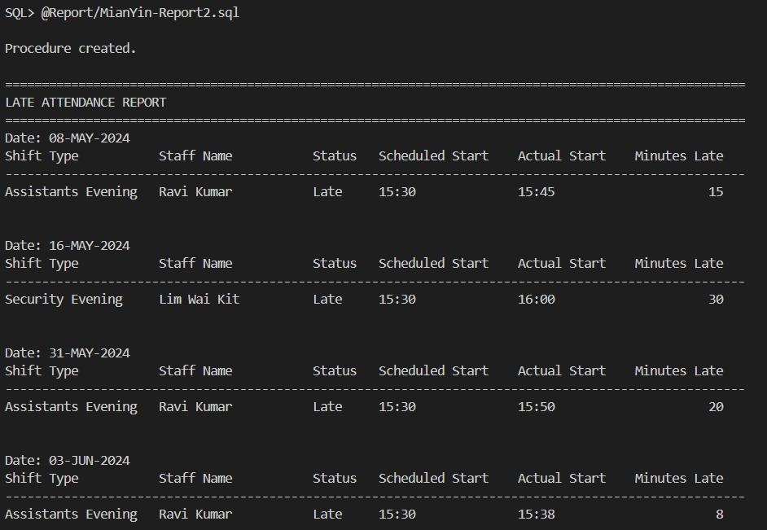
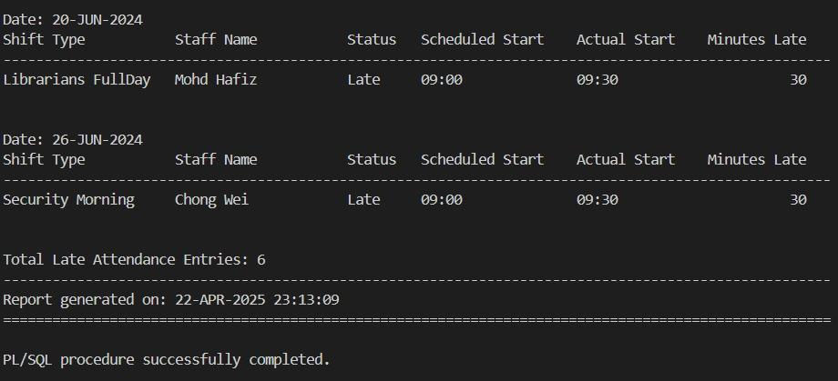

4.4 Tay Zhuang Yin

4.4.1 Query 1: Analysis of Active Members with High Extensions and Overdue Activity

Purpose:
This query identifies the ranking of active and frequency of library members applying the extensions and late return borrowed books behaviour. This query is designed to help library management make tactical decisions by monitoring and analyzing the borrowing tendencies of active members. It describes the borrowing tendencies of active members in groups by adding data from various tables such as "Members" and "Borrowed Books". This query inpoints the members who will require closer monitoring or good communication for their borrowing behavior.

Each member's number of borrowed books, total extensions, and overdue are displayed in the query result. The total number of borrowed books shows the overall library usage. The total extension is the number of borrowed records with approved or pending statuses for extension. The overdue count of a member reveals how frequently they return overdue books, which can show that they are not responsible. They will be part of the query only thanks to the query's usage of aggregate functions, multi-table joins, and conditional logic in the HAVING clause who request extensions more than twice or return borrowed books after the due date more than twice.

As a way to enhance compliance, this question attempts to empower library staff to take proactive action such as sending warning reminders and checking on borrowing privileges. Overall, this question provides information to sustain the discipline of the borrowing policies and enhance the quality of the services.

SQL statement:
-- SETUP SQLPLUS ENVIRONMENT
SET linesize 120
SET pagesize 50
SET WRAP ON
SET TRIMSPOOL ON

-- FORMAT OUTPUT FOR SQLPLUS
COLUMN "MEMBER ID" FORMAT A10
COLUMN "MEMBER NAME" FORMAT A20
COLUMN "TOTAL BORROWED" FORMAT 9999
COLUMN "TOTAL EXTENSIONS" FORMAT 9999
COLUMN "OVERDUE COUNT" FORMAT 9999

-- HEADER
PROMPT
PROMPT ==== Analysis of Active Members with High Extensions and Overdue Activity ====
PROMPT

-- QUERY
SELECT
member_id AS "MEMBER ID",
member_name AS "MEMBER NAME",
total_borrowed AS "TOTAL BORROWED",
total_extensions AS "TOTAL EXTENSIONS",
overdue_count AS "OVERDUE COUNT"
FROM
vw_member_borrow_stats
WHERE
total_extensions > 2
OR overdue_count > 2
ORDER BY
total_extensions DESC, overdue_count DESC;

Sample Output:
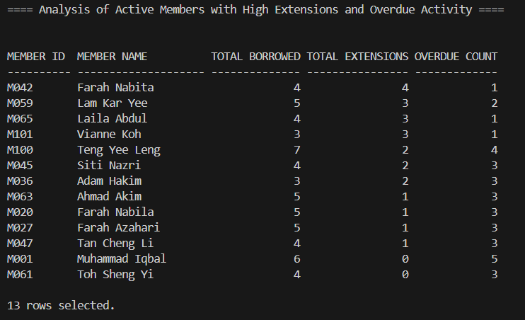

......

4.4.2 Query 2: Top N Member With Most Fine Payments
Purpose:
This query identifies the top n members who have paid the highest total fines using aggregated from a predefined view which is vxw_member_fine_payments. The user is prompted to enter the value N, which can be changed to the user's desired value. The query can be used by the library for trend identification, monitoring and controlling financial status and contributions through penalties, and making policy, financial, and member behavior decisions according to the information. It supported both operational and tactical decision-making.

Operational Usefulness:
- The library can monitor how much of the revenue which is penalties paid by members is generated. It can be used for budget forecasting and defending the imposition of late return fines.
- A large figure of fines indicates a member has been fined regularly for any offense such as damage, overdue, and lost books. This enables library staff to ascertain the type of patrons who must be warned and admonished regarding policies.
- Staff can be tasked to track the members who often incur fines in an effort to assist in the distribution of attention and resources effectively.

Tactical Usefulness:
- The query can be used for library management to identify whether prevailing fine policy is fair or efficient. For instance, indicate policy deficiencies or abuse where few members share an out-sized percentage of the penalty.
- The results of this query can be utilized to create reminders or educational content for frequently fined members, which will enhance the member experience and decrease the administrative workload.

SQL statement:
-- SETUP SQLPLUS ENVIRONMENT
SET linesize 120
SET pagesize 50
SET ECHO OFF
SET WRAP ON
SET TRIMSPOOL ON

ACCEPT n NUMBER PROMPT 'Enter the value of n to display the top n members with the most fine payments:'

-- FORMAT OUTPUT FOR SQLPLUS
COLUMN "MEMBER ID" FORMAT A10
COLUMN "MEMBER NAME" FORMAT A20
COLUMN "TOTAL FINES" FORMAT 9999
COLUMN "TOTAL PAYMENT" FORMAT 9999.99

-- HEADER
PROMPT
PROMPT ========== Top Members with Most Fine Payments ==========
PROMPT

SELECT * FROM (
SELECT
member_id AS "MEMBER ID",
member_name AS "MEMBER NAME",
total_fines AS "TOTAL FINES",
total_payment AS "TOTAL PAYMENT"
FROM
vw_member_fine_payments
ORDER BY
total_payment DESC
)
WHERE ROWNUM <= &n;

Sample Output:
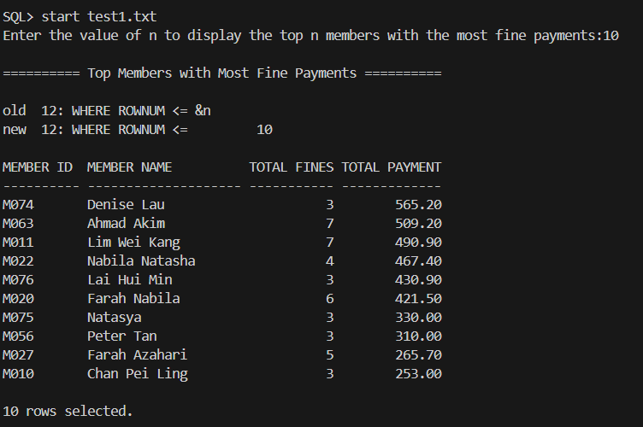

4.4.3 Stored Procedure 1: Add New Fine

Purpose:
By adding automatically, the program significantly lowers the amount of manual labor librarians must perform. The program ensures the accuracy and speed of the process by checking the borrowing status, calculating the additions, and posting the records. The program minimises duplication of logic in application code and reduces the risk of inconsistent or incorrect fines by encapsulating all rules and validations in a stored procedure.

Several validation criteria need to be satisfied prior to inserting the fine record. As an example, to qualify to be fined, the corresponding borrowed book record must exist and either the return status of the book in the BorrowedBooks table must be "Overdue" or "Lost." Checking for whether duplicate fines for the same borrow and type are prevented is included in the other validation. If the book is already marked as unavailable, returning it as a lost book may cost. Data anomalies can be avoided during validation, and precise data for reporting and audits can be maintained.

The procedure can handle multiple types of fines, including lost books and overdue returns, and is equipped with corresponding calculation logic, and has a user-definable fine calculation algorithm. Because the entire logical structure has been mechanized, the system can easily accept multiple fine policies to meet future usage needs. The sequence fines_seq have apply in this procedure to generate the new fine ID.

SQL statement:
SET DEFINE OFF

CREATE OR REPLACE PROCEDURE AddFine (
p_borrowId IN BorrowedBooks.borrowId%TYPE,
p_memberId IN Members.memberId%TYPE,
p_copyId IN BookCopies.copyId%TYPE,
p_fineType IN Fines.fineType%TYPE
)
IS
v_fineAmount NUMBER(8,2);
v_bookPrice BookTitles.price%TYPE;
v_fineIdNum NUMBER;
v_fineId VARCHAR2(4);
v_returnStatus BorrowedBooks.returnStatus%TYPE;
v_bookStatus BookCopies.bookStatus%TYPE;
v_fineExists NUMBER := 0;
BEGIN
-- Validate borrow record
BEGIN
SELECT returnStatus INTO v_returnStatus
FROM BorrowedBooks
WHERE borrowId = p_borrowId AND memberId = p_memberId;

IF v_returnStatus NOT IN ('Overdue', 'Lost') THEN
RAISE_APPLICATION_ERROR(-20010, 'Error: Cannot apply fine. Invalid return status.');
END IF;
EXCEPTION
WHEN NO_DATA_FOUND THEN
RAISE_APPLICATION_ERROR(-20011, 'Error: Borrow record not found for this member.');
END;

-- Prevent duplicate fine
SELECT COUNT(*) INTO v_fineExists
FROM Fines
WHERE borrowId = p_borrowId AND fineType = p_fineType;

IF v_fineExists > 0 THEN
RAISE_APPLICATION_ERROR(-20012, 'Error: A fine of this type already exists for this borrow record.');
END IF;

-- Fine logic based on type
IF p_fineType = 'Lost Book' THEN
-- Get book price & status
BEGIN
SELECT bt.price, bc.bookStatus INTO v_bookPrice, v_bookStatus
FROM BookTitles bt
JOIN BookCopies bc ON bt.bookId = bc.bookId
WHERE bc.copyId = p_copyId;

IF v_bookStatus = 'unavailable' THEN
RAISE_APPLICATION_ERROR(-20013, 'Error: Book is already marked as lost/unavailable.');
END IF;
EXCEPTION
WHEN NO_DATA_FOUND THEN
RAISE_APPLICATION_ERROR(-20014, 'Error: Book copy not found.');
END;

v_fineAmount := v_bookPrice + 20;

-- Mark book as unavailable
UPDATE BookCopies
SET bookStatus = 'unavailable'
WHERE copyId = p_copyId;

ELSIF p_fineType = 'Late Return' THEN
-- Flat rate fine for late return
v_fineAmount := 30;

ELSE
RAISE_APPLICATION_ERROR(-20016, 'Error: Invalid fine type.');
END IF;

-- Generate Fine ID using sequence and convert to VARCHAR2(4)
SELECT fines_seq.NEXTVAL INTO v_fineIdNum FROM DUAL;
v_fineId := 'F' || TO_CHAR(v_fineIdNum);

-- Insert fine record
INSERT INTO Fines (fineId, borrowId, fineType, fineAmount, fineDate, fineStatus)
VALUES (v_fineId, p_borrowId, p_fineType, v_fineAmount, SYSDATE, 'Unpaid');

DBMS_OUTPUT.PUT_LINE(p_fineType || ' fine added successfully.');
DBMS_OUTPUT.PUT_LINE('Fine ID: ' || v_fineId || ' | Amount: RM' || v_fineAmount);

EXCEPTION
WHEN OTHERS THEN
DBMS_OUTPUT.PUT_LINE('Unexpected error: ' || SQLERRM);
END;
/

SET SERVEROUTPUT ON;

-- Accept information from user
ACCEPT borrow_id CHAR PROMPT 'Enter Borrow ID: '
ACCEPT member_id CHAR PROMPT 'Enter Member ID: '
ACCEPT copy_id CHAR PROMPT 'Enter Copy ID: '
ACCEPT fine_type CHAR PROMPT 'Enter Fine Type (Lost Book / Late Return): '

-- Running the procedure with the inputs
BEGIN
AddFine(
p_borrowId => '&borrow_id',
p_memberId => '&member_id',
p_copyId => '&copy_id',
p_fineType => '&fine_type'
);
END;
/

4.4.4 Stored Procedure 2: Get All Fine By Member
Purpose:
This procedure is designed to retrieve, validate and display all fine records of a specific member within the library system. It presents an overview of the consumption record of the member, with consumption amount, status, type, payment date, and total paid amount provided. This supports staff in appropriately measuring usage, increases transparency, and meets the data retrieval demands of the system.

The program prompts users from the input and then checks if the member ID the user has entered is present in the member table before fetching data in an attempt to avoid processing non-existent records or querying irrelevant data. In case the relevant member is not found, the system will indicate an error. This checking mechanism provides security for member data and the library system.

All the fines associated with the given member ID are retrieved by the procedure using an implicit cursor FOR loop. This enables the system to retrieve the fine ID, number, status, type, payment date, and total amount paid. This action also has an error handling method that detects any unforeseen errors and prints the error message and the error details.

SQL statement:
CREATE OR REPLACE PROCEDURE GetAllFinesByMember (
p_memberId IN Members.memberId%TYPE
)
IS
v_memberExists INT := 0;
v_fineFound BOOLEAN := FALSE;
BEGIN
-- Check if member exists
BEGIN
SELECT COUNT(*) INTO v_memberExists
FROM Members
WHERE memberId = p_memberId;

IF v_memberExists = 0 THEN
RAISE_APPLICATION_ERROR(-20001, 'Error: Member does not exist in the system.');
END IF;
EXCEPTION
WHEN NO_DATA_FOUND THEN
RAISE_APPLICATION_ERROR(-20002, 'Error: Member not found.');
WHEN OTHERS THEN
RAISE_APPLICATION_ERROR(-20099, 'Unexpected error during member validation: ' || SQLERRM);
END;

-- Loop through fine records
FOR fine_rec IN (
SELECT
f.fineId,
f.fineAmount,
f.fineStatus,
f.fineType,
NVL(TO_CHAR(p.paymentDate, 'YYYY-MM-DD'), 'Not Paid') AS paymentDate,
NVL(p.payAmount, 0.00) AS paidAmount
FROM Fines f
JOIN BorrowedBooks bb ON f.borrowId = bb.borrowId
JOIN Members m ON bb.memberId = m.memberId
LEFT JOIN Payments p ON f.paymentId = p.paymentId
WHERE m.memberId = p_memberId
ORDER BY f.fineDate DESC
) LOOP
IF NOT v_fineFound THEN
v_fineFound := TRUE;
DBMS_OUTPUT.PUT_LINE(RPAD('-', 92, '-'));
DBMS_OUTPUT.PUT_LINE(
RPAD('Fine ID', 10) || RPAD('Amount(RM)', 15) || RPAD('Status', 12) ||
RPAD('Type', 15) || RPAD('Payment Date', 20) || RPAD('Paid Amount(RM)', 20)
);
DBMS_OUTPUT.PUT_LINE(RPAD('-', 92, '-'));
END IF;

DBMS_OUTPUT.PUT_LINE(
RPAD(fine_rec.fineId, 10) ||
RPAD(TO_CHAR(fine_rec.fineAmount, '9990.99'), 15) ||
RPAD(fine_rec.fineStatus, 12) ||
RPAD(fine_rec.fineType, 15) ||
RPAD(fine_rec.paymentDate, 20) ||
RPAD(TO_CHAR(fine_rec.paidAmount, '9999.99'), 20)
);
END LOOP;

IF NOT v_fineFound THEN
DBMS_OUTPUT.PUT_LINE('No fines records found for the specified member.');
ELSE
DBMS_OUTPUT.PUT_LINE(RPAD('-', 92, '-'));
END IF;

EXCEPTION
WHEN OTHERS THEN
DBMS_OUTPUT.PUT_LINE('Unexpected error: ' || SQLERRM);
END;
/

SET SERVEROUTPUT ON;

-- Accept information from user
ACCEPT member_id CHAR PROMPT 'Enter Member ID: '

-- Running the procedure with the inputs
BEGIN
GetAllFinesByMember(
p_memberId => '&member_id'
);
END;
/

Sample Output:

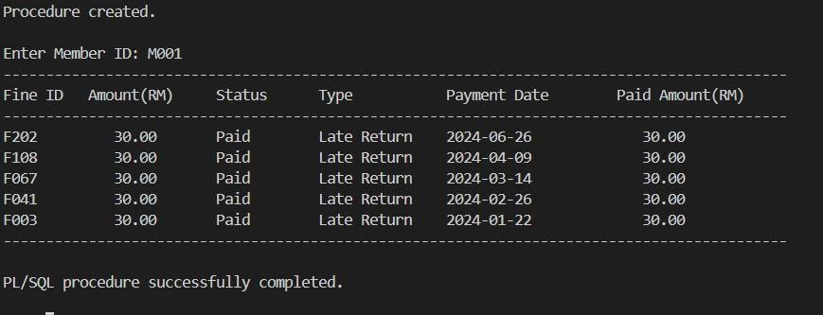

4.4.5 Trigger 1: Update Fine Amount
Purpose:
This trigger is used to pre-calculate and place a fine amount in the Fines table automatically before adding a new fine or updating an existing fine, only when the fineAmount is not input manually. By automatically determining the correct fine amount based on the fine type, this trigger avoids human error, enforces consistent business logic, and preserves data integrity across the system. This trigger guarantees that the fineAmount is calculated consistently based on the fineType and the price of the book concerned. It employs the following business rules:
- If the fine type is 'Lost Book,' the penalty is equal to the book's price plus 20.
- If the fine type is 'Damage', the fine is equal to the book's price.
- If the fine type is 'Late Return', a fine of 30 is applied.

Trigger code:
CREATE OR REPLACE TRIGGER TRG_CALCULATE_FINE_AMOUNT
BEFORE INSERT OR UPDATE ON Fines
FOR EACH ROW
WHEN (NEW.fineAmount IS NULL)
DECLARE
v_price BookTitles.price%TYPE;
BEGIN
IF :NEW.fineType IN ('Lost Book', 'Damage') THEN
SELECT BT.price
INTO v_price
FROM BookTitles BT
JOIN BookCopies BC ON BC.bookId = BT.bookId
JOIN BorrowedBooks BB ON BB.copyId = BC.copyId
WHERE BB.borrowId = :NEW.borrowId;

IF :NEW.fineType = 'Lost Book' THEN
:NEW.fineAmount := v_price + 20;
ELSIF :NEW.fineType = 'Damage' THEN
:NEW.fineAmount := v_price;
END IF;

ELSIF :NEW.fineType = 'Late Return' THEN
:NEW.fineAmount := 30;
END IF;
END;
/

4.4.6 Trigger 2: Update Payment Amount

Purpose:
This trigger is used to pre-calculate and place a payment amount in the Payments table automatically before adding a new payment or updating an existing payment, only when the payAmount is not input manually. By automatically determining the correct payment amount based on the payment type, this trigger avoids human error, enforces consistent business logic, and preserves data integrity across the system. This trigger guarantees that the payAmount is calculated consistently based on the paymentType, according to the following business rules:
- If the paymentType is 'Fines', the trigger calculates the total fine amount linked to the given paymentId by summing the fineAmount values from the Fines table. This total is then assigned to the payAmount.
- If the paymentType is 'Membership Registration', a payment amount of 50 is assigned.

Trigger code:
CREATE OR REPLACE TRIGGER TRG_CALCULATE_PAYMENT_AMOUNT
BEFORE INSERT OR UPDATE ON Payments
FOR EACH ROW
WHEN (NEW.payAmount IS NULL)
DECLARE
v_total NUMBER;
BEGIN
IF :NEW.paymentType = 'Fines' THEN
SELECT SUM(fineAmount)
INTO v_total
FROM Fines
WHERE paymentId = :NEW.paymentId;

:NEW.payAmount := NVL(v_total, 0);

ELSIF :NEW.paymentType = 'Membership Registration' THEN
:NEW.payAmount := 50;
END IF;
END;
/

4.4.7 Trigger 3: Manage Fines
Purpose:
This trigger is supposed to validate fine records before inserting or updating them in the Fines table. Its main purpose is to maintain data accuracy, consistency, and integrity by enforcing some business rules. By enforcing these rules, the trigger guarantees clean data in the Fines table and prevents invalid inputs that can lead to system crashes or erroneous reporting. This trigger performs the following validations:
- Fine type validation ensures that the fineType is one of the following valid values such as ‘Late Return’, ‘Lost Book’ and ‘Damage’. If an invalid type is provided, an exception is raised to prevent the operation.
- Fine status validation ensures that the fineStatus is either ‘Unpaid’ or ‘Paid’. Any other value will throw an error.
- Fine amount validation ensures that the fineAmount is a positive number. If the amount is zero or negative, the operation is blocked.

Trigger code:
CREATE OR REPLACE TRIGGER TRG_MANAGE_FINES
BEFORE INSERT OR UPDATE ON Fines
FOR EACH ROW
BEGIN
-- Validate fineType
IF :NEW.fineType NOT IN ('Late Return', 'Lost Book', 'Damage') THEN
RAISE_APPLICATION_ERROR(-20010, 'Invalid fine type. Allowed: Late Return, Lost Book, Damage.');
END IF;

-- Validate fineStatus
IF :NEW.fineStatus NOT IN ('Unpaid', 'Paid') THEN
RAISE_APPLICATION_ERROR(-20011, 'Invalid fine status. Allowed: Unpaid, Paid.');
END IF;

-- Validate fineAmount (ensure non-negative value)
IF :NEW.fineAmount <= 0 THEN
RAISE_APPLICATION_ERROR(-20012, 'Fine amount cannot be negative.');
END IF;
END;
/

4.4.8 Trigger 4: Manage Payments
Purpose:
This trigger is used to validate payment records and automatically update the status of related fines upon a new record insertion or an updated record in the Payments table. There are two functions served by this trigger:
- Data validation ensures that only valid data is stored in the Payments table by enforcing the following rules:
- Ensures the paymentMethod is valid such as ‘Cash’, ‘Duitnow’, ‘Tng’. If any other value is provided, the trigger raises an error to prevent the operation.
- Checks the paymentType is among the valid options such as 'Fines' and 'Membership Registration'. Any other value, and the trigger raises an error to prevent the operation.
- Ensures that payAmount is greater than 0. If the amount is zero or negative, the trigger raises an error to stop the operation.
- If the payment is made for a fine where paymentType = 'Fines' in Payments table and a proper payAmount is provided, the trigger will update the fineStatus of all related records in the Fines table based on paymentId to 'Paid'. Automatic fine system updating ensures that once a fine is paid, the status is updated immediately without manually doing it.

Trigger code:
CREATE OR REPLACE TRIGGER TRG_MANAGE_PAYMENTS
AFTER INSERT OR UPDATE ON Payments
FOR EACH ROW
BEGIN
-- Validate paymentMethod
IF :NEW.paymentMethod NOT IN ('Tng', 'Cash', 'Duitnow') THEN
RAISE_APPLICATION_ERROR(-20013, 'Invalid payment method. Allowed: Tng, Cash, Duitnow.');
END IF;

-- Validate paymentType
IF :NEW.paymentType NOT IN ('Fines', 'Membership Registration') THEN
RAISE_APPLICATION_ERROR(-20014, 'Invalid payment type. Allowed: Fines, Membership Registration.');
END IF;

-- Validate payAmount (ensure non-negative value)
IF :NEW.payAmount <= 0 THEN
RAISE_APPLICATION_ERROR(-20015, 'Payment amount cannot be negative.');
END IF;

-- Update fineStatus if payment is for a fine and has amount
IF :NEW.paymentType = 'Fines' AND :NEW.payAmount IS NOT NULL THEN
UPDATE Fines
SET fineStatus = 'Paid'
WHERE paymentId = :NEW.paymentId;
END IF;
END;
/

4.4.9 Report 1: Fine Payment Trends Report (Jan to Jun 2024)
Purpose:
The purpose of this report is geared towards creating an in-depth summary report on payments related to fines incurred through varied payment schemes across a period (January through June 2024). It has nested cursors to provide payment trends and distributions by monthly or yearly terms for each type of method. It has a several purposes of the report:
- Fine payment trends analysis by monitoring payment via various payment modes, which are 'Cash', 'Duitnow' and 'Tng' and will be able to see the number and value of payments over a period of time.
- Provide detailed time-wise analysis in two ways which include monthly breakdown and yearly breakdown. Monthly Breakdown shows monthly sum payments, no. of transactions, and aggregate fines paid. Yearly Summary provides payment patterns for the year as a whole. In this case just for the first half of 2024.
- Use of inner cursors nested within outer cursors. Outer cursors iterate over each individual payment method. Inner cursors retrieve monthly patterns and yearly patterns for the respective method.
- Calls an external function get_paid_amount to calculate total fine payments for the selected method during the date range. This modular approach supports code reuse and better organization.

Report code:
CREATE OR REPLACE PROCEDURE rpt_fine_payment_trends_method
IS
-- Cursor for distinct payment methods
CURSOR c_payment_methods IS
SELECT DISTINCT paymentMethod FROM Payments ORDER BY paymentMethod;

-- Cursor for monthly payment trends per method
CURSOR c_monthly_trends(v_method VARCHAR2) IS
SELECT
TO_CHAR(paymentDate, 'YYYY-MM') AS payment_month,
SUM(payAmount) AS total_payments,
SUM(CASE WHEN paymentType = 'Fines' THEN payAmount ELSE 0 END) AS paid_amount,
COUNT(*) AS payment_count
FROM Payments
WHERE paymentMethod = v_method
AND paymentDate BETWEEN TO_DATE('01-01-2024', 'DD-MM-YYYY')
AND TO_DATE('30-06-2024', 'DD-MM-YYYY')
GROUP BY TO_CHAR(paymentDate, 'YYYY-MM')
ORDER BY payment_month;

-- Cursor for yearly payment trends per method
CURSOR c_yearly_trends(v_method VARCHAR2) IS
SELECT
TO_CHAR(paymentDate, 'YYYY') AS payment_year,
SUM(payAmount) AS total_payments,
SUM(CASE WHEN paymentType = 'Fines' THEN payAmount ELSE 0 END) AS paid_amount,
COUNT(*) AS payment_count
FROM Payments
WHERE paymentMethod = v_method
AND paymentDate BETWEEN TO_DATE('01-01-2024', 'DD-MM-YYYY')
AND TO_DATE('30-06-2024', 'DD-MM-YYYY')
GROUP BY TO_CHAR(paymentDate, 'YYYY')
ORDER BY payment_year;

-- Variable to hold total from function
v_total_fines NUMBER;
BEGIN
-- Report Header
DBMS_OUTPUT.PUT_LINE(RPAD('=', 10, '=') || ' Fine Payment Trends Report (Jan to Jun 2024) ' || RPAD('=', 10, '='));

-- Outer loop for each payment method
FOR method_rec IN c_payment_methods LOOP
DBMS_OUTPUT.PUT_LINE(CHR(10) || 'Payment Method: ' || method_rec.paymentMethod);

-- Call the function and show total fines paid
v_total_fines := get_paid_amount(method_rec.paymentMethod,
TO_DATE('01-01-2024', 'DD-MM-YYYY'),
TO_DATE('30-06-2024', 'DD-MM-YYYY'));
DBMS_OUTPUT.PUT_LINE('>> Total Fines Paid (Using Function): RM ' || TO_CHAR(v_total_fines, '9999.99'));

DBMS_OUTPUT.PUT_LINE(RPAD('-', 66, '-'));
DBMS_OUTPUT.PUT_LINE('| Month | Total Payments (RM) | Payment Count | Paid (RM) |');
DBMS_OUTPUT.PUT_LINE(RPAD('-', 66, '-'));

-- Monthly trends loop
FOR month_rec IN c_monthly_trends(method_rec.paymentMethod) LOOP
DBMS_OUTPUT.PUT_LINE(
RPAD('| ' || month_rec.payment_month, 10) ||
RPAD('| RM ' || TO_CHAR(month_rec.total_payments, '9999.99'), 24) ||
RPAD('| ' || TO_CHAR(month_rec.payment_count, '9999'), 16) ||
RPAD('| RM ' || TO_CHAR(month_rec.paid_amount, '9999.99'), 14) || ' |'
);
END LOOP;
DBMS_OUTPUT.PUT_LINE(RPAD('-', 66, '-'));

-- Yearly section
DBMS_OUTPUT.PUT_LINE(RPAD('-', 66, '-'));
DBMS_OUTPUT.PUT_LINE('| Year | Total Payments (RM) | Payment Count | Paid (RM) |');
DBMS_OUTPUT.PUT_LINE(RPAD('-', 66, '-'));

FOR year_rec IN c_yearly_trends(method_rec.paymentMethod) LOOP
DBMS_OUTPUT.PUT_LINE(
RPAD('| ' || year_rec.payment_year, 10) ||
RPAD('| RM ' || TO_CHAR(year_rec.total_payments, '9999.99'), 24) ||
RPAD('| ' || TO_CHAR(year_rec.payment_count, '9999'), 16) ||
RPAD('| RM ' || TO_CHAR(year_rec.paid_amount, '9999.99'), 14) || ' |'
);
END LOOP;
DBMS_OUTPUT.PUT_LINE(RPAD('-', 66, '-'));
END LOOP;
END;
/

SET SERVEROUTPUT ON;

BEGIN
rpt_fine_payment_trends_method;
END;
/

Sample Output:

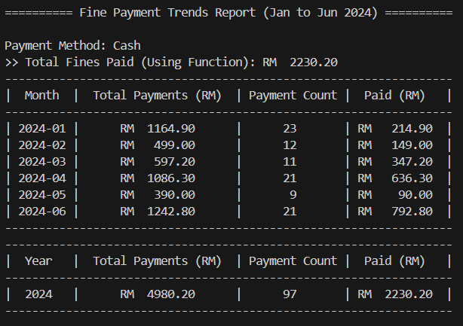

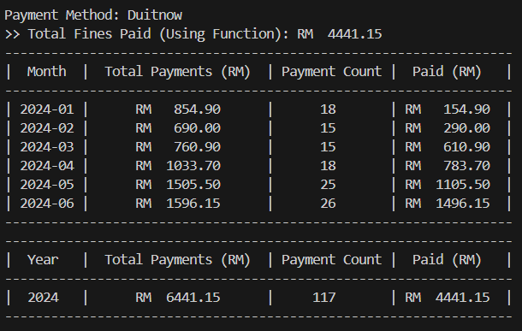

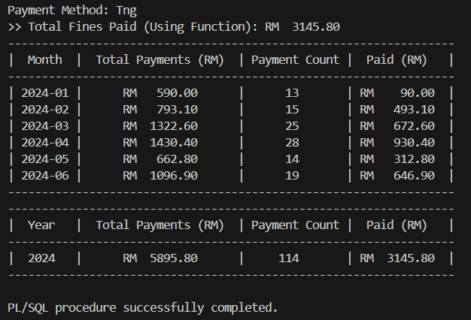

4.4.10 Report 2: Unpaid Fine Analytics
Purpose:
This report is designed to generate a comprehensive analytical report focusing on unpaid fines in a library management system. It gives summary and detailed data per member who has at least one unpaid fine. It includes the following objectives of this report:
- Aims to get all members of the library who have at least one fine with status 'Unpaid'.
- It summarizes fine statistics by member by summing the count of unpaid fines, the sum of the fines, and finding the oldest and latest dates of unpaid fines.
- It conducts a review of the fine payment history of all members by retrieving the number of fines they have already paid and checking the last payment date.
- The report determines the number of days since the last payment by the member to ascertain their payment behavior and activity level.
- For every member with unpaid fines, the report provides detailed information on each fine, including the fine ID, book title, fine type, the fine amount, and how many days the item has been overdue.
- The report is intended to support library staff and administrators in tracking outstanding balances, monitoring member behavior, and planning necessary follow-up actions such as reminders, restrictions, or escalation procedures.
- The report uses nested cursors to retrieve and process data per member and their corresponding fines, ensuring efficient handling of grouped fine records and enabling detailed sub-reporting within each member's section.
- The report utilizes a function get_paid_fines_count to modularly retrieve the total number of fines already paid by each member. This promotes code reusability and maintains clean separation of business logic.
Report code:
CREATE OR REPLACE PROCEDURE rpt_unpaid_fine_analytics
IS
-- Cursor for members with at least one unpaid fine
CURSOR c_members IS
SELECT DISTINCT m.memberId, m.memberName, m.memberTel, m.memberEmail
FROM Members m
JOIN BorrowedBooks b ON m.memberId = b.memberId
JOIN Fines f ON f.borrowId = b.borrowId
WHERE f.fineStatus = 'Unpaid';

-- Nested cursor: Unpaid fine details per member
CURSOR c_fine_details(p_memberId VARCHAR2) IS
SELECT f.fineId,
f.fineType,
f.fineAmount,
f.fineDate,
f.fineStatus,
b.dueDate,
NVL(TO_CHAR(TRUNC(SYSDATE - b.dueDate)), '0') AS daysOverdue,
bt.title
FROM Fines f
JOIN BorrowedBooks b ON f.borrowId = b.borrowId
JOIN BookCopies bc ON b.copyId = bc.copyId
JOIN BookTitles bt ON bc.bookId = bt.bookId
WHERE b.memberId = p_memberId AND f.fineStatus = 'Unpaid';

-- Cursor to check last payment info
CURSOR c_last_payment(p_memberId VARCHAR2) IS
SELECT MAX(paymentDate) AS lastPaymentDate
FROM Payments
WHERE memberId = p_memberId;

v_totalUnpaid NUMBER := 0;
v_countUnpaid NUMBER := 0;
v_earliestFine DATE;
v_latestFine DATE;
v_paidFinesCount NUMBER := 0;
v_lastPaymentDate DATE;
v_gapFromLastPayment NUMBER;

BEGIN
DBMS_OUTPUT.PUT_LINE(RPAD('=', 33, '=') || ' UNPAID FINE OVERVIEW ' || RPAD('=', 33, '='));
DBMS_OUTPUT.PUT_LINE(CHR(5));

FOR r_mem IN c_members LOOP
-- Reset per member
v_totalUnpaid := 0;
v_countUnpaid := 0;
v_earliestFine := NULL;
v_latestFine := NULL;
v_paidFinesCount := 0;
v_lastPaymentDate := NULL;
v_gapFromLastPayment := NULL;

-- Last payment information
OPEN c_last_payment(r_mem.memberId);
FETCH c_last_payment INTO v_lastPaymentDate;
CLOSE c_last_payment;

-- Use function to get paid fine count
v_paidFinesCount := get_paid_fines_count(r_mem.memberId);

-- Summary calculations for unpaid fines
SELECT COUNT(*), SUM(f.fineAmount),
MIN(f.fineDate), MAX(f.fineDate)
INTO v_countUnpaid, v_totalUnpaid, v_earliestFine, v_latestFine
FROM BorrowedBooks bb
JOIN Fines f ON bb.borrowId = f.borrowId
WHERE bb.memberId = r_mem.memberId
AND f.fineStatus = 'Unpaid';

IF v_lastPaymentDate IS NOT NULL THEN
v_gapFromLastPayment := TRUNC(SYSDATE - v_lastPaymentDate);
END IF;

-- Output Member Header
DBMS_OUTPUT.PUT_LINE(RPAD('=', 88, '='));
DBMS_OUTPUT.PUT_LINE('MEMBER ID : ' || r_mem.memberId);
DBMS_OUTPUT.PUT_LINE('NAME : ' || r_mem.memberName);
DBMS_OUTPUT.PUT_LINE('EMAIL : ' || r_mem.memberEmail);
DBMS_OUTPUT.PUT_LINE('PHONE : ' || r_mem.memberTel);
DBMS_OUTPUT.PUT_LINE('UNPAID COUNT : ' || v_countUnpaid);
DBMS_OUTPUT.PUT_LINE('PAID FINES : ' || v_paidFinesCount);
DBMS_OUTPUT.PUT_LINE('TOTAL UNPAID : RM ' || TO_CHAR(v_totalUnpaid, '9999.00'));
DBMS_OUTPUT.PUT_LINE('EARLIEST FINE : ' || TO_CHAR(v_earliestFine, 'DD-MON-YYYY'));
DBMS_OUTPUT.PUT_LINE('LATEST FINE : ' || TO_CHAR(v_latestFine, 'DD-MON-YYYY'));
DBMS_OUTPUT.PUT_LINE('LAST PAYMENT : ' || NVL(TO_CHAR(v_lastPaymentDate, 'DD-MON-YYYY'), 'N/A'));
DBMS_OUTPUT.PUT_LINE('GAP SINCE LAST PAYMENT: ' || NVL(v_gapFromLastPayment, 0) || ' DAY(S)');
DBMS_OUTPUT.PUT_LINE(RPAD('-', 88, '-'));
DBMS_OUTPUT.PUT_LINE('FineID | Book Title | Type | Amount | Overdue Days');
DBMS_OUTPUT.PUT_LINE(RPAD('-', 88, '-'));

-- Print unpaid fine
FOR r_fine IN c_fine_details(r_mem.memberId) LOOP
DBMS_OUTPUT.PUT_LINE(
LPAD(r_fine.fineId, 6) || ' | ' ||
RPAD(SUBSTR(r_fine.title, 1, 40), 40) || ' | ' ||
RPAD(r_fine.fineType, 10) || ' | ' ||
LPAD(TO_CHAR(r_fine.fineAmount, '9990.00'), 8) || ' | ' ||
LPAD(r_fine.daysOverdue, 5)
);
END LOOP;

DBMS_OUTPUT.PUT_LINE(RPAD('=', 88, '='));
DBMS_OUTPUT.PUT_LINE(CHR(10));
END LOOP;
END;
/

SET SERVEROUTPUT ON;

BEGIN
rpt_unpaid_fine_analytics;
END;
/

Sample Output:

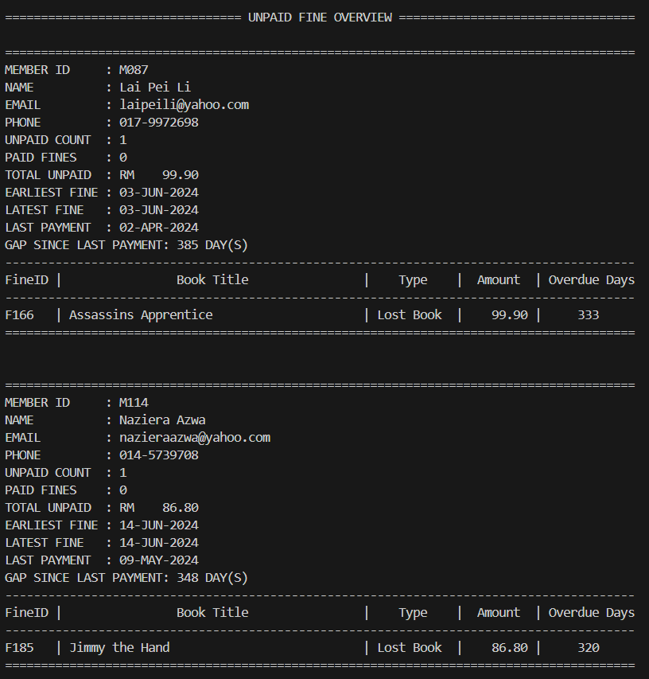

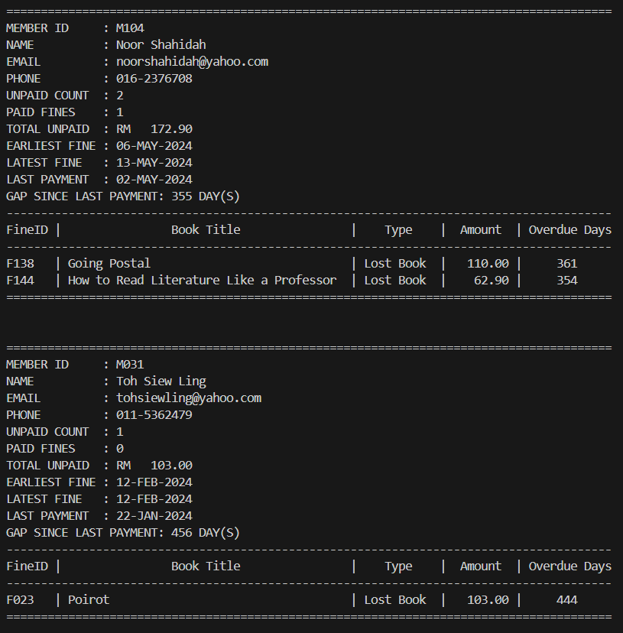

4.5 Wong Jin Xuan

4.5.1 Query 1: Most Borrowed Books (Popular Books Ranking)

Purpose: Top N Popular Books for Informed Library Management
This query identifies and ranks the most popular books in the library based on the number of times they have been borrowed. It is designed to assist strategic-level management by providing high-level insights into borrowing trends and user preferences across the entire collection.
By understanding which books are in high demand, library administrators can make informed decisions related to collection development, such as which titles to restock, promote, or acquire in larger quantities. The query is also useful for long-term planning and investment strategies, ensuring that the library continues to meet user demand and maintain engagement.
The dynamic Top N feature enhances usability, allowing decision-makers to tailor the output according to specific reporting or presentation needs. This flexibility is particularly valuable in strategic meetings or annual performance reviews where concise, data-driven evidence is essential.
Strategic Management Level Focus:
Supports long-term decision-making about acquisitions, budgeting, and overall resource allocation based on historical borrowing data.

SQL statement:
-- SETUP SQLPLUS ENVIRONMENT
SET LINESIZE 200
SET PAGESIZE 50
SET WRAP OFF
SET TRIMSPOOL ON

-- ASK USER TO ENTER VALUE FOR TOP N
ACCEPT n NUMBER PROMPT 'Enter the number of top popular books to display: '

-- FORMAT OUTPUT FOR SQLPLUS
COLUMN "RANK" FORMAT 99
COLUMN "TITLE" FORMAT A45
COLUMN "AUTHOR" FORMAT A25
COLUMN "GENRE" FORMAT A15
COLUMN "YEAR" FORMAT 9999
COLUMN "TIMES BORROWED" FORMAT 9999
COLUMN "PRICE ($)" FORMAT 99990.00
COLUMN "POPULARITY RATING" FORMAT 9.0

-- HEADER
PROMPT
PROMPT ========================================= TOP BORROWED BOOKS REPORT =========================================
PROMPT

-- QUERY
WITH RankedBooks AS (
SELECT
RANK() OVER (ORDER BY bbv.total_borrows DESC) AS "RANK",
bt.title AS "TITLE",
bt.author AS "AUTHOR",
bt.genre AS "GENRE",
bt.publicationYear AS "YEAR",
bbv.total_borrows AS "TIMES BORROWED",
bt.price AS "PRICE ($)",
bt.popularity AS "POPULARITY RATING"
FROM
BookBorrow_View bbv
JOIN
BookTitles bt ON bbv.bookId = bt.bookId
JOIN
BookCopies bc ON bt.bookId = bc.bookId
JOIN
BorrowedBooks bb ON bc.copyId = bb.copyId
GROUP BY
bt.title, bt.author, bt.genre, bt.publicationYear, bt.price, bbv.total_borrows, bt.popularity
)
SELECT * FROM RankedBooks
WHERE RANK <= &n
ORDER BY "RANK";

Sample Output:

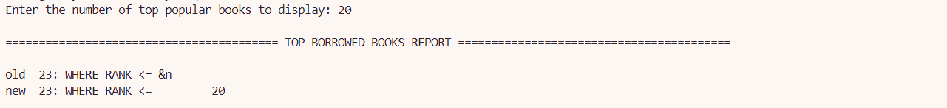
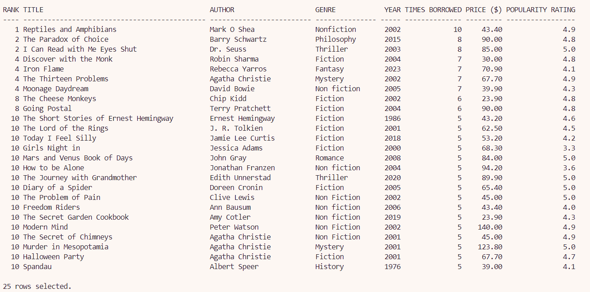

4.5.2 Query 2: Staff Performance and Efficiency Analysis

Purpose: Operational Performance of Library Staff
The purpose of this query is to evaluate and rank staff members based on their overall performance and efficiency within the library system. designed to support operational-level management by evaluating and ranking library staff based on two critical metrics: Performance Score and Efficiency Score.
Performance Score: Reflects staff attendance and productivity during scheduled shifts. It incorporates attendance behavior (e.g., Present, Late, Absent) and total hours worked to assess shift engagement.
Efficiency Score: Measures how effectively librarians and assistants process loans by calculating the number of loans handled per hour worked.
This analysis enables library supervisors and team leads to monitor daily performance, ensure shift coverage, detect attendance issues early, and take corrective action as needed. It also highlights high-performing individuals for potential rewards or leadership roles and flags areas requiring training or support.
Moreover, the use of custom functions (CalculateTotalHoursWorked, CalculateLoanProcessed) and multiple table joins ensures that data from attendance logs, shift schedules, and loan records are integrated to provide a holistic view of staff contributions.
Operational Management Level Focus:
Assists in day-to-day monitoring of staff activity, productivity optimization, and workforce planning to ensure smooth and efficient library operations.

SQL statement:
-- SQL*Plus: Set up display
SET SERVEROUTPUT ON
SET LINESIZE 150
SET PAGESIZE 50
SET WRAP ON
SET TRIMSPOOL ON
SET DEFINE OFF

-- Column formatting
COLUMN "STAFF ID" FORMAT A10
COLUMN "STAFF NAME" FORMAT A20
COLUMN "STAFF ROLE" FORMAT A10
COLUMN "TOTAL SHIFTS WORKED" FORMAT 9999
COLUMN "TOTAL HOURS WORKED" FORMAT 9999
COLUMN "LOAN PROCESSED" FORMAT 9999
COLUMN "EFFICIENCY SCORE" FORMAT 0.99
COLUMN "PERFORMANCE SCORE" FORMAT 9999.99

PROMPT ====================================================================================================================================
PROMPT
PROMPT EFFICIENCY SCORE: This score shows the staff efficiency in processing loans. It is calculated by dividing:
PROMPT - The number of loans processed by the total hours worked.
PROMPT EFFICIENCY SCORE = Loans Processed / Total Hours Worked (Librarians & Assistants only)
PROMPT
PROMPT PERFORMANCE SCORE: This score represents attendance and performance during shifts. It is calculated based on:
PROMPT - The total hours worked divided by the number of shifts.
PROMPT - The attendance score (Present 1.0, Late 0.5, Absent 0) is used to adjust the performance for each shift worked.
PROMPT PERFORMANCE SCORE = (Hours Worked / Shifts) * Attendance Factor
PROMPT
PROMPT ====================================================================================================================================
PROMPT ================================================ STAFF PERFORMANCE QUERY =====================================================
PROMPT ====================================================================================================================================

SELECT
sbv.staffId AS "STAFF ID",
sbv.staffName AS "STAFF NAME",
s.role AS "STAFF ROLE",
sbv.shiftsWorked AS "TOTAL SHIFTS WORKED",
CalculateTotalHoursWorked(sbv.staffId) AS "TOTAL HOURS WORKED",
ROUND(
(
CalculateTotalHoursWorked(sbv.staffId) / sbv.shiftsWorked
) *
(
SUM(
CASE
WHEN sa.attendanceStatus = 'Present' THEN 1
WHEN sa.attendanceStatus = 'Late' THEN 0.5
WHEN sa.attendanceStatus = 'Absent' THEN 0
ELSE 0
END
) / sbv.shiftsWorked
),
2
) AS "PERFORMANCE SCORE",
CASE
WHEN s.role IN ('librarian', 'assistant') THEN
CalculateLoanProcessed(sbv.staffId)
ELSE NULL
END AS "LOAN PROCESSED",
CASE
WHEN s.role IN ('librarian', 'assistant') THEN
ROUND(
(
CalculateLoanProcessed(sbv.staffId)
) /
CASE WHEN CalculateTotalHoursWorked(sbv.staffId) > 0 THEN CalculateTotalHoursWorked(sbv.staffId) ELSE 1 END,
2
)
ELSE NULL
END AS "EFFICIENCY SCORE"
FROM
staff_basic_view sbv
JOIN
ShiftSchedules ss ON ss.staffId = sbv.staffId
LEFT JOIN
StaffAttendance sa ON sa.scheduleId = ss.scheduleId
LEFT JOIN
Shift sh ON sh.shiftId = ss.shiftId
JOIN
Staff s ON s.staffId = sbv.staffId
GROUP BY
sbv.staffId, sbv.staffName, s.role, sbv.shiftsWorked
ORDER BY
CASE
WHEN s.role IN ('librarian', 'assistant') THEN 1
ELSE 2
END,
"STAFF ROLE",
"PERFORMANCE SCORE" DESC;

Sample Output:

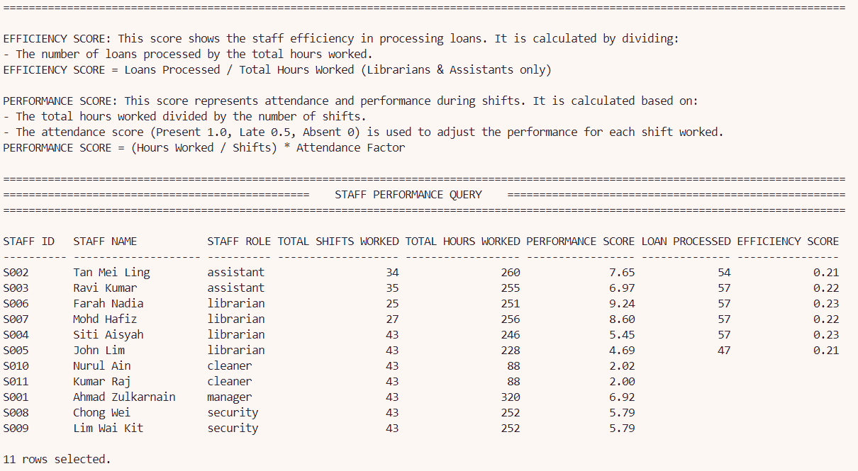

4.5.3 Stored Procedure 1: Get Borrow History for a Member

Purpose:
The purpose of this stored procedure is to retrieve the complete borrow history of a library member based on a given memberId. It validates whether the member exists in the system and checks if any borrowing records are associated with the member. Upon successful validation, it displays a formatted list of borrowed books, including key details such as borrow and return dates, return status, audit action, and the staff member who handled the transaction. This information is essential for tracking member activity, identifying overdue returns, and auditing staff responsibilities.
Usefulness:
This stored procedure is very helpful in different parts of the library system:
- Librarians can use it to quickly check a member's borrowing records during questions or disputes.
- Admins can track how books were handled and who processed each transaction.
- Reports can be generated to show member borrowing history or track borrowing trends.
- Members could receive summaries of their borrow history or receipts.
It also helps staff notice patterns like frequent late returns or very active members.
Importance:
This procedure directly supports one of the core operations of the library system: managing and tracking book borrowings. Without such a feature, it would be difficult to:
- Maintain accountability over borrowed items.
- Monitor overdue books.
- Trace transaction history for dispute resolution.
- Evaluate staff handling of loans and returns.
It enhances data transparency, member accountability, and system reliability, making it a vital component of the system's overall functionality.

SQL statement:
CREATE OR REPLACE PROCEDURE GetBorrowHistoryByMember (
p_memberId IN VARCHAR2
)
IS
v_exists INTEGER;
BEGIN
-- Validate: Check if memberId exists
SELECT COUNT(*) INTO v_exists
FROM Members
WHERE memberId = p_memberId;

IF v_exists = 0 THEN
DBMS_OUTPUT.PUT_LINE('ERROR: Member ID "' || p_memberId || '" does not exist.');
RETURN;
END IF;

-- Validate: Check if member has borrow history
SELECT COUNT(*) INTO v_exists
FROM BorrowedBooks
WHERE memberId = p_memberId;

IF v_exists = 0 THEN
DBMS_OUTPUT.PUT_LINE('! INFO: Member "' || p_memberId || '" has no borrow history.');
RETURN;
END IF;

DBMS_OUTPUT.PUT_LINE('==================================================================================================================================');
DBMS_OUTPUT.PUT_LINE('| BORROW HISTORY FOR MEMBER |');
DBMS_OUTPUT.PUT_LINE('==================================================================================================================================');

DBMS_OUTPUT.PUT_LINE(RPAD('Borrow ID', 12) || RPAD('Title', 30) || RPAD('Borrow Date', 15) || RPAD('Due Date', 15) ||
RPAD('Return Date', 15) || RPAD('Return Status', 15) || RPAD('Audit Action', 15) || 'Handled By');
DBMS_OUTPUT.PUT_LINE('----------------------------------------------------------------------------------------------------------------------------------');

FOR rec IN (
SELECT
bb.borrowId,
bt.title,
TO_CHAR(bb.borrowDate, 'YYYY-MM-DD') AS borrowDate,
TO_CHAR(bb.dueDate, 'YYYY-MM-DD') AS dueDate,
TO_CHAR(bb.returnDate, 'YYYY-MM-DD') AS returnDate,
bb.returnStatus,
ba.actionType,
s.staffName AS handledBy
FROM BorrowedBooks bb
JOIN BookCopies bc ON bb.copyId = bc.copyId
JOIN BookTitles bt ON bc.bookId = bt.bookId
LEFT JOIN BookAudit ba ON bb.borrowId = ba.borrowId
LEFT JOIN Staff s ON ba.staffId = s.staffId
WHERE bb.memberId = p_memberId
ORDER BY bb.borrowDate DESC
)
LOOP
DBMS_OUTPUT.PUT_LINE(
RPAD(rec.borrowId, 12) ||
RPAD(SUBSTR(rec.title, 1, 28), 30) ||
RPAD(NVL(rec.borrowDate, '-'), 15) ||
RPAD(NVL(rec.dueDate, '-'), 15) ||
RPAD(NVL(rec.returnDate, '-'), 15) ||
RPAD(NVL(rec.returnStatus, '-'), 15) ||
RPAD(NVL(rec.actionType, '-'), 15) ||
NVL(rec.handledBy, '-')
);
END LOOP;

DBMS_OUTPUT.PUT_LINE('==================================================================================================================================');
END;
/

SET SERVEROUTPUT ON
SET PAGESIZE 1000
SET LINESIZE 200

-- Prompt the user for input
ACCEPT memberId CHAR PROMPT 'Enter Member ID : '

-- Call the procedure with user input
BEGIN
GetBorrowHistoryByMember('&memberId');
END;
/

Sample Output:

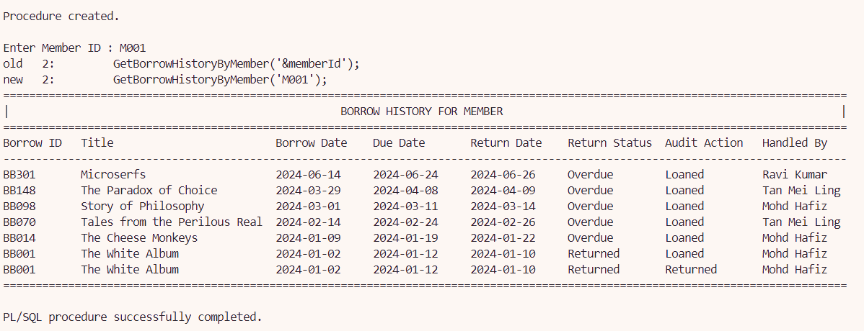

4.5.4 Stored Procedure 2: Add New Book Title with Copies

Purpose:
The purpose of this stored procedure is to insert a new book title into the BookTitles table along with a specified number of available copies into the BookCopies table. It ensures each book and copy has a unique ID, using sequences (book_id_seq and copy_id_seq) to automatically generate values. The procedure also handles exceptions such as duplicate ISBNs or errors during copy insertion.
Usefulness:
This procedure streamlines the process of adding new books into the library system by:
- Automatically generating unique IDs for both books and copies.
- Saving time for librarians by allowing them to insert the book and all its copies in one step.
- Ensuring data consistency, as it ties each copy to its corresponding book through the bookId.
- Handling exceptions with user-friendly messages to guide input correction.
- Supporting scalability, especially during mass book registrations or new stock arrivals.
Importance:
This procedure plays a vital role in the catalog management operations of the library:
- Without it, librarians would need to insert each book and its copies manually—prone to errors and inconsistencies.
- It maintains data integrity by preventing duplicate entries based on ISBN.
- It ensures accurate inventory tracking, which is crucial for borrowing, searching, and reporting features.
- It supports better resource planning by giving an exact count of available copies right from the start.
This procedure ensures that adding new books is efficient, accurate, and aligned with the system’s structure.

SQL statement:
CREATE OR REPLACE PROCEDURE add_book_title_with_copies (
p_title IN BookTitles.title%TYPE,
p_author IN BookTitles.author%TYPE,
p_genre IN BookTitles.genre%TYPE,
p_pub_year IN BookTitles.publicationYear%TYPE,
p_isbn IN BookTitles.isbn%TYPE,
p_price IN BookTitles.price%TYPE,
p_popularity IN BookTitles.popularity%TYPE,
p_num_copies IN NUMBER
)
IS
-- Exception for invalid number of copies
ex_invalid_copy_count EXCEPTION;

-- Exception if duplicate bookId or isbn exists
ex_dup_val EXCEPTION;
PRAGMA EXCEPTION_INIT(ex_dup_val, -1);

-- Local Variables
v_bookId VARCHAR2(4);
v_copy_id VARCHAR2(4);
v_copy_num NUMBER := 1;

BEGIN
-- Validate number of copies
IF p_num_copies <= 0 THEN
RAISE ex_invalid_copy_count;
END IF;

-- Generate Book ID using book_id_seq sequence
v_bookId := 'B' || LPAD(TO_CHAR(book_id_seq.NEXTVAL), 3, '0');

-- Insert into BookTitles Table
BEGIN
INSERT INTO BookTitles (bookId, title, author, genre, publicationYear, isbn, price, popularity)
VALUES (v_bookId, p_title, p_author, p_genre, p_pub_year, p_isbn, p_price, p_popularity);
EXCEPTION
WHEN ex_dup_val THEN
DBMS_OUTPUT.PUT_LINE('Error: Book ID or ISBN already exists. Please use unique values.');
RETURN;
WHEN OTHERS THEN
DBMS_OUTPUT.PUT_LINE('Unexpected error: ' || SQLERRM);
RETURN;
END;

-- Insert BookCopies
WHILE v_copy_num <= p_num_copies LOOP
-- Construct copyId based on the sequence
v_copy_id := 'C' || LPAD(TO_CHAR(copy_id_seq.NEXTVAL), 3, '0'); -- Use sequence to get the next copyId
BEGIN
INSERT INTO BookCopies (copyId, bookId, bookStatus)
VALUES (v_copy_id, v_bookId, 'available');
v_copy_num := v_copy_num + 1;
EXCEPTION
WHEN OTHERS THEN
DBMS_OUTPUT.PUT_LINE('Error adding BookCopy: ' || SQLERRM);
RETURN;
END;
END LOOP;

DBMS_OUTPUT.PUT_LINE('Successfully added book "' || p_title || '" with ' || p_num_copies || ' copies.');

-- Handle invalid copy count exception
EXCEPTION
WHEN ex_invalid_copy_count THEN
DBMS_OUTPUT.PUT_LINE('Error: Number of copies must be greater than 0.');
END;
/

SET SERVEROUTPUT ON;

-- Prompt user for input (this can be simplified if needed)
ACCEPT p_title CHAR PROMPT 'Enter Book Title: '
ACCEPT p_author CHAR PROMPT 'Enter Book Author: '
ACCEPT p_genre CHAR PROMPT 'Enter Book Genre: '
ACCEPT p_pub_year CHAR PROMPT 'Enter Publication Year: '
ACCEPT p_isbn CHAR PROMPT 'Enter ISBN: '
ACCEPT p_price CHAR PROMPT 'Enter Price: '
ACCEPT p_popularity CHAR PROMPT 'Enter Popularity: '
ACCEPT p_num_copies CHAR PROMPT 'Enter Number of Copies: '

-- Call the procedure
BEGIN
add_book_title_with_copies(
p_title => '&p_title',
p_author => '&p_author',
p_genre => '&p_genre',
p_pub_year => TO_NUMBER('&p_pub_year'),
p_isbn => '&p_isbn',
p_price => TO_NUMBER('&p_price'),
p_popularity => TO_NUMBER('&p_popularity'),
p_num_copies => TO_NUMBER('&p_num_copies')
);
END;
/

Sample Output:
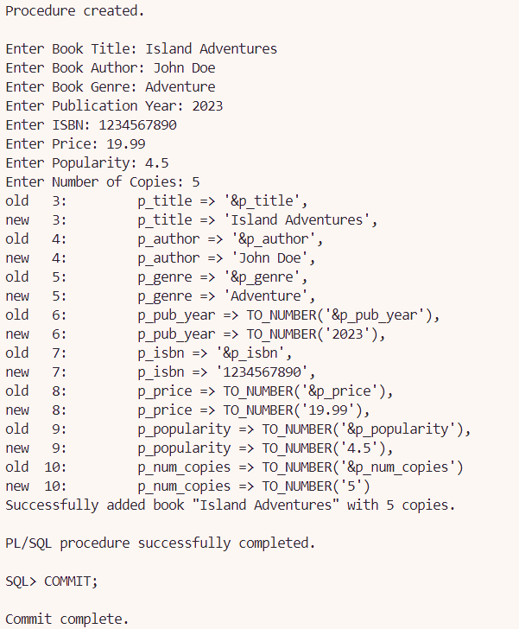

New book title and book copies added:
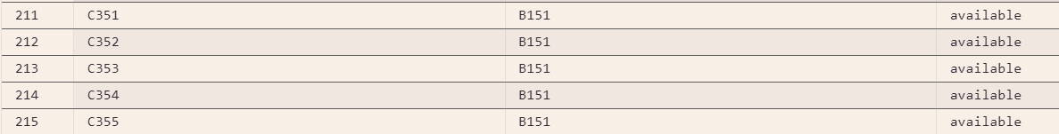

4.5.5 Trigger 1: Manage Book Details Validation

Purpose:
The purpose of this trigger is to enforce important business rules when inserting or updating records in the BookTitles table. It ensures that key data such as ISBN, publication year, price, and popularity follow defined validation rules to maintain data integrity and prevent inconsistent or invalid entries. Specifically, the trigger:
- Prevents duplicate ISBNs.
- Disallows future publication years.
- Ensures prices are non-negative.
- Restricts popularity ratings within the range of 1.0 to 5.0.
These rules reflect real-world constraints and support accurate catalog management within the library system.

Trigger code:
---------------------- TRIGGER 1 - Manage Book Details Validation -----------------------
CREATE OR REPLACE TRIGGER TRG_MANAGE_BOOK_DETAILS
BEFORE INSERT OR UPDATE ON BookTitles
FOR EACH ROW
DECLARE
v_count NUMBER;
BEGIN
-- Ensure ISBN is unique
SELECT COUNT(*) INTO v_count FROM BookTitles WHERE isbn = :NEW.isbn AND bookId <> :NEW.bookId;
IF v_count > 0 THEN
RAISE_APPLICATION_ERROR(-20001, 'Error: ISBN must be unique.');
END IF;

-- Ensure publication year is valid
IF :NEW.publicationYear > EXTRACT(YEAR FROM SYSDATE) THEN
RAISE_APPLICATION_ERROR(-20002, 'Error: Publication year cannot be in the future.');
END IF;

-- Ensure price is positive
IF :NEW.price < 0 THEN
RAISE_APPLICATION_ERROR(-20003, 'Error: Price must be zero or greater.');
END IF;

-- Ensure popularity is within the range 1.0 - 5.0
IF :NEW.popularity < 1.0 OR :NEW.popularity > 5.0 THEN
RAISE_APPLICATION_ERROR(-20004, 'Error: Popularity must be between 1.0 and 5.0.');
END IF;
END;
/

Sample output:
When invalid data is entered, the trigger raises appropriate error messages, such as:
- Error: ISBN must be unique
Input: Insert a book with same existing ISBN from B001

INSERT INTO BookTitles (bookId, title, author, genre, publicationYear, isbn, price, popularity)
VALUES ('B998', 'Test Book 1', 'Author A', 'Mystery', 2023, '1649374178', 20.00, 3.5);

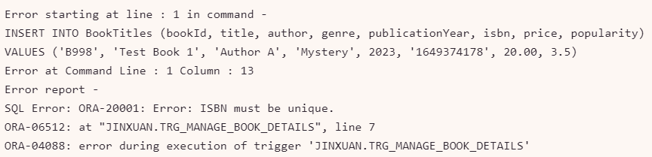

- Error: Publication year cannot be in future
Input: Insert a book with future publication year

INSERT INTO BookTitles (bookId, title, author, genre, publicationYear, isbn, price, popularity)
VALUES ('B997', 'Future Book', 'Author C', 'Sci-Fi', 2026, '9876543210', 30.00, 4.5);

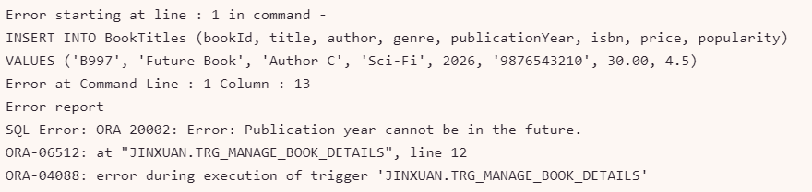

- Error: Price must be zero or greater.
Input: Insert a book with a negative price

INSERT INTO BookTitles (bookId, title, author, genre, publicationYear, isbn, price, popularity)
VALUES ('B996', 'Free Book?', 'Author D', 'Education', 2022, '1111111111', -10.00, 3.0);

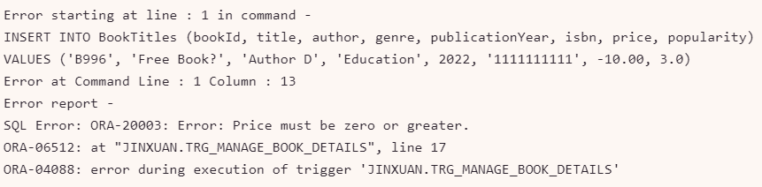

- Error: Popularity must be between 1.0 and 5.0
Input: Insert a book with popularity outside the valid range

INSERT INTO BookTitles (bookId, title, author, genre, publicationYear, isbn, price, popularity)
VALUES ('B995', 'Overrated Book', 'Author E', 'Drama', 2021, '2222222222', 18.00, 5.5);

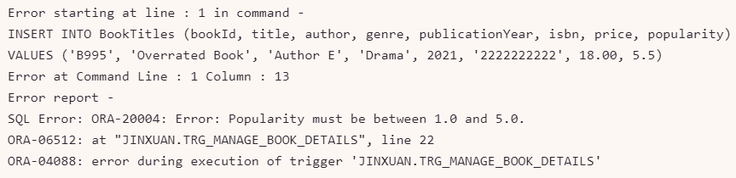

4.5.6 Trigger 2: Automatic Book Status Update

Purpose:
The purpose of this trigger is to automatically manage and update the bookStatus attribute in the BookCopies table based on specific events and business rules that occur in related tables: BorrowedBooks, Reservation, and BookAudit. This ensures accurate, consistent, and real-time updates of the availability status of book copies across the system.

Due to the nature of these interdependent processes and system-wide requirements, the logic for updating the book status is divided into three separate triggers, each responsible for one source of change:
- TRG_MANAGE_BOOK_STATUS_BB: Triggered when a book is borrowed or returned.
- TRG_MANAGE_BOOK_STATUS_RES: Triggered when a reservation is made or cancelled.
- TRG_MANAGE_BOOK_STATUS_AUDIT: Triggered when a book is marked as lost.

Trigger code:
---------------------- Trigger 2 - Automatic Book Status Update -------------------------
-- *Note: Must be separated into 3 triggers because bookStatus is referring to 3 separate tables to be updated

--------------------- TRIGGER 1 - Book Status from BorrowedBooks ------------------------
CREATE OR REPLACE TRIGGER TRG_MANAGE_BOOK_STATUS_BB
FOR INSERT OR UPDATE ON BorrowedBooks
COMPOUND TRIGGER

-- Declare a collection to store affected copyIds
TYPE CopyIdList IS TABLE OF BookCopies.copyId%TYPE;
affected_copyIds CopyIdList := CopyIdList();

-- BEFORE EACH ROW: Store affected copyIds
BEFORE EACH ROW IS
BEGIN
affected_copyIds.EXTEND;
affected_copyIds(affected_copyIds.LAST) := :NEW.copyId;
END BEFORE EACH ROW;

-- AFTER STATEMENT: Process all affected copyIds
AFTER STATEMENT IS
BEGIN
FOR i IN 1..affected_copyIds.COUNT LOOP
DECLARE
v_copyId BookCopies.copyId%TYPE := affected_copyIds(i);
v_new_status BookCopies.bookStatus%TYPE;
v_current_status BookCopies.bookStatus%TYPE;
BEGIN
-- Get current book status
SELECT bookStatus INTO v_current_status
FROM BookCopies
WHERE copyId = v_copyId;

-- Determine new book status
SELECT
CASE
-- 1. If book is borrowed, set to "Borrowed"
WHEN EXISTS (
SELECT 1 FROM BorrowedBooks
WHERE copyId = v_copyId
AND returnStatus = 'On loan'
) THEN 'borrowed'

-- 2. If book is returned, check reservations
WHEN EXISTS (
SELECT 1 FROM BorrowedBooks
WHERE copyId = v_copyId
AND returnStatus = 'Returned'
)
THEN (
CASE
WHEN EXISTS (
SELECT 1 FROM Reservation
WHERE copyId = v_copyId
AND reservationStatus = 'Pending'
) THEN 'reserved'
ELSE 'available'
END
)

ELSE v_current_status
END
INTO v_new_status
FROM dual;

-- Update only if book status has changed
IF v_new_status IS NOT NULL AND v_new_status <> v_current_status THEN
UPDATE BookCopies
SET bookStatus = v_new_status
WHERE copyId = v_copyId;
END IF;
END;
END LOOP;
END AFTER STATEMENT;
END TRG_MANAGE_BOOK_STATUS_BB;
/

--------------------- TRIGGER 2 - Book Status from Reservation ----------------------
CREATE OR REPLACE TRIGGER TRG_MANAGE_BOOK_STATUS_RES
FOR INSERT OR UPDATE ON Reservation
COMPOUND TRIGGER

TYPE Reservation_Rec IS RECORD (
copyId BookCopies.copyId%TYPE,
reservationStatus Reservation.reservationStatus%TYPE
);

TYPE Reservation_Table IS TABLE OF Reservation_Rec;
reservation_data Reservation_Table := Reservation_Table(); -- Initialize collection

BEFORE EACH ROW IS
BEGIN
-- Store data for later processing
reservation_data.EXTEND;
reservation_data(reservation_data.LAST).copyId := :NEW.copyId;
reservation_data(reservation_data.LAST).reservationStatus := :NEW.reservationStatus;
END BEFORE EACH ROW;

AFTER STATEMENT IS
BEGIN
FOR i IN 1..reservation_data.COUNT LOOP
DECLARE
v_current_status BookCopies.bookStatus%TYPE;
v_new_status BookCopies.bookStatus%TYPE;
BEGIN
-- Get current book status
SELECT bookStatus INTO v_current_status
FROM BookCopies
WHERE copyId = reservation_data(i).copyId;

-- Determine new book status
v_new_status :=
CASE
-- 3. If a reservation is made while book is available, set to "reserved"
WHEN reservation_data(i).reservationStatus = 'Pending'
AND v_current_status = 'available'
THEN 'reserved'

-- 4. If a reservation is cancelled, book becomes "available"
WHEN reservation_data(i).reservationStatus = 'Cancelled'
THEN 'available'

ELSE v_current_status
END;

-- Update only if book status has changed
IF v_new_status IS NOT NULL AND v_new_status <> v_current_status THEN
UPDATE BookCopies
SET bookStatus = v_new_status
WHERE copyId = reservation_data(i).copyId;
END IF;
END;
END LOOP;
END AFTER STATEMENT;

END TRG_MANAGE_BOOK_STATUS_RES;
/

--------------------- TRIGGER 3 - Book Status from BookAudit ------------------------
CREATE OR REPLACE TRIGGER TRG_MANAGE_BOOK_STATUS_AUDIT
FOR INSERT OR UPDATE ON BookAudit
COMPOUND TRIGGER

TYPE Audit_Rec IS RECORD (
copyId BookCopies.copyId%TYPE,
actionType BookAudit.actionType%TYPE
);

TYPE Audit_Table IS TABLE OF Audit_Rec;
audit_data Audit_Table := Audit_Table(); -- Initialize

BEFORE EACH ROW IS
v_copyId BookCopies.copyId%TYPE;
BEGIN
-- Get the copyId from BorrowedBooks
SELECT copyId INTO v_copyId
FROM BorrowedBooks
WHERE borrowId = :NEW.borrowId;

-- Store data for later processing
audit_data.EXTEND;
audit_data(audit_data.LAST).copyId := v_copyId;
audit_data(audit_data.LAST).actionType := :NEW.actionType;
END BEFORE EACH ROW;

AFTER STATEMENT IS
BEGIN
FOR i IN 1..audit_data.COUNT LOOP
-- Update BookCopies status based on actionType
-- 5. If book is lost set to "Unavailable"
IF audit_data(i).actionType IN ('Lost') THEN
UPDATE BookCopies
SET bookStatus = 'unavailable'
WHERE copyId = audit_data(i).copyId;
END IF;
END LOOP;
END AFTER STATEMENT;

END TRG_MANAGE_BOOK_STATUS_AUDIT;
/

Sample output
bookStatus in BookCopies table are updated by the triggers. Initially, all bookStatus is ‘available’ during insert of records

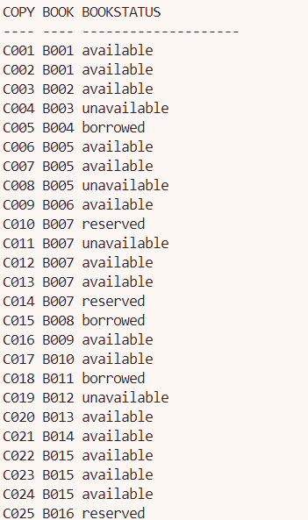

4.5.7 Report 1: Most Popular Genres & Authors: A Genre Borrowing Analytics Report

Purpose:
The purpose of this report is to analyze borrowing trends within a specific genre by providing a comprehensive, data-driven overview of book borrowing trends categorized by genre and further analyzed at the author level. This report is designed to support library administrators, acquisition teams, and decision-makers in understanding:
- Which genres are most popular based on borrowing frequency.
- Who the top-performing authors are within a selected genre.
- Which books are most borrowed, most valuable, or highly rated in popularity within those genres.

The report consists of two parts:
- A summary report that ranks all genres by total borrow counts (rpt_genre_ranking).
- A detailed, parameterized report that generates borrowing analytics for a specific genre passed as input (rpt_genre_author_report). This includes nested cursor logic to break down each author's contributions and book-level statistics such as publication year, popularity, price, and borrow frequency.

The use of both standalone and nested cursors ensures efficient data traversal and a structured presentation of hierarchical relationships (Genre → Author → Book).

The procedures also return additional analytics such as:
- The most borrowed book in the genre.
- Average popularity score of books.
- Total number and value of books in the genre.
- The top author by number of published titles in the genre.

Report code:
SET SERVEROUTPUT ON;
SET PAGESIZE 1000;
SET LINESIZE 300;

CREATE OR REPLACE PROCEDURE rpt_genre_author_report(p_genre IN VARCHAR2)
IS
-- Custom exception for invalid genre
ex_invalid_genre EXCEPTION;

-- Validation variable
v_genre_exists NUMBER;

-- Cursors
CURSOR cur_authors IS
SELECT bt.author, COUNT(bb.borrowId) AS borrow_count
FROM BookTitles bt
JOIN BookCopies bc ON bt.bookId = bc.bookId
JOIN BorrowedBooks bb ON bb.copyId = bc.copyId
WHERE LOWER(bt.genre) = LOWER(p_genre)
GROUP BY bt.author
ORDER BY borrow_count DESC;

CURSOR cur_books(p_author VARCHAR2) IS
SELECT bt.title, bt.publicationYear, bt.popularity, bt.price, COUNT(bb.borrowId) AS borrow_count
FROM BookTitles bt
JOIN BookCopies bc ON bt.bookId = bc.bookId
JOIN BorrowedBooks bb ON bb.copyId = bc.copyId
WHERE LOWER(bt.genre) = LOWER(p_genre)
AND bt.author = p_author
GROUP BY bt.title, bt.publicationYear, bt.popularity, bt.price
ORDER BY borrow_count DESC;

v_top_title BookTitles.title%TYPE;
v_top_borrows NUMBER;
v_avg_popularity NUMBER;
v_total_books NUMBER;
v_top_author BookTitles.author%TYPE;
v_top_author_books NUMBER;
v_total_value NUMBER(10,2);
BEGIN

SELECT COUNT(*) INTO v_genre_exists
FROM BookTitles
WHERE LOWER(genre) = LOWER(p_genre);

IF v_genre_exists = 0 THEN
RAISE ex_invalid_genre;
END IF;

DBMS_OUTPUT.PUT_LINE(RPAD('=', 100, '='));
DBMS_OUTPUT.PUT_LINE(RPAD('||', 100));
DBMS_OUTPUT.PUT_LINE(RPAD('||', 5) || RPAD('Genre Report: ' || UPPER(p_genre), 92) || '||');
DBMS_OUTPUT.PUT_LINE(RPAD('||', 5) ||
RPAD('Generated On: ' || TO_CHAR(SYSDATE, 'DD-MON-YYYY HH24:MI:SS'), 92) || '||');
DBMS_OUTPUT.PUT_LINE(RPAD('||', 100));
DBMS_OUTPUT.PUT_LINE(RPAD('=', 100, '='));

FOR author_rec IN cur_authors LOOP
DBMS_OUTPUT.PUT_LINE('Author: ' || author_rec.author);
DBMS_OUTPUT.PUT_LINE('Total Borrow Count: ' || author_rec.borrow_count);
DBMS_OUTPUT.PUT_LINE(RPAD('-', 100, '-'));

DBMS_OUTPUT.PUT_LINE(RPAD('No.', 5) ||
RPAD('Title', 45) ||
RPAD('Year', 8) ||
RPAD('Popularity', 12) ||
RPAD('Price (RM)', 12) ||
'Borrows');
DBMS_OUTPUT.PUT_LINE(RPAD('-', 100, '-'));

DECLARE
book_num NUMBER := 0;
BEGIN
FOR book_rec IN cur_books(author_rec.author) LOOP
book_num := book_num + 1;
DBMS_OUTPUT.PUT_LINE(RPAD(book_num, 5) ||
RPAD(book_rec.title, 45) ||
RPAD(book_rec.publicationYear, 8) ||
RPAD(TO_CHAR(book_rec.popularity, '9.9'), 12) ||
RPAD(TO_CHAR(book_rec.price, '9990.00'), 12) ||
book_rec.borrow_count);
END LOOP;
END;

DBMS_OUTPUT.PUT_LINE(CHR(10));
END LOOP;

-- Most Borrowed Book
SELECT title, times_borrowed INTO v_top_title, v_top_borrows
FROM (
SELECT bt.title, COUNT(bb.borrowId) AS times_borrowed
FROM BookTitles bt
JOIN BookCopies bc ON bt.bookId = bc.bookId
JOIN BorrowedBooks bb ON bb.copyId = bc.copyId
WHERE LOWER(bt.genre) = LOWER(p_genre)
GROUP BY bt.title
ORDER BY times_borrowed DESC
)
WHERE ROWNUM = 1;

-- Average Popularity
SELECT ROUND(AVG(popularity), 2)
INTO v_avg_popularity
FROM BookTitles
WHERE LOWER(genre) = LOWER(p_genre);

-- Total Books in Genre
SELECT COUNT(*) INTO v_total_books
FROM BookTitles
WHERE LOWER(genre) = LOWER(p_genre);

-- Top Author by Book Count
SELECT author, book_count INTO v_top_author, v_top_author_books
FROM (
SELECT author, COUNT(*) AS book_count
FROM BookTitles
WHERE LOWER(genre) = LOWER(p_genre)
GROUP BY author
ORDER BY book_count DESC
)
WHERE ROWNUM = 1;

-- Total Book Value
SELECT SUM(price) INTO v_total_value
FROM BookTitles
WHERE LOWER(genre) = LOWER(p_genre);

-- Final Summary
DBMS_OUTPUT.PUT_LINE(RPAD('-', 100, '-'));
DBMS_OUTPUT.PUT_LINE(RPAD('||', 100));

DBMS_OUTPUT.PUT_LINE(RPAD('||', 10) || RPAD('**************** Additional Stats ****************', 88) || '||');
DBMS_OUTPUT.PUT_LINE(RPAD('||', 10) || RPAD('Most Borrowed Book : ' || v_top_title || ' (' || v_top_borrows || ' times)', 88) || '||');
DBMS_OUTPUT.PUT_LINE(RPAD('||', 10) || RPAD('Average Popularity : ' || TO_CHAR(v_avg_popularity, '9.99'), 88) || '||');
DBMS_OUTPUT.PUT_LINE(RPAD('||', 10) || RPAD('Total Books in Genre : ' || v_total_books, 88) || '||');
DBMS_OUTPUT.PUT_LINE(RPAD('||', 10) || RPAD('Top Author by Book Count : ' || v_top_author || ' (' || v_top_author_books || ' books)', 88) || '||');
DBMS_OUTPUT.PUT_LINE(RPAD('||', 10) || RPAD('Total Book Value in Genre : RM ' || TO_CHAR(v_total_value, '9999990.00'), 88) || '||');

DBMS_OUTPUT.PUT_LINE(RPAD('||', 100));
DBMS_OUTPUT.PUT_LINE(RPAD('-', 100, '-'));

EXCEPTION
WHEN ex_invalid_genre THEN
DBMS_OUTPUT.PUT_LINE('Error: Genre "' || UPPER(p_genre) || '" does not exist in the database.');
WHEN OTHERS THEN
DBMS_OUTPUT.PUT_LINE('An unexpected error occurred: ' || SQLERRM);
END;
/

CREATE OR REPLACE PROCEDURE rpt_genre_ranking
IS
CURSOR cur_genres IS
SELECT LOWER(bt.genre) AS genre,
COUNT(bb.borrowId) AS total_borrows
FROM BookTitles bt
JOIN BookCopies bc ON bt.bookId = bc.bookId
JOIN BorrowedBooks bb ON bb.copyId = bc.copyId
WHERE bt.genre IS NOT NULL
GROUP BY LOWER(bt.genre)
ORDER BY total_borrows DESC;

genre_num NUMBER := 0;
BEGIN
DBMS_OUTPUT.PUT_LINE(RPAD('=', 100, '='));
DBMS_OUTPUT.PUT_LINE(RPAD('||', 100));
DBMS_OUTPUT.PUT_LINE(RPAD('||', 5) || RPAD('Genre Ranking Summary', 92) || '||');
DBMS_OUTPUT.PUT_LINE(RPAD('||', 5) || RPAD('Generated On: ' || TO_CHAR(SYSDATE, 'DD-MON-YYYY HH24:MI:SS'), 92) || '||');
DBMS_OUTPUT.PUT_LINE(RPAD('||', 100));
DBMS_OUTPUT.PUT_LINE(RPAD('=', 100, '='));

DBMS_OUTPUT.PUT_LINE(RPAD('No.', 5) || RPAD('Genre', 40) || 'Total Borrows');
DBMS_OUTPUT.PUT_LINE(RPAD('-', 100, '-'));

FOR genre_rec IN cur_genres LOOP
genre_num := genre_num + 1;
DBMS_OUTPUT.PUT_LINE(RPAD(genre_num, 5) ||
RPAD(INITCAP(genre_rec.genre), 40) ||
genre_rec.total_borrows);
END LOOP;

DBMS_OUTPUT.PUT_LINE(RPAD('-', 100, '-'));
END;
/

SET SERVEROUTPUT ON;

EXEC rpt_genre_ranking;

-- Prompt the user for input
ACCEPT v_genre CHAR PROMPT 'Enter a genre to view author-level details: ';

-- Execute the procedure
EXEC rpt_genre_author_report('&v_genre');

Sample Output:
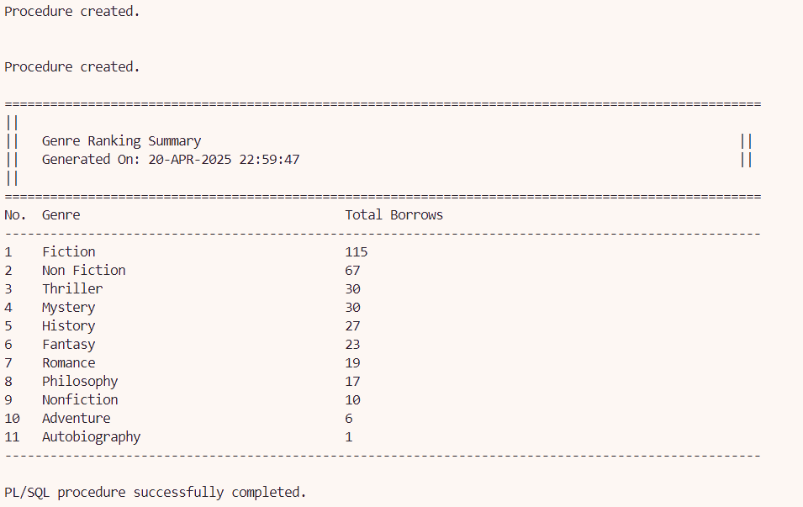
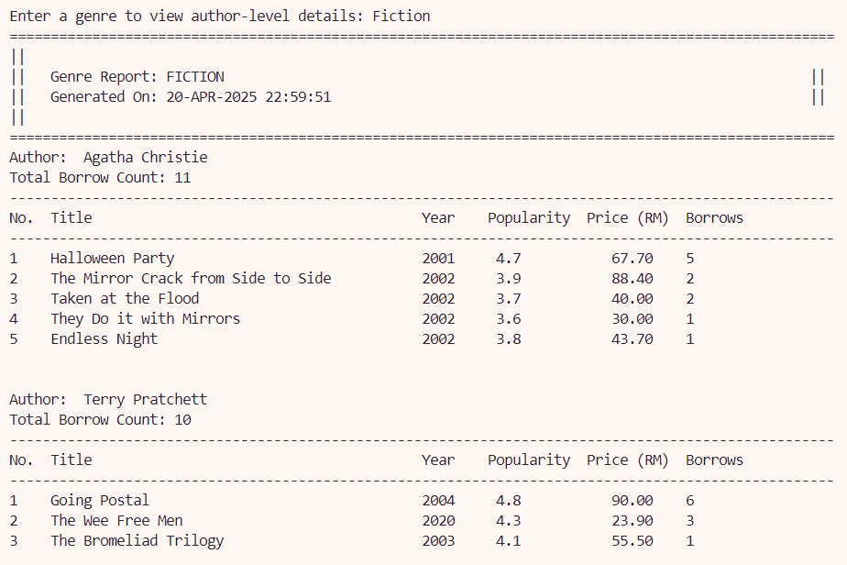
...
...
...
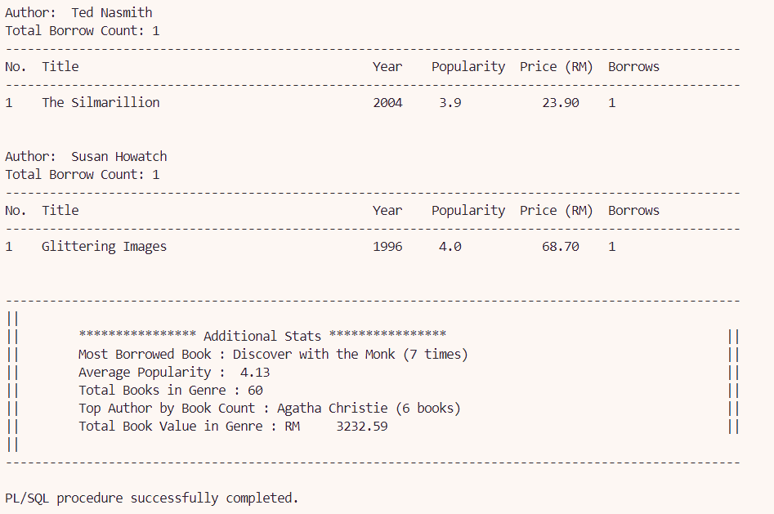

4.5.8 Report 2: Book Status Analytics: Availability & Borrowing Duration Report

Purpose:
The purpose of this report is to analyze books in the library based on their current status (available, borrowed, or reserved) and provide insights into their borrowing patterns. The report includes:
- The number of times each book has been borrowed while in the given status.
- The average duration (in days) that each book was borrowed before being returned.
- A detailed breakdown of individual borrowing records for returned books.
- A summary of total books, total borrow events, and average borrow duration across all listed books.

This report supports the library administration by identifying book usage trends and potential inventory shortage, helping in optimizing resource allocation and procurement decisions.

The report uses both standalone and nested cursors to provide a clear, multilevel analysis. The report makes use of both standalone and nested cursors to deliver a structured and insightful analysis. The main cursor retrieves books filtered by their current status (available, borrowed, or reserved), while nested cursors are used to compute the average borrow duration for each book and to display detailed borrowing records per title.

This nested cursor approach enables a multi-level drill-down view, from book-level summaries to borrower-specific insights, allowing library administrators to understand both high-level trends and detailed borrowing behavior.

Report code:
SET SERVEROUTPUT ON;
SET PAGESIZE 1000;
SET LINESIZE 300;

CREATE OR REPLACE PROCEDURE rpt_bookstat_borrowduration(p_status IN VARCHAR2)
IS
-- Cursor to fetch books by status
CURSOR cur_books IS
SELECT bt.bookId, bt.title, bt.genre, bc.bookStatus, COUNT(bb.borrowId) AS borrow_count
FROM BookTitles bt
JOIN BookCopies bc ON bt.bookId = bc.bookId
LEFT JOIN BorrowedBooks bb ON bb.copyId = bc.copyId AND bb.returnStatus IN ('On loan', 'Overdue')
WHERE bc.bookStatus = p_status
GROUP BY bt.bookId, bt.title, bt.genre, bc.bookStatus
ORDER BY bt.title;

-- Cursor to calculate average borrowing duration
CURSOR cur_avg_borrow_duration(p_bookId VARCHAR2) IS
SELECT AVG(bb.dueDate - bb.borrowDate) AS avg_duration
FROM BorrowedBooks bb
JOIN BookCopies bc ON bb.copyId = bc.copyId
WHERE bc.bookId = p_bookId AND bb.returnStatus = 'Returned';

-- Cursor to get borrowing details per book
CURSOR cur_borrow_details(p_bookId VARCHAR2) IS
SELECT bb.borrowId, m.memberName AS member_name, (bb.dueDate - bb.borrowDate) AS duration
FROM BorrowedBooks bb
JOIN BookCopies bc ON bb.copyId = bc.copyId
JOIN Members m ON bb.memberId = m.memberId
WHERE bc.bookId = p_bookId AND bb.returnStatus = 'Returned';

-- Variables
v_avg_borrow_duration NUMBER := 0;
v_total_books NUMBER := 0;
v_total_borrows NUMBER := 0;
v_total_duration NUMBER := 0;
v_row_num NUMBER := 0;
BEGIN
DBMS_OUTPUT.PUT_LINE(RPAD('=', 130, '='));
DBMS_OUTPUT.PUT_LINE(RPAD('||', 100));
DBMS_OUTPUT.PUT_LINE('|| ' || RPAD('Book Availability and Borrowing Duration Report', 118) || ' ||');
DBMS_OUTPUT.PUT_LINE('|| Generated On: ' || TO_CHAR(SYSDATE, 'DD-MON-YYYY HH24:MI:SS') || RPAD(' ', 85) || '||');
DBMS_OUTPUT.PUT_LINE(RPAD('||', 100));
DBMS_OUTPUT.PUT_LINE(RPAD('=', 130, '='));
DBMS_OUTPUT.PUT_LINE(RPAD('|', 100));
-- Column headers
DBMS_OUTPUT.PUT_LINE(
RPAD('No.', 5) ||
RPAD('Book ID', 12) ||
RPAD('Title', 40) ||
RPAD('Genre', 20) ||
RPAD('Status', 18) ||
RPAD('Borrows', 10) ||
RPAD('Avg Duration (Days)', 25)
);
DBMS_OUTPUT.PUT_LINE(RPAD('=', 130, '='));

FOR book_rec IN cur_books LOOP
v_row_num := v_row_num + 1;
v_avg_borrow_duration := 0;

BEGIN
FOR rec IN cur_avg_borrow_duration(book_rec.bookId) LOOP
v_avg_borrow_duration := NVL(rec.avg_duration, 0);
END LOOP;
EXCEPTION
WHEN OTHERS THEN
v_avg_borrow_duration := 0;
END;

v_total_books := v_total_books + 1;
v_total_borrows := v_total_borrows + book_rec.borrow_count;
v_total_duration := v_total_duration + v_avg_borrow_duration;

-- Print book row
DBMS_OUTPUT.PUT_LINE(
RPAD(v_row_num, 5) ||
RPAD(book_rec.bookId, 12) ||
RPAD(SUBSTR(book_rec.title, 1, 39), 40) ||
RPAD(book_rec.genre, 20) ||
RPAD(book_rec.bookStatus, 18) ||
RPAD(book_rec.borrow_count, 10) ||
RPAD(TO_CHAR(v_avg_borrow_duration, '990.00'), 15)
);
DBMS_OUTPUT.PUT_LINE(RPAD('|', 100));

-- Borrow details neatly formatted
FOR borrow_rec IN cur_borrow_details(book_rec.bookId) LOOP
DBMS_OUTPUT.PUT_LINE(
RPAD('| -> ', 10) ||
RPAD('Borrow ID:', 12) || RPAD(borrow_rec.borrowId, 12) ||
RPAD('Member:', 10) || RPAD(SUBSTR(borrow_rec.member_name, 1, 20), 22) ||
RPAD('Duration:', 12) || RPAD(borrow_rec.duration, 4) || ' days'
);
END LOOP;

DBMS_OUTPUT.PUT_LINE(RPAD('|', 100));
DBMS_OUTPUT.PUT_LINE(RPAD('-', 130, '-'));
END LOOP;

-- Summary Section
IF v_total_books > 0 THEN
DBMS_OUTPUT.PUT_LINE(RPAD('|', 100));
DBMS_OUTPUT.PUT_LINE(RPAD('=', 130, '='));
DBMS_OUTPUT.PUT_LINE(RPAD('||', 100));
DBMS_OUTPUT.PUT_LINE('|| ******************** Summary of Report ********************' || RPAD(' ', 58) || '||');
DBMS_OUTPUT.PUT_LINE('|| Total Books: ' || RPAD(v_total_books, 25) || RPAD(' ', 77) || '||');
DBMS_OUTPUT.PUT_LINE('|| Total Borrows: ' || RPAD(v_total_borrows, 23) || RPAD(' ', 77) || '||');
DBMS_OUTPUT.PUT_LINE('|| Average Borrow Duration for All Books: ' ||
TO_CHAR(v_total_duration / v_total_books, '990.00') || ' days' || RPAD(' ', 64) || '||');
DBMS_OUTPUT.PUT_LINE(RPAD('||', 100));
DBMS_OUTPUT.PUT_LINE(RPAD('=', 130, '='));

ELSE
DBMS_OUTPUT.PUT_LINE('No books available for the selected status.');
END IF;
END;
/

SET SERVEROUTPUT ON;

-- Prompt the user for input
ACCEPT v_status CHAR PROMPT 'Enter book status to view (available / borrowed / reserved): '

-- Execute the procedure with user input
EXEC rpt_bookstat_borrowduration('&v_status');

Sample output:
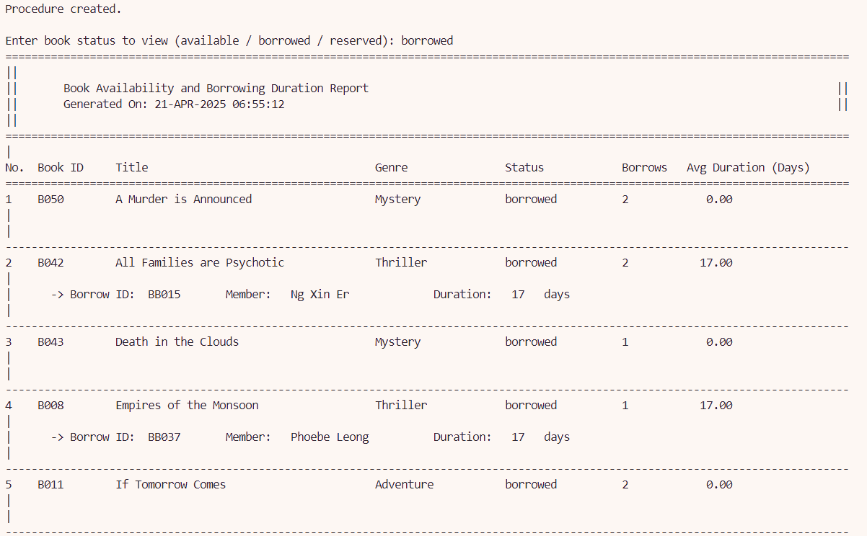
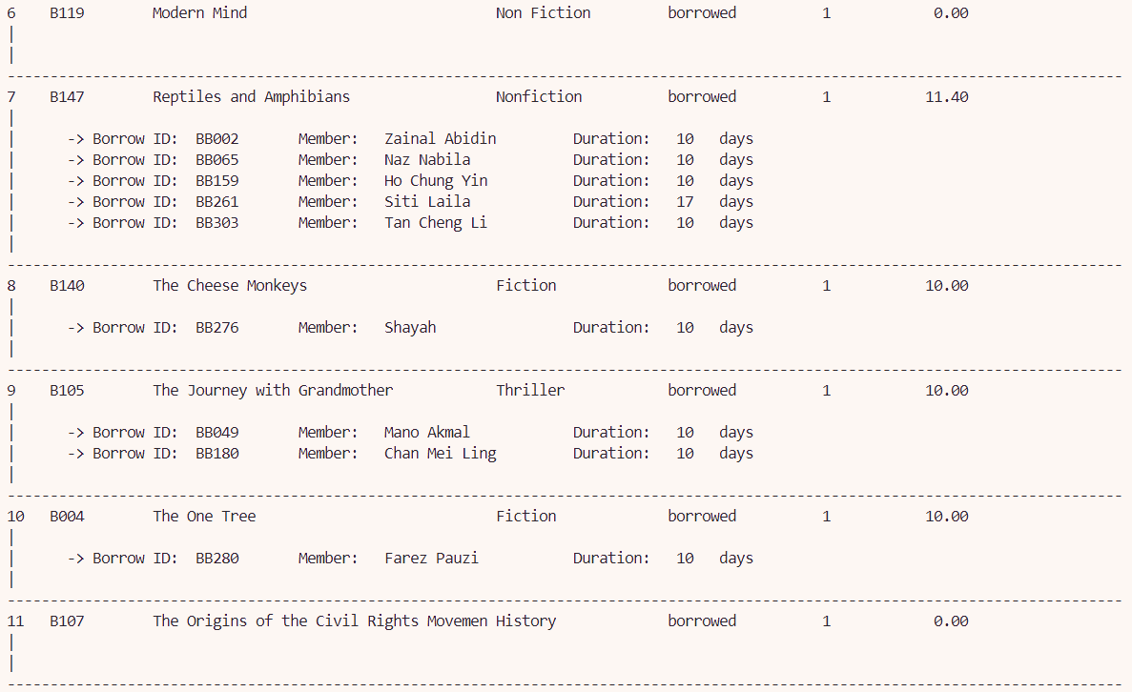
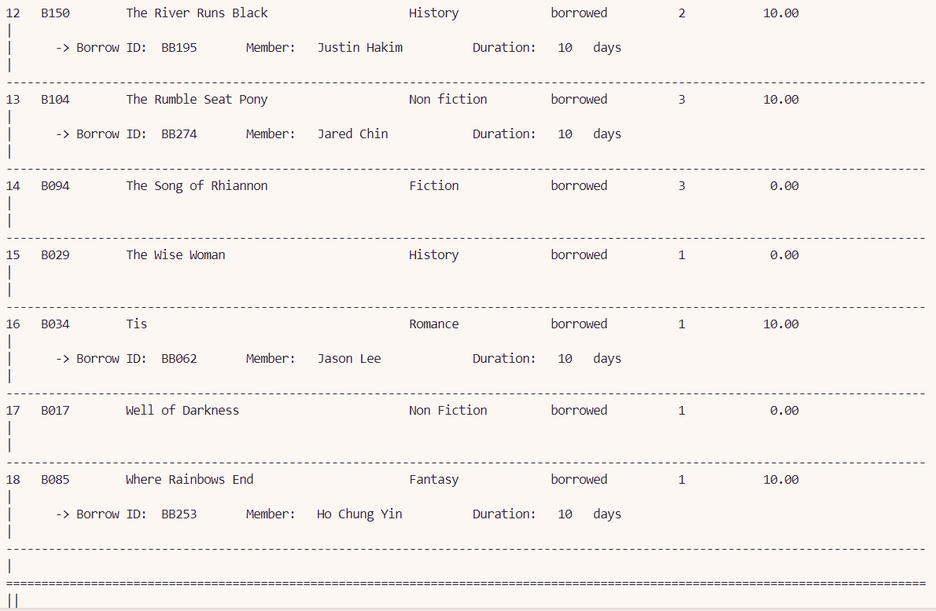
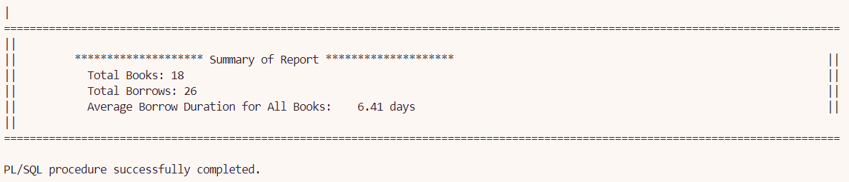

Chapter 5 Extra Effort Highlights

5.1 Dorcas Lim Yuan Yao

5.1.1 Views

View 1: StaffShiftReservationSummary
Purpose:
This view acts as a powerful analytical tool that transforms raw library data into actionable insights about staff reservation handling efficiency. By consolidating data from five tables and applying standardized business rules, it provides leadership with a clear picture of which staff members and shifts are most effective at processing reservations. The solution addresses multiple operational needs - from evaluating individual performance to optimizing shift schedules - while ensuring consistent, accurate metrics across all reports.

This view serves as a predefined performance dashboard that:
- Tracks staff efficiency by counting how many reservations each librarian/assistant processes during their shifts
- Ranks staff performance by sorting results from highest to lowest reservation volume
- Correlates productivity with shift schedules by including shift types and times
- Provides standardized metrics for evaluating reservation handling across the library staff
Justification for use in Query 1:
(TOTAL RESERVATIONS HANDLED BY EACH STAFF PER SHIFT )

The view significantly enhances the library's reporting capabilities by simplifying complex queries into an easily accessible format. It improves system performance through pre-compiled joins, maintains data integrity with consistent filters, and strengthens security by abstracting underlying tables. The design incorporates practical considerations like clear naming conventions and preserved sorting to ensure usability. Ultimately, this view enables data-driven decision making that can improve patron service, staff productivity, and overall library operations.
- Code Simplification: Eliminates duplicate code if used across multiple reports and replaces 15 lines of complex SQL joins with a simple view reference
- Guaranteed Consistency: Ensures all reports use identical business logic for:
- Valid reservation statuses ('Available')
- Eligible staff roles ('librarian', 'assistant')
- Correct join conditions between tables
- Performance Optimization: The view can be materialized to store pre-aggregated results and avoids re-executing the same complex joins repeatedly
- Security Layer: Restricts direct table access while exposing only necessary columns and allows column renaming without breaking queries
This view maintains the original report format with column aliases and also inherits all filtering/sorting from the view. It help reduces maintenance to one object (the view) instead of multiple queries. For future changes to reservation logic, it only requires view modification.

SQL Statement:

CREATE OR REPLACE VIEW vw_staffreservationperformance AS
SELECT
s.staffId AS "STAFF_ID",
s.staffName AS "STAFF_NAME",
sh.shiftId AS "SHIFT_ID",
sh.shiftType AS "SHIFT_TYPE",
TO_CHAR(sh.startTime, 'HH24:MI') AS "START_TIME",
TO_CHAR(sh.endTime, 'HH24:MI') AS "END_TIME",
COUNT(DISTINCT r.reservationId) AS "TOTAL_RESERVATIONS"
FROM
Staff s
JOIN
ShiftSchedules ss ON s.staffId = ss.staffId
JOIN
Shift sh ON ss.shiftId = sh.shiftId
LEFT JOIN
BookAudit ba ON ba.staffId = s.staffId
AND ba.actionType IN ('Loaned', 'Returned')
LEFT JOIN
BorrowedBooks bb ON ba.borrowId = bb.borrowId
LEFT JOIN
Reservation r ON (r.copyId = bb.copyId OR r.memberId = bb.memberId)
AND r.reservationStatus = 'Available'
WHERE
s.role IN ('librarian', 'assistant')
GROUP BY
s.staffId, s.staffName, sh.shiftId, sh.shiftType, sh.startTime, sh.endTime
ORDER BY
COUNT(DISTINCT r.reservationId) DESC,
sh.shiftType,
s.staffId;

Sample Output:
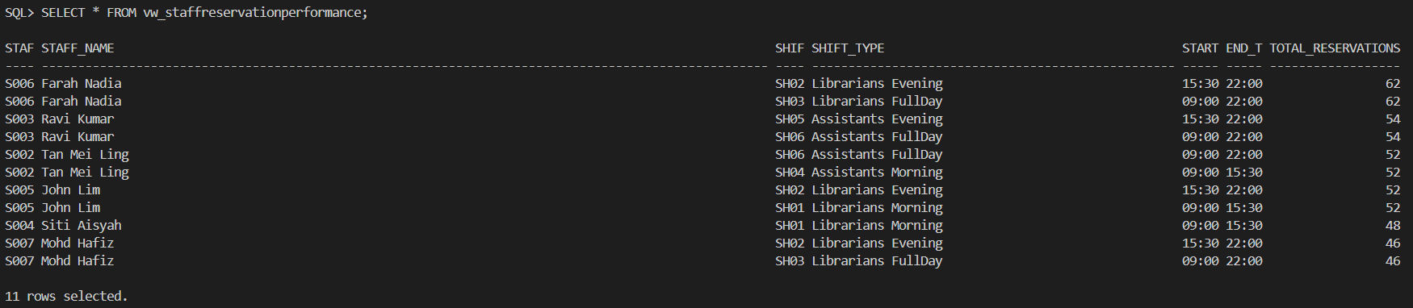
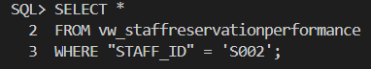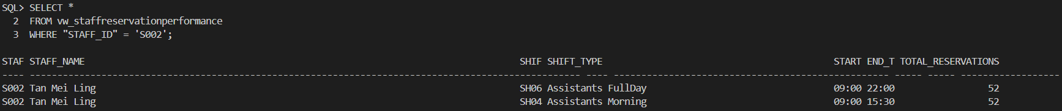

View 2: RecentMemberReservation
Purpose:
The RecentMemberReservation view serves as a consolidated snapshot of member reservation activity during Q2 2024 (April-June). It tracks recent reservation behavior of members, including their latest reservation date, number of reservations made between April–June 2024, and the book IDs reserved.
Its key purposes are:
- Activity Monitoring: Tracks which members are actively reserving books
- Usage Patterns: Reveals reservation frequency and recency per member
- Book Demand Analysis: Aggregates reserved book IDs to show popular titles
- Temporal Filtering: Focuses specifically on Q2 2024 data
- Data Consolidation: Combines information from Members, Reservation, BookCopies, and BookTitles tables

Justification for use in Query 2: (RECENT MEMBERS RESERVATION ACTIVITY )
This view provides a comprehensive member engagement analysis tool that tracks reservation patterns during Q2 2024. By aggregating reservation data, it reveals which members are most active and which books are in highest demand, offering valuable insights for collection development and service improvements. The consolidated format simplifies reporting while enabling data-driven decisions about membership outreach and resource allocation.
- Performance Optimization: The view pre-computes complex aggregations (LISTAGG, COUNT, MAX). It reduces query execution time compared to running raw joins repeatedly
- Consistency Assurance: Guarantees all reports use the same:
- Date range (01-APR to 30-JUN 2024)
- Table join logic
- Aggregation methods
- Simplified Maintenance: Date range or calculation changes only need view modification. It eliminates risk of inconsistent filters across multiple queries
- Security Layer: Protects underlying tables while exposing only necessary columns and allows column renaming without impacting dependent queries
The view improves both performance and maintainability. It help maintains identical output format to original query and inherits all predefined calculations from the view. This view preserves sorting logic (recent reservations first) and future date range updates only require view modification.

SQL Statement:

CREATE OR REPLACE VIEW RecentMemberReservation AS
SELECT
m.memberId AS member_id,
m.memberName AS member_name,
TO_CHAR(MAX(r.reservationDate), 'YYYY-MM-DD') AS latest_reservation,
COUNT(r.reservationId) AS total_reservations,
LISTAGG(bt.bookId, ', ')
WITHIN GROUP (ORDER BY bt.bookId) AS reserved_book_ids
FROM
Members m
JOIN
Reservation r ON r.memberId = m.memberId
JOIN
BookCopies bc ON r.copyId = bc.copyId
JOIN
BookTitles bt ON bc.bookId = bt.bookId
WHERE
r.reservationDate BETWEEN TO_DATE('01-APR-2024', 'DD-MON-YYYY')
AND TO_DATE('30-JUN-2024', 'DD-MON-YYYY')
GROUP BY
m.memberId, m.memberName;

Sample Output:
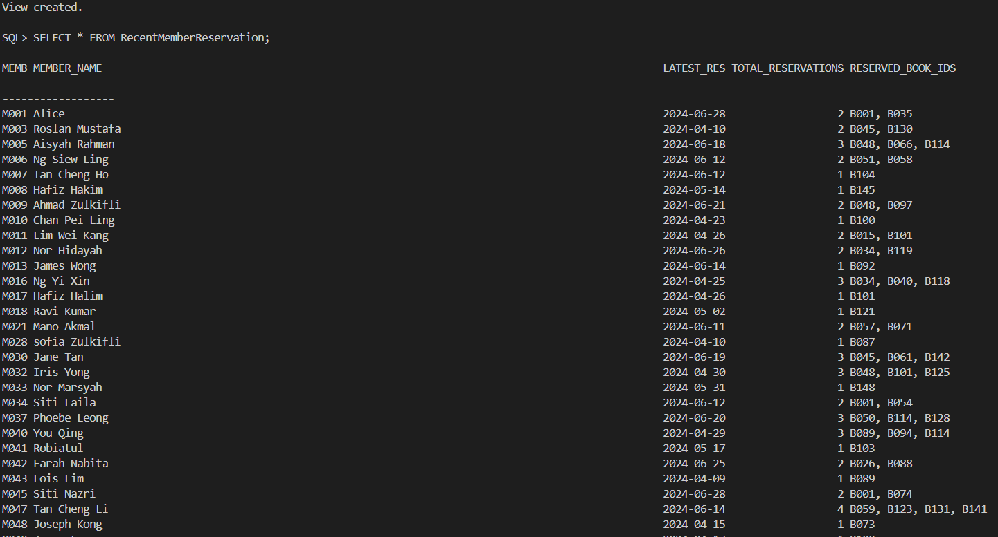

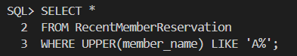
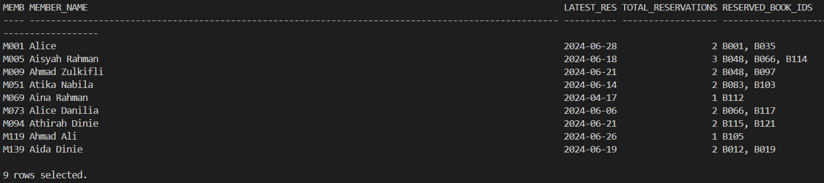

5.1.2 Indexes

Index 1: idx_reservation_statusmonth
Purpose:
This index optimizes queries filtering by reservation status and month, ensuring fast retrieval of reservation records based on these criteria.
Oracle will use this index to quickly locate rows with matching status and reservation month.

Usage and Justification: (Reservation Report by Status and Month)
Used in reports or procedures (like rpt_reservation_by_statusmonth) that filter reservations by:
- Status ( Pending, Available, Cancelled)
- Month (e.g., 04 for April, 05 for May)

- Performance Boost – Speeds up filtering on reservationStatus and reservationDate (month).
- Case-Insensitive & Trimmed Matching – Ensures consistent lookups even if status values have inconsistent formatting.
- Optimized for Monthly Reports – Helps in generating monthly reservation trend reports efficiently.

SQL Statement:
-- Index 1: Reservation Report by Status and Month
-- rpt_reservation_by_statusmonth
CREATE INDEX idx_reservation_statusmonth
ON Reservation (LOWER(TRIM(reservationStatus)),TO_CHAR(reservationDate, 'MM'));

Index 2: idx_due_return
Purpose:
This conditional index specifically targets overdue books. This index optimizes filtering by dueDate, speeds up queries where returnDate IS NULL (common in overdue scenarios). It allows Oracle to quickly find unreturned books that are overdue.

Usage and Justification: (Overdue Books Report)
Used in reports (like rpt_overdue_books) that track overdue books.
- Focused on Overdue Books – Only indexes records where returnDate IS NULL, reducing index size and improving speed.
- Efficient Overdue Detection – Allows Oracle to quickly find books past their due date.
- Reduces Full Table Scans – Without this index, Oracle would scan all BorrowedBooks to find overdue items.

SQL Statement:
-- Index 2: Overdue Books Report
-- rpt_overdue_books
CREATE INDEX idx_due_return ON BorrowedBooks (returnDate, dueDate);

5.1.3 User Defined Functions

Function 1: TotalBooksBorrowed(memberID)&DisplaysBookIDsNotReturned

Purpose:
This function is created to process member borrowing records from the BorrowedBooks table. It is designed to:
- Calculate the total count of books borrowed by a specified member (via memberId)
- Generate a list of all currently unreturned books (where returnDate IS NULL)
- Support member account reviews and overdue book tracking by library staff

Usage and Justification:

Usage
- Member Activity Tracking: Library staff can quickly assess a member's borrowing activity
- Overdue Book Management: Helps identify books that need to be returned
- Account Management: Useful when members want to check their current borrow status
Justification
- Efficiency: Combines counting and listing operations in a single function call
- User-Friendly: Provides immediate visual feedback about unreturned books
- Error Handling: Gracefully manages cases where no data exists or errors occur
- Data Integrity: Ensures accurate tracking of borrowed materials

SQL Statement:

CREATE OR REPLACE FUNCTION fn_borrowed_book_count(p_memberId IN VARCHAR2)
RETURN NUMBER
IS
v_count NUMBER;
BEGIN
SELECT COUNT(*)
INTO v_count
FROM BorrowedBooks
WHERE memberId = p_memberId;

DBMS_OUTPUT.PUT_LINE('Books not yet returned:');
FOR rec IN (
SELECT copyId
FROM BorrowedBooks
WHERE memberId = p_memberId
AND returnDate IS NULL
) LOOP
DBMS_OUTPUT.PUT_LINE(' - ' || rec.copyId);
END LOOP;

RETURN v_count;
EXCEPTION
WHEN NO_DATA_FOUND THEN
RETURN 0;
WHEN OTHERS THEN
RETURN -1;
END;
/

Function 2: TotalBooksLostOrDamage
Purpose:
This function is created on the Fines table to count books associated with loss or damage penalties. It is designed to:
- Track the total quantity of books flagged with 'Lost Book' or 'Damage' fine types
- Support inventory reconciliation and financial reporting
- Provide a metric for collection preservation efforts

Usage and Justification:

Usage
- Collection Management: Quickly assess how many items are permanently lost or damaged
- Financial Reporting: Calculate potential replacement costs during budget planning
- Member Accountability: Identify patterns of frequent loss/damage
- Service Quality Metrics: Monitor collection deterioration rates over time
Justification
- Operational Efficiency: Automates what would otherwise require manual counting of loss/damage incidents
- Data Accuracy: Standardizes the counting methodology across all reports
- Decision Support: Provides quantifiable data for:
  - Collection budgeting (replacement funds)
  - Policy adjustments (stricter borrowing rules for high-risk items)
  - Member education programs (care of materials)
- Error Resilience: Handles exceptions gracefully with:
  - Default return of 0 for no records
  - Error flag (-1) for system issues
- Integration Ready: Can be embedded in:
  - Monthly financial reports
  - Collection condition audits
  - Member account review processes

SQL Statement:
CREATE OR REPLACE FUNCTION fn_books_with_fines
RETURN NUMBER
IS
v_count NUMBER;
BEGIN
SELECT COUNT(*)
INTO v_count
FROM Fines
WHERE fineType IN ('Lost Book', 'Damage');

RETURN v_count;
EXCEPTION
WHEN NO_DATA_FOUND THEN
RETURN 0;
WHEN OTHERS THEN
RETURN -1;
END;
/

5.1.4 User Defined Exceptions

Exception 1: RAISE_APPLICATION_ERROR
Implementation: Stored Procedure 1 - AddNewReservation
Purpose:
This exception enforces business rules by preventing inactive members from making reservations. When a member's status isn't 'active', the procedure immediately terminates with a clear error message that explains the restriction. This maintains data integrity by ensuring only eligible members can reserve books, while providing actionable feedback to users about account status issues. The error code allows applications to programmatically identify and handle this specific failure case.
SQL Statement:

DECLARE
v_status VARCHAR2(10);
BEGIN
SELECT memberStatus INTO v_status
FROM Members
WHERE memberId = 'M001';
IF v_status != 'active' THEN
RAISE_APPLICATION_ERROR(-20012, 'Cannot reserve a book: Member is not active.');
END IF;
END;
/

Sample output:
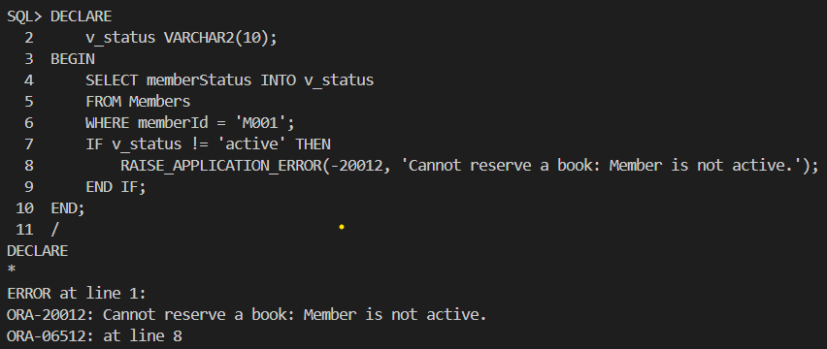

Exception 2: Default Exception Handling
Implementation: Report - rpt_reservation_by_statusmonth
Purpose:
The NO_DATA_FOUND exception handling ensures reports degrade gracefully when no matching records exist. Instead of showing errors, the code outputs a friendly "No reservations found" message, improving user experience. This is particularly important for scheduled reports that might run with empty result sets. The exception handling preserves the professional appearance of reports while maintaining system stability, as unhandled exceptions could interrupt automated report generation processes.
SQL Statement:
DECLARE
v_total_reservations NUMBER;
p_status VARCHAR2(20) := 'Pending';
BEGIN
SELECT COUNT(*) INTO v_total_reservations
FROM Reservation
WHERE reservationStatus = p_status;

DBMS_OUTPUT.PUT_LINE('Total reservations: ' || v_total_reservations);
EXCEPTION
WHEN NO_DATA_FOUND THEN
DBMS_OUTPUT.PUT_LINE('No reservations found.');
END;
/

Sample output:

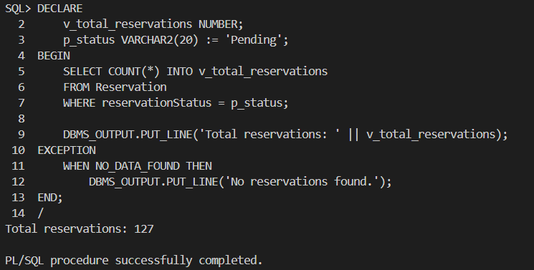

Exception 3: Custom Execption
Implementation: Stored Procedure 2 - CheckBookAvailability
Purpose:
The custom ex_invalid_book exception (-20020) validates input data quality by verifying book IDs exist before processing availability checks. This proactive error handling prevents misleading "0 available" results for nonexistent books, instead clearly indicating invalid references. Custom exceptions make the code more readable by giving semantic meaning to error conditions, while the PRAGMA INIT associates it with a unique error number for consistent error handling throughout the application.
SQL Statement:

DECLARE
ex_invalid_book EXCEPTION;
PRAGMA EXCEPTION_INIT(ex_invalid_book, -20020);
v_count NUMBER;
p_bookId BookTitles.bookId%TYPE := 'B001';
BEGIN
SELECT COUNT(*) INTO v_count FROM BookTitles WHERE bookId = p_bookId;
IF v_count = 0 THEN
RAISE ex_invalid_book;
END IF;

EXCEPTION
WHEN ex_invalid_book THEN
DBMS_OUTPUT.PUT_LINE('Invalid Book ID provided.');
END;
/

5.1.5 Sequences

Sequence 1: Reservation_seq

Purpose:
This sequence is designed to generate unique reservation IDs (starting from R351, R352,...) for new records in the Reservation table.

Justification and Usage: (Stored Procedure 1: AddNewReservation)
The Reservation_seq sequence is used to:
- Generate Unique Reservation IDs and Avoids Manual ID Management
- Automatically assigns the next available reservation ID (e.g., R351, R352, etc.) when inserting a new record.
- Eliminates the risk of human error in assigning reservation IDs.
- Ensures uniqueness without requiring a SELECT MAX(reservationId) check.
- Ensures no duplicates or manual ID assignment errors.
- Format the ID Correctly
- Combines with 'R' to create a structured ID (e.g., R001, R002).
Justification
- Thread-Safe for Concurrent Reservations
  - Multiple users can reserve books simultaneously without ID conflicts.
  - Oracle handles sequence increments atomically.
- Scalable for High-Volume Systems
  - Efficiently generates IDs even with thousands of reservations.
  - Reduces database overhead compared to manual ID generation.
This sequence guarantees unique reservation IDs by automation where no manual tracking needed. It is audit compliancewhere sequential IDs help track reservation history.

SQL Statement:
-- Sequence: Reservation_seq
-- Latest Key Value: R350

CREATE SEQUENCE Reservation_seq
START WITH 351
INCREMENT BY 1
NOCACHE
NOCYCLE;

5.1.6 Output Formatting

Query 1: Total Reservation Handled by Each Staff per Shift

Format Element | SQLPLUS Command | Description
Environment Setup | -- SETUP SQLPLUS ENVIRONMENT  SET LINESIZE 200  SET PAGESIZE 50  SET WRAP OFF  SET TRIMSPOOL ON | Configures the SQL*Plus environment for optimal report display. It sets the line width to 200 characters, page length to 50 lines, disables text wrapping, and enables trimming of trailing spaces in output files. These settings ensure clean, consistent formatting when viewing or exporting the report results.
Column Format | -- FORMAT OUTPUT FOR SQLPLUS  COLUMN "STAFF ID" FORMAT A10  COLUMN "STAFF NAME" FORMAT A25  COLUMN "SHIFT ID" FORMAT A10  COLUMN "SHIFT TYPE" FORMAT A20  COLUMN "START TIME" FORMAT A10  COLUMN "END TIME" FORMAT A10  COLUMN "TOTAL RESERVATIONS" FORMAT 9999 | Defines specific formatting for each column in the output. It allocates character widths for staff IDs (10), names (25), shift information (10-20), time displays (10 each), and reservation counts (4-digit numeric). This careful column sizing guarantees proper alignment and prevents data truncation in the final report.
Header Display | -- HEADER  PROMPT  PROMPT ======================== TOTAL RESERVATIONS HANDLED BY EACH STAFF PER SHIFT (RANKED) ========================  PROMPT | Descriptive header that clearly labels the report's purpose: "TOTAL RESERVATIONS HANDLED BY EACH STAFF PER SHIFT (RANKED)". This prominent title immediately communicates the report's focus on staff performance metrics, specifically their reservation handling efficiency across different work shifts.

Query 2: Recent Member Reservation Activity (Apr-Jun 2024)

Format Element | SQLPLUS Command | Description
Environment Setup | -- SETUP SQLPLUS ENVIRONMENT  SET LINESIZE 200  SET PAGESIZE 30  SET WRAP OFF  SET TRIMSPOOL ON | Configuries the SQL*Plus environment for optimal report generation. It establishes a 200-character line width and 30-line page length while disabling text wrapping and enabling space trimming in output files. These settings ensure clean, readable report formatting whether viewed on screen or exported.
Column Format | -- FORMAT OUTPUT FOR SQLPLUS  COLUMN "MEMBER ID" FORMAT A10  COLUMN "MEMBER NAME" FORMAT A25  COLUMN "LATEST RESERVATION" FORMAT A19  COLUMN "TOTAL RESERVATIONS" FORMAT 9999  COLUMN "RESERVED BOOK ID(S)" FORMAT A30 | Defines specific formatting for each data column in the report. It allocates space for member IDs (10 characters), names (25 characters), reservation dates (19 characters), reservation counts (4-digit numeric), and book IDs (30 characters). This careful column sizing prevents data truncation and maintains proper alignment in the output.
Header Display | -- HEADER  PROMPT  PROMPT =========================== RECENT MEMBERS RESERVATION ACTIVITY (APR-JUN 2024) ===========================  PROMPT | Descriptive header labeling the report as "RECENT MEMBERS RESERVATION ACTIVITY (APR-JUN 2024)". This title immediately identifies the report's focus on member reservation patterns during the specified quarterly period, helping users quickly understand the report's scope and timeframe.

5.2 Tan Yen Ping

5.2.1 Views

View 1: BorrowingReturnTracking
Purpose:
- It provides a summarized view of borrowing activities and return statuses for each member on date.
- This view simplifies the generation of borrowing performance reports by consolidating relevant information such as total borrows, distinct book borrowed and total books returned.
- It is particularly useful for reporting modules that monitor borrowing trends, evaluate member engagement, and track return rates in a given period.

SQL Statement:
CREATE VIEW BorrowingReturnTracking AS
SELECT
TO_CHAR(bb.borrowDate, 'DD-MON-YYYY') AS "DATE",
m.memberId AS "MEMBER ID",
m.memberName AS "MEMBER NAME",
COUNT(bb.borrowId) AS "TOTAL BORROWS",
COUNT(DISTINCT bb.copyId) AS "TOTAL BOOKS BORROWED",
SUM(CASE WHEN bb.returnStatus = 'Returned' THEN 1 ELSE 0 END) AS "TOTAL RETURNED"
FROM
BorrowedBooks bb
JOIN
Members m ON bb.memberId = m.memberId
JOIN
BookCopies bc ON bb.copyId = bc.copyId
JOIN
BookTitles bt ON bc.bookId = bt.bookId
GROUP BY
bb.borrowDate, m.memberId, m.memberName;

Sample Output:
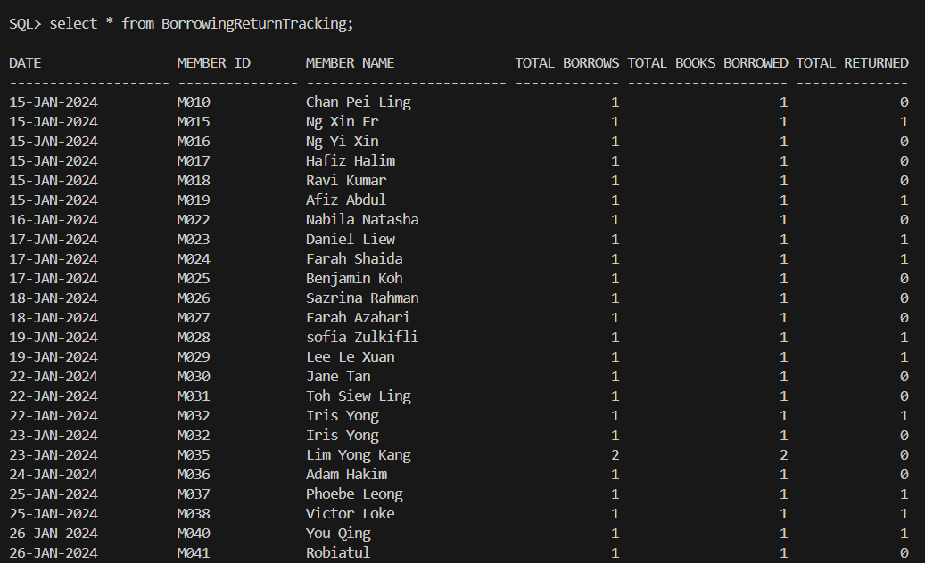

View 2: Book_Borrow_Return_History

Purpose:
- To provide a detailed history of each book borrowing transaction along with its return status and associated audit actions.
- This view combines data from multiple related tables to present a complete record of book movements, including who borrowed the book, when it was due, whether it was returned or lost, and what actions staff performed.
- It is useful for tracking individual transactions, supporting return history analysis, and auditing staff actions involved in book management.

SQL Statement:
CREATE OR REPLACE VIEW Book_Borrow_Return_History AS
SELECT
bt.title AS "BOOK TITLE",
bb.memberId AS "MEMBER ID",
bb.borrowDate AS "BORROW DATE",
bb.dueDate AS "DUE DATE",
bb.returnStatus AS "RETURN STATUS",
ba.actionType AS "ACTION TYPE",
ba.staffId AS "STAFF ID",
ba.actionDate AS "ACTION DATE"
FROM
BorrowedBooks bb
JOIN
BookCopies bc ON bb.copyId = bc.copyId
JOIN
BookTitles bt ON bc.bookId = bt.bookId
JOIN
BookAudit ba ON bb.borrowId = ba.borrowId;

Sample Output:
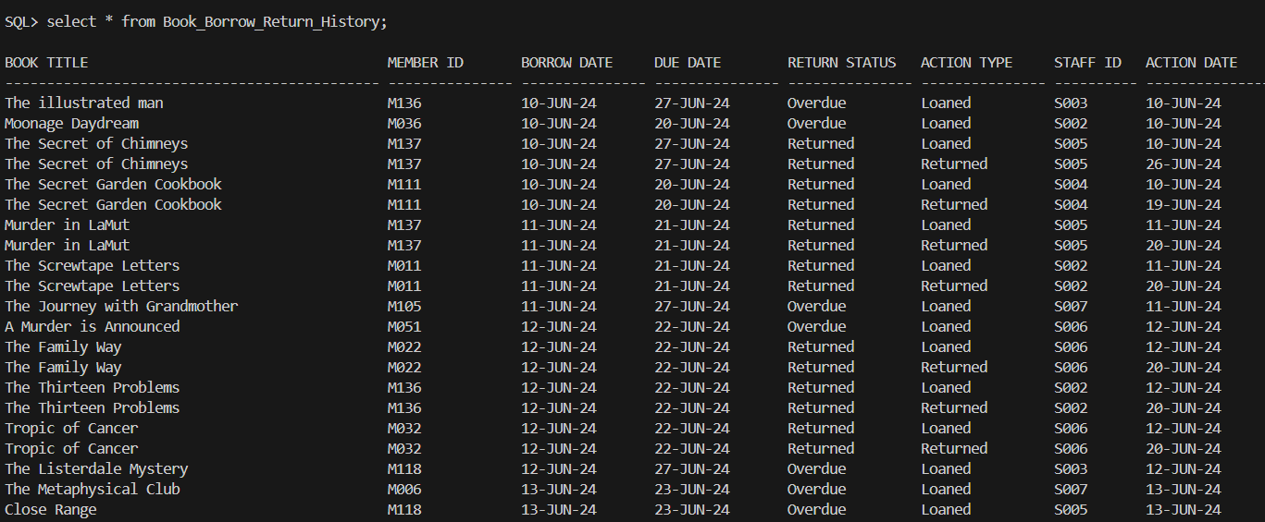

5.2.2 Indexes

Indexes 1: idx_borrow_month
Purpose:
To enhance performance of queries that involve filtering, grouping, or analyzing borrow records by month and year.

Usage and Justification:
- This index is specifically created to support SQL reports and PL/SQL procedures that analyze trends on a monthly basis.
- It enhances the efficiency of conditions like TO_CHAR(borrowDare, ‘MON-YYYY’ which appear frequently in monthly reports.
- By indexing the formatted date, the system can quickie relevant records using the indexed expression.
SQL Statement:
-- For faster filtering/grouping by month
CREATE INDEX idx_borrow_month ON BorrowedBooks (TO_CHAR(borrowDate, 'MON-YYYY'));

Indexes 2: idx_borrow_member_book
Purpose:
To improve performance for member-centric borrow history reports that involve sorting or filtering by member and borrow date.

Usage and Justification:
- This index supports detailed reporting modules that analyze borrowing behavior of members over time.
- It is especially useful in reports that sort, filter, or rank borrowing data by memberId and borrowDate, such as in the rpt_Top_Members procedure where frequent access is needed to find which members borrowed the most books.
- The combination of memberId and borrowDate ensures that the system can quickly retrieve a member's borrow history in chronological order, which is critical for audit tracking and performance analytics.
- This reduces the need for repeated sorting operations and enhances join efficiency with other tables such as BookAudit.

SQL Statement:
-- For report sorting and ranking
CREATE INDEX idx_borrow_member_book ON BorrowedBooks (memberId, borrowDate)

5.2.3 User Defined Functions

Function 1: Get_Borrow_Duration
Purpose:
To calculate the number of days a book was borrowed based on the borrow and return dates.

Usage and Justification:
This function is useful in reports to show how long members keep borrowed books. It helps monitor borrowing behavior and detect late returns or misuse.

SQL Statement:
CREATE OR REPLACE FUNCTION Get_Borrow_Duration(
p_borrow_date IN DATE,
p_return_date IN DATE
) RETURN NUMBER IS
BEGIN
IF p_return_date IS NULL THEN
RETURN 0;
ELSIF p_return_date < p_borrow_date THEN
RETURN 0;
ELSE
RETURN TRUNC(p_return_date - p_borrow_date);
END IF;
END;
/

Function 2: Get_Member_Since_Days
Purpose:
To calculate the number of days since a member registered.

Usage and Justification:
This function is useful in member-related reports to indicate how long a user has been active in the library system. It helps categorize long-term vs new members.

SQL Statement:
CREATE OR REPLACE FUNCTION Get_Member_Since_Days(
p_registration_date IN DATE
) RETURN NUMBER IS
v_today DATE := TO_DATE('10-JUL-2024', 'DD-MON-YYYY');
BEGIN
RETURN TRUNC(v_today - p_registration_date);
END;
/

Function 3: Get_Extension_Percent
Purpose:
To calculate the percentage of total book loan extensions made by a specific member in a given month.

Usage and Justification:
This function supports loan extension summary reports. It helps track individual contributions to total extension requests, useful for identifying heavy users or potential abusers of the extension system.

SQL Statement:
CREATE OR REPLACE FUNCTION Get_Extension_Percent(
p_member_id IN VARCHAR2,
p_month IN VARCHAR2
) RETURN NUMBER IS
v_total_extensions NUMBER;
v_member_extensions NUMBER;
BEGIN
-- Calculate total loan extensions in the given month
SELECT COUNT(*)
INTO v_total_extensions
FROM BorrowedBooks
WHERE TO_CHAR(returnDate, 'MON-YYYY') = UPPER(p_month)
AND extendStatus = 'Approved';

-- Calculate the number of extensions for the specific member in the given month
SELECT COUNT(*)
INTO v_member_extensions
FROM BorrowedBooks
WHERE memberId = p_member_id
AND TO_CHAR(returnDate, 'MON-YYYY') = UPPER(p_month)
AND extendStatus = 'Approved';

-- Calculate the percentage contribution
IF v_total_extensions > 0 THEN
RETURN (v_member_extensions / v_total_extensions) * 100;
ELSE
RETURN 0;
END IF;
EXCEPTION
WHEN NO_DATA_FOUND THEN
RETURN 0;
END;
/

5.2.4 User Defined Exceptions

Exception 1: Book Audit Validation Rules
Implementation: Trigger 2 - trg_prevent_invalid_action
Purpose: To prevent audit logging unless the book is correctly marked as 'Returned' or 'Lost'.
SQL Statement:
RAISE_APPLICATION_ERROR(-20001, 'Book must be marked as Returned in BorrowedBooks to log a Returned action.');
RAISE_APPLICATION_ERROR(-20002, 'Book must be marked as Lost in BorrowedBooks to log a Lost action.');

Exception 2: Check if the member exists
Implementation: Stored Procedure 1 - Add_Borrowed_Book
Purpose: To prevent the insertion of a borrowed record for a non-existent member.
SQL Statement:
RAISE_APPLICATION_ERROR(-20001, 'Member does not exist.');

Exception 3: Handle general errors in Add_Borrowed_Book
Implementation: Stored Procedure 1 - Add_Borrowed_Book
Purpose: To catch unexpected errors during the borrow operation and ensure transaction rollback.
SQL Statement:
EXCEPTION
WHEN OTHERS THEN
ROLLBACK;
DBMS_OUTPUT.PUT_LINE('Error: ' || SQLERRM);
END;
/

Exception 4: Handle error in SP-Get_Book_Status
Implementation: Stored Procedure 2 - Get_Book_Status
Purpose: To handle no results, invalid input, or unknown errors during book status report generation.
SQL Statement:
EXCEPTION
-- Handling errors when no records are found
WHEN NO_DATA_FOUND THEN
DBMS_OUTPUT.PUT_LINE('No records found for the specified month: ' || p_month || ' and status: ' || p_status_filter || '.');

-- Handling invalid month format or any other input-related issues
WHEN VALUE_ERROR THEN
DBMS_OUTPUT.PUT_LINE('Invalid input provided. Please check the format of the month or status.');

-- Handling any other unexpected errors
WHEN OTHERS THEN
DBMS_OUTPUT.PUT_LINE('An unexpected error occurred: ' || SQLERRM);
DBMS_OUTPUT.PUT_LINE('Please check your input or the system configuration.');
END;

Exception 5: Check Any Data in Function Get_Extension_Percent
Implementation: Function 2 - Get_Extension_Percent
Purpose: To return 0 if no approved extensions are found, avoiding divide-by-zero or null errors.
SQL Statement:
EXCEPTION
WHEN NO_DATA_FOUND THEN
RETURN 0;
END;

5.2.5 Sequence

Sequence 1: bookaudit_seq
Purpose:
To auto-generate unique auditId values for each new record in the BookAudit table.

Usage and Justification:
- Used in the trg_generate_audit_id trigger to assign IDs like BA0524, BA0525, etc.
- Ensures consistency and avoids manual ID entry.
- Maintains audit trail integrity.

SQL Statement:
CREATE SEQUENCE bookaudit_seq
START WITH 525
INCREMENT BY 1
NOCACHE
NOCYCLE;

Sequence 2: borrow_seq
Purpose:
To generate unique borrowId values for new records in the BorrowedBooks table.

Usage and Justification:
- Used during book borrowing operations to insert new borrowing records.
- Prevents ID duplication and ensures proper linking with audit and return data.
- Simplifies reference and tracking of borrow transactions.

SQL Statement:
CREATE SEQUENCE borrow_seq
START WITH 346
INCREMENT BY 1
NOCACHE
NOCYCLE;

5.2.6 Output Formatting

Query 1 - Borrowing And Member Activity Tracking
Format Element | SQLPLUS Command | Description
Environment Setup | SET LINESIZE 200  SET PAGESIZE 50  SET WRAP OFF  SET TRIMSPOOL ON | SET LINESIZE 200 and SET PAGESIZE 50 ensure the query output fits neatly on screen. WRAP OFF prevents line wrapping, and TRIMSPOOL ON removes trailing spaces when spooling.
Column Format | COLUMN "DATE" FORMAT A20  COLUMN "MEMBER ID" FORMAT A15  COLUMN "MEMBER NAME" FORMAT A25  COLUMN "TOTAL BORROWS" FORMAT 9999  COLUMN "TOTAL BOOKS BORROWED" FORMAT 9999  COLUMN "TOTAL RETURNED" FORMAT 9999 | COLUMN commands format output columns like "DATE", "MEMBER NAME", and totals to keep the data aligned and easy to read during display.
Header Display | PROMPT  PROMPT ================================= BORROWING AND MEMBER RETURN RATE TRACKING ==================================== | PROMPT commands show a clear title before the query runs, helping users quickly identify the purpose of the report.

Query 2 - Borrowing Status And Return History
Format Element | SQLPLUS Command | Description
Environment Setup | SET LINESIZE 200  SET PAGESIZE 50  SET WRAP OFF  SET TRIMSPOOL ON | Same settings as Query 1 to maintain wide, scroll-friendly formatting without line wrapping or clutter.
Column Format | COLUMN "BOOK TITLE" FORMAT A45  COLUMN "MEMBER ID" FORMAT A10  COLUMN "BORROW DATE" FORMAT A15  COLUMN "DUE DATE" FORMAT A15  COLUMN "RETURN STATUS" FORMAT A15  COLUMN "ACTION TYPE" FORMAT A15  COLUMN "STAFF ID" FORMAT A10  COLUMN "ACTION DATE" FORMAT A15 | Used to align key fields such as "BOOK TITLE", "RETURN STATUS", and "ACTION DATE" for a structured, readable output.
Header Display | PROMPT  PROMPT ========================================= BORROWING STATUS AND RETURN HISTORY ================================================  PROMPT | PROMPT creates a section title before the query to clearly mark the beginning of the Borrowing Status report.

Report 1 - Report 1- Detail report of Top 5 Members Who Borrowed Books in a Given Months
Format Element | SQLPLUS Command | Description
Environment Setup | SET SERVEROUTPUT ON;  SET PAGESIZE 1000;  SET LINESIZE 300; | SET SERVEROUTPUT ON is required to enable DBMS_OUTPUT.PUT_LINE for printing. LINESIZE 300 and PAGESIZE 1000 allow full-width, uninterrupted output.
Column Format | DBMS_OUTPUT.PUT_LINE('----------------------------------------------------------------------------------------------');  DBMS_OUTPUT.PUT_LINE('Rank : #' || v_rank_no);  DBMS_OUTPUT.PUT_LINE('Member ID : ' || v_memberId);  DBMS_OUTPUT.PUT_LINE('Name : ' || v_memberName);  DBMS_OUTPUT.PUT_LINE('Telephone : ' || v_memberTel);  DBMS_OUTPUT.PUT_LINE('Books Borrowed: ' || v_total_borrowed);  DBMS_OUTPUT.PUT_LINE('Total Days : ' || v_total_duration_days || ' day(s)');  DBMS_OUTPUT.PUT_LINE('Joined For : ' || v_member_since_days || ' day(s)');  DBMS_OUTPUT.PUT_LINE('Book Details:');  DBMS_OUTPUT.PUT_LINE(RPAD(' BorrowID', 22) || RPAD('Title', 40) || RPAD('Borrow Date', 15) || RPAD('Return Date', 15) || 'Days'); | The report uses RPAD inside DBMS_OUTPUT.PUT_LINE to align columns like Borrow ID, Title, and Dates into neat rows, improving readability.
Header Display | DBMS_OUTPUT.PUT_LINE('==============================================================================================');  DBMS_OUTPUT.PUT_LINE('======================= TOP 5 MEMBERS WHO BORROWED BOOKS IN ' || UPPER(p_month) || ' =========================');  DBMS_OUTPUT.PUT_LINE('==============================================================================================');  DBMS_OUTPUT.PUT_LINE('Report Prepared By Manager : Mr.' || v_staffName);  DBMS_OUTPUT.PUT_LINE('Report Generated On: ' || TO_CHAR(SYSDATE, 'DD-MON-YYYY')); | DBMS_OUTPUT.PUT_LINE is used to print a title with the month, manager’s name, and generation date for clear context at the top of the report.

Report 2 - Summary report of Loan Extension
Format Element | SQLPLUS Command | Description
Environment Setup | SET PAGESIZE 1000;  SET LINESIZE 300; | Same settings as Report 1 ensure full output visibility and formatting for the summary report with no truncation.
Column Format | DBMS_OUTPUT.PUT_LINE('Member ID: ' || mrec.memberId ||  ', Name: ' || mrec.memberName ||  ', Tel: ' || mrec.memberTel);  DBMS_OUTPUT.PUT_LINE('Contribution to Total Extensions: ' || ROUND(v_percentage, 2) || '%');  DBMS_OUTPUT.PUT_LINE(' Borrow ID Book Title Borrow Date Due Date Return Date Extension Days');  DBMS_OUTPUT.PUT_LINE(RPAD('-', 98, '-')); | DBMS_OUTPUT.PUT_LINE structures loan extension details like member ID, book title, and extension days into aligned rows using RPAD.
Header Display | DBMS_OUTPUT.PUT_LINE('==================================================================================================');  DBMS_OUTPUT.PUT_LINE('=========================== Loan Extension Summary Report IN ' || v_month || ' ============================');  DBMS_OUTPUT.PUT_LINE('==================================================================================================');  DBMS_OUTPUT.PUT_LINE('Report Prepared By: Manager - ' || v_staffName);  DBMS_OUTPUT.PUT_LINE('Generated On: ' || TO_CHAR(SYSDATE, 'DD-MON-YYYY'));  DBMS_OUTPUT.PUT_LINE('Report Month: ' || v_month); | The header is printed with DBMS_OUTPUT.PUT_LINE showing the report month, manager name, and generation date to introduce the loan extension summary.

5.3 Tay Mian Yin

5.3.1 Views

View 1: MonthlyReservationOverview_View
Purpose:
The purpose of this view is to give a monthly overview of reservation activity across the library system. It aggregates and counts reservation records by month such as number of total reservations, unique members, completed, pending, and cancelled reservations, number of unique books reserved and latest reservation date for the month.

Justification and usage in query: Query 1 Monthly Reservations Overview
- Reusability:
The view captures it once for reuse instead of repeating this complex aggregation logic in numerous queries or reports.
- Simplicity and Readability:
The query using the view is much more readable and easier to maintain. The logic is abstracted.
- Consistency:
Reports built from this view will always use the same logic and formatting to reduce the chance of varying results between systems.
- Performance:
If indexed properly and used in reporting tools, the view can be optimized for performance, especially if materialized.

SQL Statement:
CREATE OR REPLACE VIEW MonthlyReservationsOverview AS
SELECT
TO_CHAR(r.reservationDate, 'YYYY-MM') AS month,
COUNT(r.reservationId) AS total_reservations,
COUNT(DISTINCT r.memberId) AS unique_reservers,
SUM(CASE WHEN r.reservationStatus = 'Available' THEN 1 ELSE 0 END) AS fulfilled_reservations,
SUM(CASE WHEN r.reservationStatus = 'Pending' THEN 1 ELSE 0 END) AS pending_reservations,
SUM(CASE WHEN r.reservationStatus = 'Cancelled' THEN 1 ELSE 0 END) AS cancelled_reservations,
COUNT(DISTINCT bc.bookId) AS distinct_books_reserved,
TO_CHAR(MAX(r.reservationDate), 'YYYY-MM-DD') AS latest_reservation
FROM
Reservation r
JOIN
BookCopies bc ON r.copyId = bc.copyId
JOIN
BookTitles bt ON bc.bookId = bt.bookId
WHERE
r.reservationDate IS NOT NULL
GROUP BY
TO_CHAR(r.reservationDate, 'YYYY-MM');

Sample Output:
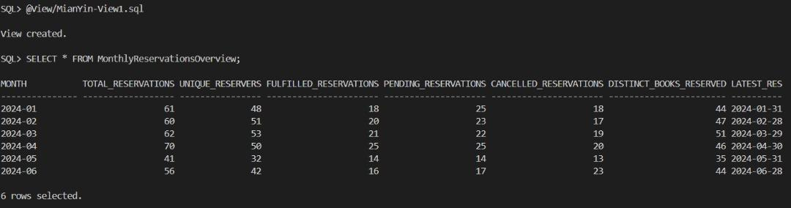

View 2: BookDemand_View
Purpose:
The purpose of this view is to identify high-demand books in the library that are currently unavailable for borrowing as the copies are not in ‘Available’ status and have more than 3 pending reservations. This gives the library a clear vision of frequently reserved books but currently in short supply, enabling better-informed acquisition and stock management decisions.

Justification and usage in query: Query 2 High-Demand Books: Frequently Reserved but Unavailable
- Focus on Key Insights:
Rather than looking at all the rows of the reservations table, the view restricts itself to books with demand greater than the threshold like more than 3 pending reservations. This highlights resource bottlenecks and focuses on underserved user demand.
- Reusability:
The join table logic, filtering on status, counting of reservations, and application of threshold is complex and would be reusable across different reports or dashboards from this single view.
- Improved Readability and Maintainability:
Since this logic has been abstracted out to a view, downstream queries are simple, readable, and less prone to errors.
- Strategic Decision-Making:
This view would be a goldmine in collection development decision-making such as re-ordering titles, digitizing, or making priorities for purchasing.

SQL Statement:
CREATE OR REPLACE VIEW BooksDemandView AS
SELECT
bt.title AS title,
COUNT(r.reservationId) AS total_reservations
FROM
BookTitles bt
JOIN
BookCopies bc ON bt.bookId = bc.bookId
JOIN
Reservation r ON bc.copyId = r.copyId
WHERE
bc.bookStatus != 'Available'
AND r.reservationStatus = 'Pending'
GROUP BY
bt.title
HAVING
COUNT(r.reservationId) > 3;

5.3.2 Indexes

Indexes 1: idx_shiftdate
Purpose:
The main purpose of this index is to optimize the performance of queries and procedures that filter shift schedules by date, especially when using: WHERE TRUNC(shiftDate) = TRUNC(p_shiftDate). Since the TRUNC() function removes the time component, it disables the use of regular indexes on shiftDate. Creating a function-based index on TRUNC(shiftDate) enables Oracle to quickly find matching records based on just the date, even when time values are stored in the column.

Justification and usage:
- Performance
Improve the performance of On-Demand Detailed Attendance Report by Shift Date. This report is date driven. Each time it is run, it filters shifts by date. A function-based index ensures that this filtering function works efficiently, even if the shiftDate column contains time values.
- Avoiding Full Table Scans
Without an index, Oracle scans all rows to calculate TRUNC(shiftDate) = TRUNC(p_shiftDate), which is expensive for large data sets.
- Supports Real-Time On-Demand Reporting
This report is triggered by the user via an ACCEPT v_date statement, so response time is critical. This index ensures that the report is generated quickly and does not slow down the system.
- Best Practice for Function-Based Filtering
Because the WHERE clause contains TRUNC(), this index follows Oracle's best practices to pre-compute the results and index them.

SQL Statement:
-- Index 1: For Detailed Attendance Report by Shift Date
CREATE INDEX idx_shiftdate ON ShiftSchedules(TRUNC(shiftDate));

Indexes 2: idx_sa_status_sched
Purpose:
The purpose of this index is designed to optimize the performance of queries in the rpt_late_attendance_report procedure, specifically queries that filter on attendanceStatus = 'Late' and join with scheduleId. This index is a composite index, which means it covers two columns that are often used together in WHERE clauses and JOIN conditions in reports.

Justification for the Index:
- Improved Query Performance
The index speeds up row retrieval where attendanceStatus = 'Late' is a frequent filter. This is especially useful for large datasets where only a small fraction of records (late records) are relevant for reporting.
- Efficient Joins
Since scheduleId is used to join StaffAttendance with ShiftSchedules, the index supports faster join operations.
- Supports Reporting Needs
This index is designed to optimize reports that HR or administrators may run regularly. Employee punctuality reports are time-sensitive and data-intensive. The index ensures that results are delivered in a timely manner.
- Minimizes Full Table Scans
Without an index, the system may perform a full table scan of the StaffAttendance table to find late records, which is inefficient.
- Balanced Indexing
By indexing (attendanceStatus, scheduleId), the index balances filter selectivity and join efficiency.

SQL Statement:
-- Index 2: For Late Attendance Report
CREATE INDEX idx_sa_status_sched ON StaffAttendance(attendanceStatus, scheduleId);

5.3.3 User Defined Functions

Function 1: Get Shift Duration
Purpose:
The purpose of this function is to calculate the total duration of a shift (in hours and minutes) based on its start and end times. It converts a time difference (in DATE format) into a human-readable duration like "3h 45m".
Justification and usage in report: Report 1 On-Demand Detailed Attendance Report by Shift Date (rpt_attend_detail_by_date)
- Reusability and abstraction
The time difference calculation logic is abstracted into a reusable function. It can be used in other processes or queries that require shift durations without rewriting the logic.
- Improve readability
The report readability is improved by displaying the time in "xh ym" format (rather than raw timestamps). It is easier for managers or employees to quickly understand the duration of each shift.
- Simplify the main report logic
Keep the report flow simple and focus on the structure/format. The function handles the formatting details and reduces the clutter inside the main report.
- Handle exceptions gracefully
The built-in exception handling ensures that if any invalid time is passed, the function will return "invalid time" instead of causing the report to crash.
- Report consistency
Standardize the calculation and display of durations, especially when used in multiple reports or UI components.
SQL Statement:
CREATE OR REPLACE FUNCTION get_shift_duration(
p_start_time IN DATE,
p_end_time IN DATE
) RETURN VARCHAR2
IS
v_minutes NUMBER;
v_hours NUMBER;
BEGIN
v_minutes := ROUND((p_end_time - p_start_time) * 24 * 60);
v_hours := TRUNC(v_minutes / 60);
v_minutes := MOD(v_minutes, 60);

RETURN TO_CHAR(v_hours) || 'h ' || TO_CHAR(v_minutes) || 'm';
EXCEPTION
WHEN OTHERS THEN
RETURN 'Invalid Time';
END;
/

Function 2: Calculate Minutes Late
Purpose:
This function is designed to calculate the delay (lateness) of an employee by comparing the employee's actual shift start time with the scheduled start time. It returns the result in minutes. It safely returns NULL in case of any error (such as null value). This function helps to standardize the time difference calculation logic and can be reused wherever tardiness calculation is required.
Justification and usage in report: Report 2 Late Attendance Report (rpt_late_attendance_report)
- Encapsulation of Reusable Logic
Time difference calculations can be complex and may appear in multiple reports or modules. By putting it in a function, you only need to encapsulate the logic once and call it when needed.
- Improved Readability
The main program (rpt_late_attendance_report) is more concise and easier to read. Instead of repeatedly embedding formulas, it is called as a self-explanatory function: calculate_minutes_late().
- Maintainability
If the calculation logic changes such as rounding rules or break time adjustments, just update it in the function, not in every report.
- Improved Report Accuracy
Minutes of lateness is a key indicator for human resources and performance appraisal. Ensure that lateness is calculated and displayed consistently across all reports.
SQL Statement:
CREATE OR REPLACE FUNCTION calculate_minutes_late(
p_actual_start IN DATE,
p_scheduled_start IN DATE
) RETURN NUMBER
IS
v_minutes NUMBER;
BEGIN
-- Calculate time difference in minutes
v_minutes := ROUND((p_actual_start - p_scheduled_start) * 24 * 60);
RETURN v_minutes;
EXCEPTION
WHEN OTHERS THEN
RETURN NULL;
END;
/

5.3.4 User Defined Exceptions

Exception 1: table_missing
Implementation: Stored Procedure 1 - proc_check_shift_overlap
Implementation: Stored Procedure 2 - proc_staff_attendance_summary
Purpose:
The table_missing exception is explicitly designed to catch the Oracle error ORA-00942, which occurs when a table or view does not exist in the database. This maps the system error ORA-00942 to a named exception (table_missing), which you can handle specifically in the EXCEPTION block.
Justification of Using table_missing Exception:
- Improved User Feedback
- Debugging Support
It helps developers or database administrators quickly identify whether the problem is due to a dropped or missing table, a typo in the table name, or missing permissions.
- System Resilience and Graceful Failure
Instead of crashing or stopping execution, the process handles the problem gracefully and continues to run without breaking the entire application.
- Production Readiness
Especially in production systems, missing objects due to migration errors or environment mismatches can cause serious problems. This exception helps to detect such issues explicitly.
SQL Statement:
table_missing EXCEPTION;
PRAGMA EXCEPTION_INIT(table_missing, -00942);

WHEN table_missing THEN
DBMS_OUTPUT.PUT_LINE('Error: Required table or view does not exist. Please check ShiftSchedules table.');

WHEN table_missing THEN
DBMS_OUTPUT.PUT_LINE('Error: Missing required table/view. Please check StaffAttendance or ShiftSchedules.');

Exception 2: WHEN OTHERS
Implementation: Stored Procedure 1 - proc_check_shift_overlap
Implementation: Stored Procedure 2 - proc_staff_attendance_summary
Purpose:
1. Error Handling Safety Net - Catches all unexpected or unhandled errors that occur during procedure execution.
2. Debugging and Logging - Can be used to print/log SQLERRM (error message) and SQLCODE for further debugging.
3. Prevent Program Crashes - Prevents the abrupt termination of procedures or packages due to unhandled errors.
Justification:
1. Unknown Runtime Errors - There may be unexpected issues like null values, division by zero, type mismatches, etc., not known at design time.
2. Robustness - Ensures the procedure doesn't terminate midway; it handles the error gracefully and continues system execution.
3. Minimal Debug Info Exposure - Prevents exposure of sensitive internal database errors directly to end-users, while still printing meaningful messages for developers.
SQL Statement:
WHEN OTHERS THEN
DBMS_OUTPUT.PUT_LINE('Error checking shift overlap: ' || SQLERRM);
WHEN OTHERS THEN
DBMS_OUTPUT.PUT_LINE('Error generating summary: ' || SQLERRM);

5.3.5 Sequence

Sequence 1: shift_schedules_seq
Purpose:
The purpose of this sequence is to automatically generate unique scheduleId values when adding a new record into the ShiftSchedules table. It is used to avoid manual input and ensure data integrity.
SQL Statement:
CREATE SEQUENCE shift_schedules_seq
START WITH 423
INCREMENT BY 1
NOCACHE
NOCYCLE;

Sequence 2: staff_attendance_seq
Purpose:
The purpose of this sequence is to automatically generate unique attendanceId values when adding a new record into the StaffAttendance table. It is used to avoid manual input and ensure data integrity.
SQL Statement:
CREATE SEQUENCE staff_attendance_seq
START WITH 423
INCREMENT BY 1
NOCACHE
NOCYCLE;

5.3.6 Output Formatting
Query 1 - Monthly Reservations Overview
Format Element | SQLPLUS Command | Description
Environment Setup | SET LINESIZE 200  SET PAGESIZE 100  SET TRIMSPOOL ON  SET TAB OFF  SET FEEDBACK ON  SET VERIFY OFF | - Make each page of output longer for better readability.  - Make each page of output wider for better readability.  - Removes extra spaces when saving to a file  - Ensures alignment by using spaces instead of tabs.  - Displays the number of lines affected by each command.  - Hides repeated prompts when using input variables, resulting in a clearer display.
Column Format | COLUMN "Month" FORMAT A15  COLUMN "Total Reservations" FORMAT 9999  COLUMN "Unique Reservers" FORMAT 9999  COLUMN "Fulfilled Reservations" FORMAT 9999  COLUMN "Pending Reservations" FORMAT 9999  COLUMN "Cancelled Reservations" FORMAT 9999  COLUMN "Distinct Books Reserved" FORMAT 9999  COLUMN "Latest Reservation" FORMAT A20 | Define the width of each column and how numbers or text are displayed to make your reports more organized and easier to interpret.
Header Display | PROMPT  PROMPT ================================================================== Monthly Reservations Overview ==================================================================  PROMPT | Add a custom title or label to the top of your output to help users understand what the report shows before the actual data appears.
Query 2 - High-Demand Books: Frequently Reserved but Unavailable

Format Element | SQLPLUS Command | Description
Environment Setup | SET LINESIZE 120  SET PAGESIZE 50  SET WRAP OFF  SET TRIMSPOOL ON | Control the appearance of the report when it is displayed and ensure that the output is readable on the screen or in a file, properly spaced, and neatly formatted.
Column Format | COLUMN "Title" FORMAT A60  COLUMN "Total Reservations" FORMAT 9999 | Define the width of each column and how numbers or text are displayed to make your reports more organized and easier to interpret.
Header Display | PROMPT  PROMPT =========== High-Demand Books: Frequently Reserved but Unavailable ============  PROMPT | Add a custom title or label to the top of your output to help users understand what the report shows before the actual data appears.

5.4 Tay Zhuang Yin

5.4.1 Views

VIEW 1: MemberBorrowStatus_VIEW
Purpose:
This view is to present the active members' borrowing activity by giving their ID and name, number of borrowed books, number of extensions with 'Pending' or 'Approved' status, and number of overdue returns. This view facilitates easing the analysis since you can notice directly which active members often extend borrowing time frames or overdue return.

Justification and usage in query: Query 1 Analysis of Active Members with High Extensions and Overdue Activity
The view is created to:
- Simplify complex logic by grouping JOINs and summations such as total borrowed books, extensions, and overdue returns into a form that can be reused.
- Encourage code readability and reusability by not having to duplicate complicated SQL in numerous queries.
- Focus on active members only, ensuring that reports and analysis are based on currently engaged users.
- Enable better data management by decoupling data preparation within the view from presentation of data in queries.
SQL Statement:
CREATE OR REPLACE VIEW vw_member_borrow_status AS
SELECT
m.memberId AS member_id,
m.memberName AS member_name,
COUNT(bb.borrowId) AS total_borrowed,
SUM(CASE WHEN bb.extendStatus IN ('Pending', 'Approved') THEN 1 ELSE 0 END) AS total_extensions,
SUM(CASE WHEN bb.returnStatus = 'Overdue' THEN 1 ELSE 0 END) AS overdue_count
FROM
Members m
JOIN
BorrowedBooks bb ON m.memberId = bb.memberId
JOIN
BookCopies bc ON bb.copyId = bc.copyId
WHERE
m.memberStatus = 'active'
GROUP BY
m.memberId, m.memberName;

VIEW 2: MemberFinePayments_VIEW
Purpose:
This view is to show fine payment activity per member by the member's name and ID, the total fines paid, and the total sum paid on the fines. It only considers fines with a status of 'Paid' so that full payments only would be accounted for. It helps in tracking and comparing members' financial responsibility by fine.

Justification and usage in query: Query 2 Top Members with Most Fine Payments
The view is created to:
- Joins Members, Payments, and Fines tables.
- Filters only fines with status 'Paid' to ensure only completed transactions are analyzed.
- Aggregates data to show member_id and member_name, total_fines paid and total_payment made by each member.
- Simplifies complex joins and aggregation logic.
- Improves code reusability, readability, and maintainability.

SQL Statement:
CREATE OR REPLACE VIEW vw_member_fine_payments AS
SELECT
m.memberId AS member_id,
m.memberName AS member_name,
COUNT(f.fineId) AS total_fines,
SUM(p.payAmount) AS total_payment
FROM
Members m
JOIN
Payments p ON m.memberId = p.memberId
JOIN
Fines f ON p.paymentId = f.paymentId
WHERE
f.fineStatus = 'Paid'
GROUP BY
m.memberId, m.memberName;

5.4.2 Indexes

Index 1: idx_payments_method_date
Purpose:
The index is to improve the efficiency of data retrieval operations on the Payments table by organizing the data based on the paymentMethod and paymentDate columns. This composite index allows the database to quickly locate and access records that match specific values in these columns, especially when filtering or sorting is involved. By indexing both paymentMethod and paymentDate together, the index supports queries that rely on one or both of these fields, enabling faster search operations and better query optimization.

Justification and Usage:
The purpose of the index improves performance for reports such as:
Report 1 - Fine Payment Trends Report (Jan to Jun 2024)
The index enhances the performance of the report rpt_fine_payment_trends_method by significantly reducing the time needed to filter and retrieve relevant payment records. Since the report repeatedly queries payment data by paymentMethod and a specific date range (paymentDate), the index enables the database engine to quickly locate matching records without scanning the entire Payments table. This is especially important in the c_monthly_trends and c_yearly_trends cursors, which rely on these conditions to group and summarize payments. By leveraging the index, these operations become more efficient, leading to faster report generation and better scalability as the volume of data grows.

SQL Statement:
-- Index 1: Payment Trends Report (rpt_fine_payment_trends_method)
CREATE INDEX idx_payments_method_date ON Payments(paymentMethod, paymentDate);

Index 2: idx_fines_status
Purpose:
The index is used to optimize query performance in searching fine records by status such as 'Unpaid' or 'Paid'. The index is most useful when the application needs to constantly search for fines of a specific status, since it organizes the data internally so that the database engine can easily identify and return only the required rows, rather than having to search through the entire Fines table. By indexing the fineStatus column, this table provides for quicker data retrieval and speeds up the responsiveness of operations in fine categorization.

Justification and Usage:
The purpose of the index improves performance for reports such as:
Report 2 - Unpaid Fine Analytics
The index enhances the performance of the rpt_unpaid_fine_analytics report by reducing considerably the time required to search for and read records where fineStatus = 'Unpaid'. This filter condition occurs in a number of locations within the report such as in the c_members and c_fine_details cursors, and in the unpaid fine counts' and totals' and date ranges' aggregate calculations. Without the index, these queries would perform full table scans on the Fines table, which would be slow, particularly with a huge number of fine records. With the index, the database can look up all the unpaid fines and fetch only such rows immediately, improving overall report execution performance and scalability.

SQL Statement:
-- Index 2: Unpaid Report (rpt_unpaid_fine_analytics)
CREATE INDEX idx_fines_status ON Fines(fineStatus);

5.4.3 User Defined Functions

Function 1: get_paid_amount
Purpose:
The purpose of this function is to calculate and return the total amount of fines paid via a given payment method within a given date range. It filters the Payments table to include only payments that have the paymentType as 'Fines', and then sums up the payAmount for payments that have the given payment method and fall within the given date range. This operation encourages code modularity and reuse by encapsulating the logic into a single callable unit, as well as gracefully catching exceptions to ensure the function always returns a numeric value, even in the event of an error.

Justification and Usage in Report 1 - Fine Payment Trends Report (Jan to Jun 2024)
In the rpt_fine_payment_trends_method report, the get_paid_amount function is employed to provide a quick and centralized view of the quantity of fine payments received for every distinct payment method (e.g., cash, card, online) in January and June 2024. It provides clarity and consistency to the report by removing the calculation logic from the procedural code body. This allows the report to query and report total fines paid by source directly, validating the accuracy of monthly and yearly trends subsequently reported in the report. Using the function, the report is rendered more adaptable to future development or reuse in other reporting modules requiring the same summed financial data.

SQL Statement:
CREATE OR REPLACE FUNCTION get_paid_amount(
p_method IN VARCHAR2,
p_start_date IN DATE,
p_end_date IN DATE
) RETURN NUMBER
IS
v_total_paid NUMBER := 0;
BEGIN
SELECT NVL(SUM(payAmount), 0)
INTO v_total_paid
FROM Payments
WHERE paymentMethod = p_method
AND paymentType = 'Fines'
AND paymentDate BETWEEN p_start_date AND p_end_date;

RETURN v_total_paid;
EXCEPTION
WHEN OTHERS THEN
RETURN 0;
END;
/

Function 2: get_paid_fines_count
Purpose:
The purpose of this function is to calculate and return how many fines have a status of 'Paid' for a member given their memberId. The function encapsulates the logic of tallying paid fines into a block of code that can be reused anywhere in the PL/SQL codebase, thus rendering the program more modular, readable, and maintainable. It also provides exception handling to gracefully return a default of 0 when there is no data, or -1 if any other type of errors are encountered during execution.

Justification and Usage in Report 2 - Unpaid Fine Analytics
In the rpt_unpaid_fine_analytics report, the get_paid_fines_count function is called to provide a complete financial picture of each member by showing not only their unpaid fine but also how many fines they have paid. This serves to make the report as useful as possible to library staff or administrators by showing member behavior—whether they will pay their dues in the end or not. It is complementary to the unpaid fine calculation by offering a contrastive measure of payment responsibility and supporting decision-making actions such as follow-ups, warnings, or privilege limitation. Having a distinct function is also useful in maintaining the primary process clean and focused towards report generation.

SQL Statement:
CREATE OR REPLACE FUNCTION get_paid_fines_count(p_memberId VARCHAR2)
RETURN NUMBER
IS
v_count NUMBER;
BEGIN
SELECT COUNT(*)
INTO v_count
FROM BorrowedBooks bb
JOIN Fines f ON bb.borrowId = f.borrowId
WHERE bb.memberId = p_memberId
AND f.fineStatus = 'Paid';

RETURN v_count;
EXCEPTION
WHEN NO_DATA_FOUND THEN
RETURN 0;
WHEN OTHERS THEN
RETURN -1;
END;
/

5.4.4 User Defined Exceptions

Exception 1: Return Status Checking
Implementation: StoredProcedure1 - Add New Fine

Purpose:
The exception ensures that the fine can only be applied if the return status of the book borrowed is "Overdue" or "Lost". When the v_returnStatus is not among these valid statuses, the RAISE_APPLICATION_ERROR function raises an error. The error number -20010 and the user-defined error message 'Error: Cannot apply fine. Invalid return status.' inform the user or system that the process to impose the fine cannot proceed due to an invalid or unexpected return status. This enforces business rules and prevents the imposition of fines on items with inappropriate return statuses, i.e., "Returned" and "On loan".

SQL Statement:
RAISE_APPLICATION_ERROR(-20010, 'Error: Cannot apply fine. Invalid return status.');
Sample output:
When the return status is entered as ‘Returned’, the following message will be displayed:

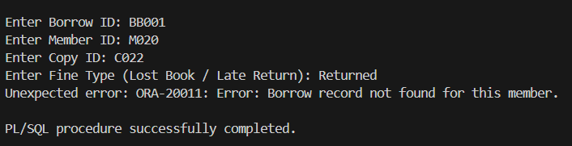

Exception 2: Member Existing Checking
Implementation: StoredProcedure2 - Get All Fine Records by Member
Purpose:
This exception is called to handle in particular the scenario where a function or procedure attempts to perform an operation on a library member that does not exist in the system's Members table. When this kind of condition is found—typically through a failed lookup or a search yielding no records—the exception is raised to cancel the operation and return a distinct, user-defined error message. Its role is to enforce data consistency and prevent unauthorized operations, such as inserting a fine, processing a loan, or registering a payment against a non-member. By raising this application-level exception, it ensures the system has consistent and valid relationships between data and provides helpful feedback for debugging or notifying users.

SQL Statement:
RAISE_APPLICATION_ERROR(-20001, 'Error: Member does not exist in the system.');

Sample output:
When the member id is entered as ‘M200’, the following message will be displayed:
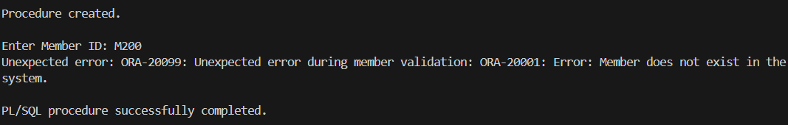

5.4.5 Sequences
Sequence 1: fines_seq
Purpose:
The fine_seq sequence is declared to generate sequential, unique numeric IDs starting from 210 automatically as fine identifiers. This way, all fine records in the system are assigned different IDs without any intervention by a human user. Incremented by 1 for every new fine, the sequence allows for uninterrupted and reliable generation of primary key values or identifiers to prevent duplication and improve data integrity.

Justification and Usage in Stored Procedure 1 - Add New Fine
In the AddFine procedure, the fines_seq sequence is used to generate a unique fineId for each new fine record being inserted. The output from the sequence (fines_seq.NEXTVAL) is concatenated with the character 'F' to generate a standard fine ID format. For instance, F210, F211, and so on. In this way, each fine has a traceable and identifiable id. Use of the sequence simplifies ID management within the process, avoids duplication or collision, and adheres to database best practices for creating primary keys in a multi-user system.

SQL Statement:
-- Sequence 1: Fines
-- Latest Key Values: F209
CREATE SEQUENCE fines_seq
START WITH 210
INCREMENT BY 1
NOCACHE
NOCYCLE;

Sequence 2: payments_seq
Purpose:
The payments_seq sequence is made to automatically produce distinct, increasing numbers beginning at 330 and continuing from the previous key value that was utilised, F329. Its primary function is to act as the system's automatic method for creating payment IDs. By doing this, the Payments table's data consistency and uniqueness are preserved, as each new payment record is given a unique and sequential identifier, doing away with the need for manual entry or tracking of the next available ID.

Justification and Usage
For effective payment record management, particularly when handling several transactions over time, the payments_seq sequence is essential. Payments_seq.NEXTVAL can be used to generate the numeric portion of a new paymentId, which is frequently paired with a prefix (such as 'F') to form IDs like F330, F331, and so on. This sequence can be called in procedures or triggers that insert new payment data. This method maintains payment ID assignment continuity, avoids duplication, and expedites record creation. It also facilitates scalability in multi-user settings by permitting conflict-free concurrent insertions, which is crucial for reliable transaction processing in library management systems.

SQL Statement:
-- Sequence 2: Payments
-- Latest Key Values: F329
CREATE SEQUENCE payments_seq
START WITH 330
INCREMENT BY 1
NOCACHE
NOCYCLE;

5.4.6 Output Formatting
Query 1 - Analysis of Active Members with High Extensions and Overdue Activity
Format Element | SQLPLUS Command | Description
Environment Setup | -- SETUP SQLPLUS ENVIRONMENT  SET linesize 120  SET pagesize 50  SET WRAP ON  SET TRIMSPOOL ON | Configures the display of query results to improve readability. SET LINESIZE 120 provides for wider lines, PAGESIZE 50 sets the number of rows per page, WRAP ON wraps long text rather than chopping it, and TRIMSPOOL ON removes superfluous spaces from spooled files for cleaner output.
Column Format | -- FORMAT OUTPUT FOR SQLPLUS  COLUMN "MEMBER ID" FORMAT A10  COLUMN "MEMBER NAME" FORMAT A20  COLUMN "TOTAL BORROWED" FORMAT 9999  COLUMN "TOTAL EXTENSIONS" FORMAT 9999  COLUMN "OVERDUE COUNT" FORMAT 9999 | Defines the width of each column, with "MEMBER ID" being 10 characters, "MEMBER NAME" 20 characters, and numeric columns like "TOTAL BORROWED", "TOTAL EXTENSIONS", and "OVERDUE COUNT" to display up to four digits.
Header Display | -- HEADER  PROMPT  PROMPT ==== Analysis of Active Members with High Extensions and Overdue Activity ====  PROMPT | This header provides a clear and descriptive title before the query output, assisting users in understanding that the next results are for active members with high extension and overdue activity.

Query 2 - Top Members with Most Fine Payments

Format Element | SQLPLUS Command | Description
Environment Setup | -- SETUP SQLPLUS ENVIRONMENT  SET linesize 120  SET pagesize 50  SET WRAP ON  SET TRIMSPOOL ON | Configures the display of query results to improve readability. SET LINESIZE 120 provides for wider lines, PAGESIZE 50 sets the number of rows per page, WRAP ON wraps long text rather than chopping it, and TRIMSPOOL ON removes superfluous spaces from spooled files for cleaner output.
Column Format | -- FORMAT OUTPUT FOR SQLPLUS  COLUMN "MEMBER ID" FORMAT A10  COLUMN "MEMBER NAME" FORMAT A20  COLUMN "TOTAL FINES" FORMAT 9999  COLUMN "TOTAL PAYMENT" FORMAT 9999.99 | Defines the width of each column, with "MEMBER ID" to 10, "MEMBER NAME" to 20, "TOTAL FINES" to show a maximum of four digits, and "TOTAL PAYMENT" to show a maximum of four digits with two places for decimal.
Header Display | -- HEADER  PROMPT  PROMPT ========== Top Members with Most Fine Payments ==========  PROMPT | This header provides a title that indicates the following query results will present the most contributing members who have paid the most fine. It provides clarity of the information that is being provided.

5.5 Wong Jin Xuan

5.5.1 Views

View 1: BookBorrow_View
Purpose:
The BookBorrow_View is designed to provide a summarized view of each book's borrowing activity by combining data from the BookTitles, BookCopies, and BorrowedBooks tables. It shows how many times each book (across all its copies) has been borrowed, along with key book details such as title, author, genre, publication year, and price.

This view essentially acts as a pre-processed popularity index that feeds into analytics or reporting modules like the ranked list, supporting decision-making for library acquisitions, promotions, or circulation policy.

Justification and Usage in the Query : Query 1 - Most Borrowed Books (Popular Books Ranking)
This view simplifies and optimizes the main query for generating a Top Borrowed Books Report by:

- Pre-aggregating borrow counts (total_borrows) per book, reducing repetitive joins and computations in the main report.
- Supporting Ranking: Since total_borrows is already computed in the view, it enables efficient use of the RANK() window function to determine the most popular books.
- Cleaner Query Logic: It helps modularize SQL logic by separating raw data aggregation from report formatting, making the report query easier to maintain and extend.
- User Input Friendly: Allows dynamic selection of the top N popular books (ACCEPT n NUMBER) using a ranked subquery that leverages the view.
SQL Statement:

CREATE OR REPLACE VIEW BookBorrow_view AS
SELECT
bt.bookId,
bt.title,
bt.author,
bt.genre,
bt.publicationYear,
COUNT(bb.borrowId) AS total_borrows,
bt.price
FROM
BookTitles bt
JOIN
BookCopies bc ON bt.bookId = bc.bookId -- Join with BookCopies to get the copies of books
JOIN
BorrowedBooks bb ON bc.copyId = bb.copyId -- Join with BorrowedBooks to count borrows
GROUP BY
bt.bookId, bt.title, bt.author, bt.genre, bt.publicationYear, bt.price;

Sample Output:
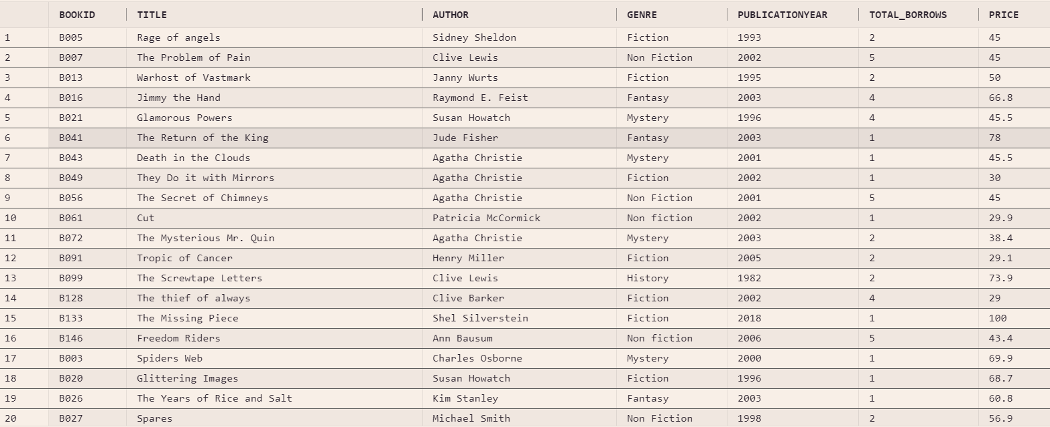

View 2: staff_basic_view
Purpose:
The staff_basic_view summarizes the number of shifts worked by each staff member. It filters out staff who have worked more than 10 shifts, focusing on employees with significant shift activity.

Justification and Usage in the Query : Query 2 - Staff Performance and Efficiency Analysis
This view simplifies performance analysis by pre-aggregating essential shift data:

- It reduces data volume by excluding low-activity staff.
- It supports efficient calculation of performance metrics like:
Total hours worked, Loans processed (for librarians and assistants), Efficiency score (loans per hour), Performance score (hours per shift adjusted by attendance)

In the main query, staff_basic_view acts as the foundation for computing detailed metrics by joining with ShiftSchedules (for attendance & shift details), StaffAttendance (to determine attendance status), and custom functions like CalculateTotalHoursWorked and CalculateLoanProcessed.

By abstracting shift count logic into a view, the query becomes cleaner, more readable, and easier to maintain.

SQL Statement:
CREATE OR REPLACE VIEW staff_basic_view AS
SELECT
s.staffId,
s.staffName,
COUNT(DISTINCT ss.scheduleId) AS shiftsWorked
FROM
Staff s
LEFT JOIN
ShiftSchedules ss ON ss.staffId = s.staffId
GROUP BY
s.staffId, s.staffName
HAVING
COUNT(DISTINCT ss.scheduleId) > 10;

Sample output:
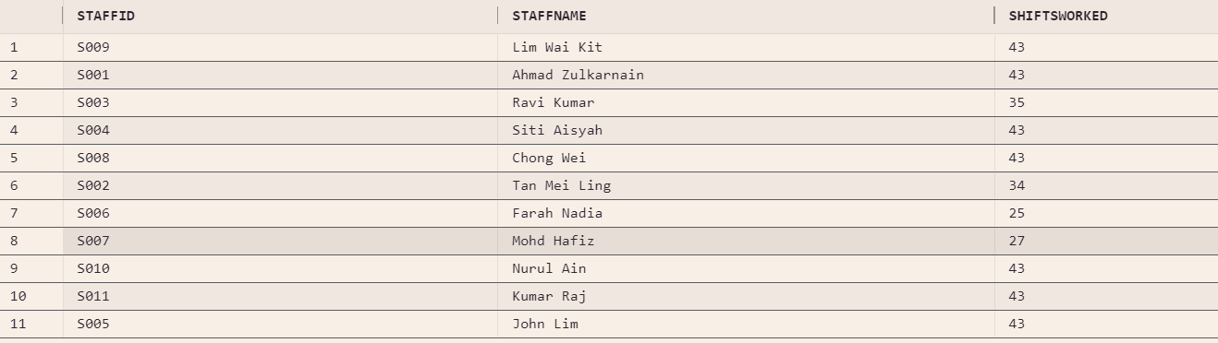

5.5.2 Indexes

Index 1: idx_genre_bookid
Purpose:
This index is created on the genre (converted to lowercase) and bookId columns of the BookTitles table. It is designed to support queries that filter, group, or rank books by genre, especially in genre-based reports.

Justification and Usage:
The index improves performance for reports such as:
Report 1 - Most Popular Genres & Authors: A Genre Borrowing Analytics Report

- rpt_genre_author_report which groups books by genre and author.
- rpt_genre_ranking which ranks genres based on popularity or borrowing frequency.

By indexing LOWER(genre), the index supports case-insensitive comparisons (e.g. WHERE LOWER(genre) = 'fiction') without requiring a full table scan. Including bookId helps when multiple books share the same genre, improving lookup and join efficiency in grouped or ordered queries.

SQL Statement:
-- Index 1: For genre reports
-- (rpt_genre_author_report, rpt_genre_ranking)
CREATE INDEX idx_genre_bookid ON BookTitles(LOWER(genre), bookId);

Index 2: idx_status_bookcopy
Purpose:
This index is created on the bookStatus, bookId, and copyId columns in the BookCopies table. It supports queries and reports that analyze book circulation based on their status (available, reserved, borrowed).

Justification and Usage:
The index enhances the performance of reports such as:
Report 2 - Book Status Analytics: Availability & Borrowing Duration Report

- rpt_bookstat_borrowduration – which summarizes borrow durations for books based on their current status.

The ordering of columns (bookStatus, then bookId, then copyId) allows efficient filtering by status (e.g. WHERE bookStatus = 'borrowed') and quick access to all copies of a specific book. It is especially helpful in nested cursor queries where borrowing history and availability trends are analyzed per book.

SQL Statement:
-- Index 2: For book status report
-- (rpt_bookstat_borrowduration)
CREATE INDEX idx_status_bookcopy ON BookCopies(bookStatus, bookId, copyId);

5.5.3 User Defined Functions

Function 1: CalculateTotalHoursWorked(staff_id)
Purpose:
The CalculateTotalHoursWorked function calculates the total number of hours a staff member has worked, based on their actual shift start and end times. It only includes hours from shifts where the staff’s attendance status is marked as 'Present'.

Justification and Usage in Query 2 - Staff Performance and Efficiency Analysis:
This function is critical for computing:
- The Performance Score, which depends on the average hours worked per shift and attendance consistency.
- The Efficiency Score for librarians and assistants, which measures how many loans are processed per hour of work.

By centralizing the logic in a function:
- We avoid redundancy, as the total hours worked is referenced multiple times in the query.
- We ensure consistent logic across multiple calculations.
- The function improves code readability and maintainability, especially when adjusting how hours are calculated in future.

In the main query, the function is used to return "TOTAL HOURS WORKED" directly and used in the calculation for "PERFORMANCE SCORE" and "EFFICIENCY SCORE" to assess both productivity and attendance performance.

SQL Statement:
CREATE OR REPLACE FUNCTION CalculateTotalHoursWorked (staff_id IN VARCHAR2)
RETURN NUMBER IS
total_hours NUMBER := 0;
BEGIN
SELECT SUM(
CASE
WHEN sa.attendanceStatus = 'Present' THEN
(EXTRACT(DAY FROM (sa.actualEndTime - sa.actualStartTime)) * 24) +
EXTRACT(HOUR FROM (sa.actualEndTime - sa.actualStartTime))
ELSE 0
END
)
INTO total_hours
FROM ShiftSchedules ss
JOIN StaffAttendance sa ON sa.scheduleId = ss.scheduleId
WHERE ss.staffId = staff_id;

RETURN total_hours;
END;
/

Function 2: CalculateLoanProcessed(staff_id)
Purpose:
The CalculateLoanProcessed function counts the total number of loan transactions processed by a specific staff member. It filters records in the BookAudit table where the actionType is 'Loaned'.

Justification and Usage in Query 2 - Staff Performance and Efficiency Analysis:
This function is vital for evaluating staff efficiency in handling loans, especially for roles like librarians and assistants whose performance is closely tied to loan activity.

By using a dedicated function:
- We improve clarity and abstraction by encapsulating the loan counting logic.
- Allows future reuse in other queries or reports such as weekly or monthly loan statistics.
- Keeps the main query clean and modular, aiding in performance optimisation and debugging.

In the main query, the function is used to display "LOAN PROCESSED" as a performance metric for relevant staff and also used in computing "EFFICIENCY SCORE" by dividing the number of loans processed by the total hours worked.

SQL Statement:
CREATE OR REPLACE FUNCTION CalculateLoanProcessed (staff_id IN VARCHAR2)
RETURN NUMBER IS
total_loans NUMBER := 0;
BEGIN
SELECT COUNT(*)
INTO total_loans
FROM BookAudit ba
WHERE ba.staffId = staff_id AND ba.actionType = 'Loaned'; -- staffId is now VARCHAR2

RETURN total_loans;
END;
/

5.5.4 User Defined Exceptions

Exception 1: ISBN Uniqueness Check
Implementation: Trigger 1 - TRG_MANAGE_BOOK_DETAILS
Purpose:
The purpose of this exception is to ensure that the ISBN value for each book in the BookTitles table is unique. An ISBN (International Standard Book Number) is a unique identifier for books, and having duplicates would lead to data inconsistencies and confusion for book identification.

It is important to prevent the insertion or update of a record that would violate this uniqueness rule, as this could lead to the incorrect management and tracking of books in the system.

SQL Statement:
RAISE_APPLICATION_ERROR(-20001, 'Error: ISBN must be unique.');

Sample output:
Input: Insert a book with same existing ISBN from B001

INSERT INTO BookTitles (bookId, title, author, genre, publicationYear, isbn, price, popularity)
VALUES ('B998', 'Test Book 1', 'Author A', 'Mystery', 2023, '1649374178', 20.00, 3.5);



Exception 2: Publication Year Validation
Implementation: Trigger 1 - TRG_MANAGE_BOOK_DETAILS
Purpose:
The purpose of this exception is to prevent inserting or updating a book record with a publication year that is set in the future. This ensures the integrity of the book data by only allowing valid historical publication years or the current year. Future publication years could represent incorrect or speculative data.

SQL Statement:
RAISE_APPLICATION_ERROR(-20002, 'Error: Publication year cannot be in the future.');

Sample output:
Input: Insert a book with future publication year

INSERT INTO BookTitles (bookId, title, author, genre, publicationYear, isbn, price, popularity)
VALUES ('B997', 'Future Book', 'Author C', 'Sci-Fi', 2026, '9876543210', 30.00, 4.5);



Exception 3: Price Validation
Implementation: Trigger 1 - TRG_MANAGE_BOOK_DETAILS
Purpose:
This exception ensures that the price of a book is non-negative. A price less than zero is invalid, as it would imply the book is being sold at a loss or there is an error in the pricing. This helps maintain financial data consistency within the system.

SQL Statement:
RAISE_APPLICATION_ERROR(-20003, 'Error: Price must be zero or greater.');

Sample output:
When the price of a book is entered as a negative number, the following message will be displayed:

INSERT INTO BookTitles (bookId, title, author, genre, publicationYear, isbn, price, popularity)
VALUES ('B996', 'Free Book?', 'Author D', 'Education', 2022, '1111111111', -10.00, 3.0);



Exception 4: Popularity Validation
Implementation: Trigger 1 - TRG_MANAGE_BOOK_DETAILS
Purpose:
This exception ensures that the popularity score for a book falls within a valid range of 1.0 to 5.0. A popularity score outside this range could skew data or provide unrealistic values for how popular a book is perceived to be. By setting boundaries on the score, this validation helps maintain consistent and reasonable data.

SQL Statement:
RAISE_APPLICATION_ERROR(-20004, 'Error: Popularity must be between 1.0 and 5.0.');

Sample output:
If a user enters a popularity value outside the valid range (either less than 1.0 or greater than 5.0), the following error message will appear:

INSERT INTO BookTitles (bookId, title, author, genre, publicationYear, isbn, price, popularity)
VALUES ('B995', 'Overrated Book', 'Author E', 'Drama', 2021, '2222222222', 18.00, 5.5);



Exception 5: Invalid Genre Validation
Implementation: Report 1 - rpt_genre_author_report
Purpose:
This user-defined exception ensures that the report is only generated for genres that exist in the database. If the input genre does not match any genre in the BookTitles table, the procedure raises a meaningful error instead of executing unnecessary or faulty logic. This prevents confusion and ensures only valid data is used for reporting.

SQL Statement:
-- Custom exception for invalid genre
ex_invalid_genre EXCEPTION;

-- Validation variable
v_genre_exists NUMBER;

IF v_genre_exists = 0 THEN
RAISE ex_invalid_genre;
END IF;

EXCEPTION
WHEN ex_invalid_genre THEN
DBMS_OUTPUT.PUT_LINE('Error: Genre "' || UPPER(p_genre) || '" does not exist in the database.');
WHEN OTHERS THEN
DBMS_OUTPUT.PUT_LINE('An unexpected error occurred: ' || SQLERRM);

Sample output:
If a user enters a genre that does not exist in the system, such as "Comedy" (assuming no books exist in that genre), the following message will be displayed:

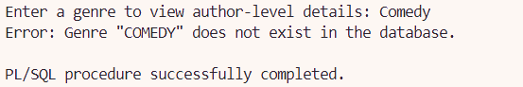

Exception 6: Invalid Copy Count Validation
Implementation: Stored Procedure 2 - add_book_title_with_copies
Purpose:
This user-defined exception ensures that the number of book copies entered is greater than 0. It prevents inserting book entries with zero or negative copies, which could lead to data inconsistency and confusion in the library’s inventory system.

SQL Statement:
-- Exception for invalid number of copies
ex_invalid_copy_count EXCEPTION;

-- Validate number of copies
IF p_num_copies <= 0 THEN
RAISE ex_invalid_copy_count;
END IF;

-- Handle invalid copy count exception
EXCEPTION
WHEN ex_invalid_copy_count THEN
DBMS_OUTPUT.PUT_LINE('Error: Number of copies must be greater than 0.');

Sample output:
If the user inputs 0 as the number of copies, the following message will be displayed:

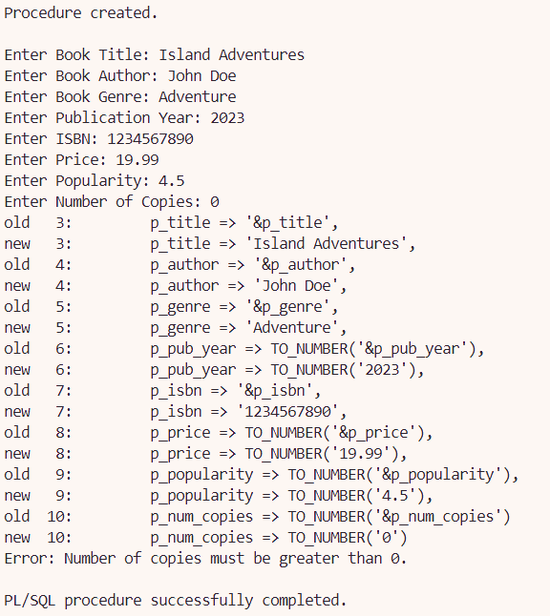

Exception 7: Duplicate Book ID or ISBN (PRAGMA EXCEPTION_INIT)
Implementation: Stored Procedure 2 - add_book_title_with_copies
Purpose:
This exception handles the scenario where a duplicate bookId or isbn is inserted, violating the table’s uniqueness constraints. By using PRAGMA EXCEPTION_INIT, the Oracle error code -1 (unique constraint violation) is mapped to a named exception, allowing a cleaner and more readable exception block.

SQL Statement:
-- Exception if duplicate bookId or isbn exists
ex_dup_val EXCEPTION;
PRAGMA EXCEPTION_INIT(ex_dup_val, -1);

EXCEPTION
WHEN ex_dup_val THEN
DBMS_OUTPUT.PUT_LINE('Error: Book ID or ISBN already exists. Please use unique values.');
RETURN;
WHEN OTHERS THEN
DBMS_OUTPUT.PUT_LINE('Unexpected error: ' || SQLERRM);
RETURN;
END;

Sample output:
If a user tries to insert a book with an ISBN that already exists in the system (B001 ISBN: 1649374178):

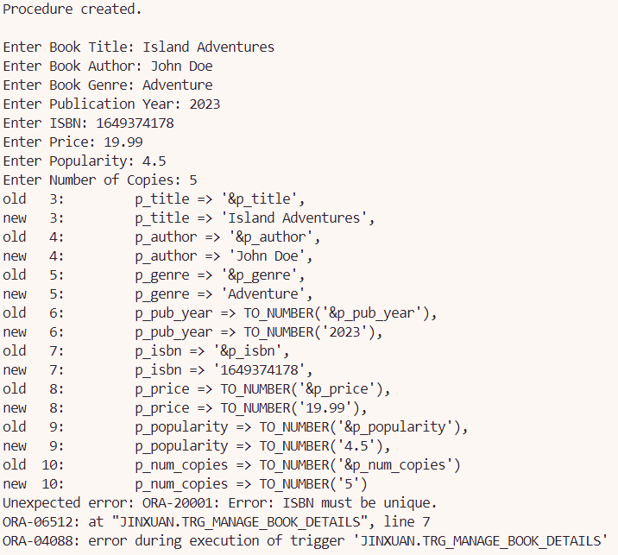

5.5.5 Sequences

Sequence 1: book_id_seq
Purpose:
The sequence book_id_seq is designed to automatically generate unique bookId values for new entries in the BookTitles table. The sequence starts from 151, following the latest used ID B150.

Justification and Usage in Stored Procedure 2 - Add New Book Title with Copies:
In the stored procedure add_book_title_with_copies, the book_id_seq is used to:

- Ensure uniqueness of the bookId for every new book inserted.
- Automate ID generation, reducing the risk of human error or duplication.
- Maintain consistent formatting by prefixing the numeric value with 'B' and padding with zeros (B151, B152, etc.).

This automation is crucial in systems handling large data entries, ensuring data integrity and smooth scalability. By using a sequence, the system avoids hardcoding or manual tracking of primary key values, making the procedure efficient and reliable.

SQL Statement:
-------- Sequence 1: BookTitles bookID ---------
-- Latest Key Value: B150
CREATE SEQUENCE book_id_seq
START WITH 151
INCREMENT BY 1
NOCACHE;

Sequence 2: copy_id_seq
Purpose:
The sequence copy_id_seq is responsible for generating unique copyId values for each physical copy of a book inserted into the BookCopies table. It begins at 351, following the latest ID C350.

Justification and Usage in Stored Procedure 2 - Add New Book Title with Copies:
In the add_book_title_with_copies procedure:

- copy_id_seq is used inside a loop to generate a new copyId for each copy.
- This ensures each physical book copy is uniquely identifiable, even when multiple copies of the same title exist.
- The use of sequence within a loop allows the dynamic creation of multiple entries based on the user-defined p_num_copies input.
- Similar to book_id_seq, the sequence-generated ID is formatted with a 'C' prefix and zero padding (C351, C352, etc.), preserving ID consistency.

The sequence helps maintain the one-to-many relationship between BookTitles and BookCopies by uniquely identifying each copy and linking them back to a single bookId.

SQL Statement:
-------- Sequence 2: BookCopies copyID ---------
-- Latest Key Value: C350
CREATE SEQUENCE copy_id_seq
START WITH 351
INCREMENT BY 1
NOCACHE;

5.5.6 Output Formatting
Query 1 - Most Borrowed Books (Popular Books Ranking)
Format Element | SQLPLUS Command | Description
Environment Setup | -- SETUP SQLPLUS ENVIRONMENT  SET LINESIZE 200  SET PAGESIZE 50  SET WRAP OFF  SET TRIMSPOOL ON | Configures the output display by setting a line width of 200 characters, limiting the page size to 50 lines, disabling text wrapping for continuous lines, and trimming trailing spaces in the spool file to ensure cleaner and more readable output.
Column Format | -- FORMAT OUTPUT FOR SQLPLUS  COLUMN "RANK" FORMAT 99  COLUMN "TITLE" FORMAT A45  COLUMN "AUTHOR" FORMAT A25  COLUMN "GENRE" FORMAT A15  COLUMN "YEAR" FORMAT 9999  COLUMN "TIMES BORROWED" FORMAT 9999  COLUMN "PRICE ($)" FORMAT 99990.00  COLUMN "POPULARITY RATING" FORMAT 9.0 | Defines the display format for each column in the query result: "RANK" as a 2-digit number, "TITLE" as a 45-character string, "AUTHOR" as a 25-character string, "GENRE" as a 15-character string, "YEAR" as a 4-digit number, "TIMES BORROWED" as a 4-digit number, "PRICE ($)" as a number with 2 decimal places, and "POPULARITY RATING" as a single-digit number.
Header Display | -- HEADER  PROMPT  PROMPT ========================================= TOP BORROWED BOOKS REPORT =========================================  PROMPT | Adds a custom header to the report for a clear section title, making the report visually easier to navigate.

Query 2 - Staff Performance and Efficiency Analysis
Format Element | SQLPLUS Command | Description
Environment Setup | -- SQL*Plus: Set up display  SET SERVEROUTPUT ON  SET LINESIZE 150  SET PAGESIZE 50  SET WRAP ON  SET TRIMSPOOL ON  SET DEFINE OFF | Configures the output display by enabling server output, setting the line width to 150 characters, limiting the page size to 50 lines, enabling text wrapping, trimming trailing spaces in the spool file, and disabling the substitution variable for security.
Column Format | -- Column formatting  COLUMN "STAFF ID" FORMAT A10  COLUMN "STAFF NAME" FORMAT A20  COLUMN "STAFF ROLE" FORMAT A10  COLUMN "TOTAL SHIFTS WORKED" FORMAT 9999  COLUMN "TOTAL HOURS WORKED" FORMAT 9999  COLUMN "LOAN PROCESSED" FORMAT 9999  COLUMN "EFFICIENCY SCORE" FORMAT 0.99  COLUMN "PERFORMANCE SCORE" FORMAT 9999.99 | Defines the display format for each column in the query result: "STAFF ID" as a 10-character string, "STAFF NAME" as a 20-character string, "STAFF ROLE" as a 10-character string, "TOTAL SHIFTS WORKED" and "TOTAL HOURS WORKED" as 4-digit numbers, "LOAN PROCESSED" as a 4-digit number, "EFFICIENCY SCORE" as a decimal number with 2 digits, and "PERFORMANCE SCORE" as a decimal number with 2 digits.
Header Display | PROMPT ====================================================================================================================================, PROMPT EFFICIENCY SCORE: ..., PROMPT PERFORMANCE SCORE: ..., PROMPT ================================================ STAFF PERFORMANCE QUERY ===================================================== | Adds custom headers and descriptions to the report, providing explanations for the "EFFICIENCY SCORE" and "PERFORMANCE SCORE", as well as section titles to help users understand the context of the displayed data.

Report 1 - Most Popular Genres & Authors: A Genre Borrowing Analytics Report
Format Element | SQLPLUS Command | Description
Output Setup | SET SERVEROUTPUT ON;  SET PAGESIZE 1000;  SET LINESIZE 300; | Configures output settings for display, enabling DBMS_OUTPUT and setting page and line sizes to ensure proper formatting in the output.
Procedure Header | DBMS_OUTPUT.PUT_LINE(RPAD('=', 100, '=')); | Uses DBMS_OUTPUT.PUT_LINE to create a header section with equal signs (=) and labels such as "Genre Report" and "Generated On".
Formatting Rows and Concatenation | DBMS_OUTPUT.PUT_LINE(RPAD('No.', 5) ||  RPAD('Title', 45) ||  RPAD('Year', 8) ||  RPAD('Popularity', 12) ||  RPAD('Price (RM)', 12) ||  'Borrows');  DBMS_OUTPUT.PUT_LINE(RPAD('-', 100, '-')); | RPAD is used to pad and align text for consistent column formatting (e.g., title, popularity).

Report 2 - Book Status Analytics: Availability and Borrowing Duration Report
Format Element | SQLPLUS Command | Description
Output Setup | SET SERVEROUTPUT ON;  SET PAGESIZE 1000;  SET LINESIZE 300; | Configures output settings for display, enabling DBMS_OUTPUT and setting page and line sizes to ensure proper formatting in the output.
Procedure Header | DBMS_OUTPUT.PUT_LINE(RPAD('=', 130, '='));  DBMS_OUTPUT.PUT_LINE(RPAD('||', 100));  DBMS_OUTPUT.PUT_LINE('|| ' || RPAD('Book Availability and Borrowing Duration Report', 118) || ' ||');  ... | Uses DBMS_OUTPUT.PUT_LINE to create a header section with equal signs (=) and labels such as the report title 'Book Availability and Borrowing Duration Report' and "Generated On".
Formatting Rows and Concatenation | -- Print book row  DBMS_OUTPUT.PUT_LINE(  RPAD(v_row_num, 5) ||  RPAD(book_rec.bookId, 12) ||  RPAD(SUBSTR(book_rec.title, 1, 39), 40) ||  RPAD(book_rec.genre, 20) ||  RPAD(book_rec.bookStatus, 18) ||  RPAD(book_rec.borrow_count, 10) ||  RPAD(TO_CHAR(v_avg_borrow_duration, '990.00'), 15)  ); | This line of code prints a row of book details in a neatly formatted table, using RPAD to align each value to a fixed width for consistent column formatting, including the book ID, title, genre, status, borrow count, and average borrowing duration.

